|  |
| --- |
| microsoft |
| Microsoft Media Platform Content Manager |
| Documentation |
|  |
| **Microsoft** |
| **12/9/2010** |

|  |
| --- |
|  |

Table of Contents

Introduction 4

Who should read this? 4

Expected audience knowledge 4

Learn More 5

Reading Guide 5

Acronyms 5

Server Roles 6

Can the MMPCM help my organization? How? 7

Educational Institute 7

Public Broadcasting Network 8

Private Multinational Company 8

MMPCM Architecture 10

High Level Architecture 10

Asset Metadata Structure 11

Asset content type 13

File Asset content type 13

RCE Asset content type 14

Live Asset content type 14

VOD Infrastructure 14

Built-in IIS Transform Manager Tasks included in the MMPCM 14

File Import Flow 16

RCE Import Flow 17

Live Infrastructure 18

Encoder Automation Service 18

Encoder Manager Service 19

Encoder Status Service 19

Schedule Xml Service 20

Live Dashboard 20

Installing the MMPCM 23

Hardware and Software Requirements 23

Unblock the Installation Files 24

Automated Installation Process 24

Enabling Watch Folders 35

Using a host header 37

How to configure Search service 38

Getting to know the MMPCM – First Run Experience 43

Site Template 43

Live Broadcasting 46

Ad Insertion Tool 47

Metadata Export 48

Asset Gallery 49

Rough Cut Editor 50

Transform Manager Tasks 51

Working with the MMPCM 52

How To – *Create a Project Site* 52

How To – *Create Video on Demand Assets* 54

How To – *Create RCE Assets* 59

How To – *Manage Live Events* 61

How To – *Categorize Assets* 68

Categories 68

Collections 70

Gallery View 71

Tags 72

How To – *Configure Targeted Platforms* 72

Creating a Targeted Platform in SharePoint 72

Configure a Targeted Platform output folder in a Transform Manager preset 73

How To – *Enable multicast support for Live Events* 74

How To – *Approve Items* 75

How To – *Insert Ads In a Live Event* 77

Architecture 77

How does Ad Insertion works? 79

How To – *Import Data From an Excel Spreadsheet* 88

CMS Import Tool 89

How To – *Suggested Security Schema* 93

Administrator 94

Producer 94

Editor 94

Visitor 94

How To – *Configure Third Party Player Access* 95

Metadata XML Export 96

Extensibility 104

Customizing a Project Site 104

Features & Package 108

List Forms 111

Using a different Live infrastructure 115

# Introduction

* 1. The **Microsoft Media Platform Content Manager (MMPCM)** is an open source solution that can be used by enterprises, educational institutions and broadcasting companies to manage their video assets using a lightweight and highly-customizable solution built on **Microsoft SharePoint 2010** and Microsoft media-related technologies, such as **Silverlight 4**, **IIS Media Services** and **Expression Encoder 4** among others.
  2. The MMPCM infrastructure enables users to:
  + Define, edit and approve / reject video assets
  + Transcode video into different formats
  + Broadcast Live Events
  + Insert Ads on Live Event transmissions
  + Edit videos online right within MMPCM
  + Publish videos to external players
  + The present document will provide both an architectural and a technical description of the **Microsoft Media Platform Content Manager**.

## Who should read this?

* 1. This document will be useful for any **editor**, **producer** and **administrator** wishing to manage and stream his or her video library using the MMPCM infrastructure. Also, this guide will help **architects** and **developers** understanding how the MMPCM works internally and how to extend it. Specifically this guide will be helpful for:
  + Administrators, who want to deploy and setup the MMPCM infrastructure on his or her company.
  + Editors, who want to use the MMPCM for uploading, managing and editing content in the MMPCM.
  + Producers, who want to work with editors, having the additional responsibility for approving or rejecting content on the MMPCM.
  + Architects and developers, who want to extend MMPCM infrastructure to cope additional requirements in their organizations.

### Expected audience knowledge

* 1. Experience on the usage of Expression Encoder and IIS Media Services is expected in order to understand how the MMPCM broadcasts live media sources using **IIS Media Services Publishing Points.**
  2. Understanding the concept of **IIS Transform Manager** **tasks** and **watch folders** will help understand how the MMPCM workflows encode and upload media to the SharePoint 2010 site.
  3. **SharePoint 2010** and **WCF Services** development knowledge is required to understand the extension mechanisms.
  4. **Note:** basic **SharePoint 2010** knowledge is desired, but not mandatory.

### Learn More

* 1. If you think you have missed some of the technologies listed above, you might want to take a look to some of the following resources:
  + [Microsoft SharePoint 2010 web site](http://sharepoint.microsoft.com/en-us/Pages/default.aspx)
  + [The Official Microsoft IIS Media Services web site](http://www.iis.net/media)
  + [IIS Transform Manager on MSDN](http://msdn.microsoft.com/en-us/library/ff728121(v=vs.90).aspx)
  + [Hosting and Consuming WCF Services on MSDN](http://msdn.microsoft.com/en-us/library/bb332338.aspx)
  + [SharePoint 2010 Reference: Software Development Kit](http://www.microsoft.com/downloads/en/details.aspx?FamilyID=f0c9daf3-4c54-45ed-9bde-7b4d83a8f26f&displaylang=en)

## Reading Guide

* 1. First, you will find an introduction to the MMPCM high level architecture, helping you understand how every MMPCM component fits in its infrastructure, and how they all work together to execute the MMPCM workflows.
  2. Then, installation instructions and a first run experience will be detailed, providing step by step instructions on the MMPCM installation in a single machine, and a walkthrough on the output of the installation, allowing you to know the basics of the MMPCM user experience.
  3. Finally, specific extensibility topics will be presented, which will allow you to start building a customized MMPCM infrastructure that suits your specific needs.

## Acronyms

* 1. The following table lists the Acronyms used through the document

|  |  |
| --- | --- |
| Acronym | Stands For |
| MMPCM | Microsoft Media Platform Content Manager |
| IIS | Internet Information Services |
| VOD | Video on Demand |
| RCE | Rough Cut Editor |
| EAS | Encoder Automation Service |
| EMS | Encoder Management Service |
| LSS | Live Streaming Service |
| SXS | Schedule XML Service |
| GUID | Globally Unique Identifier |

## Server Roles

* 1. The Server Roles listed below were defined based on a separation of concerns, as well as balancing the workload on them.
  2. Although the MMPCM can be installed in one server, we recommend the following deployment for a better performance and easier management.
  3. 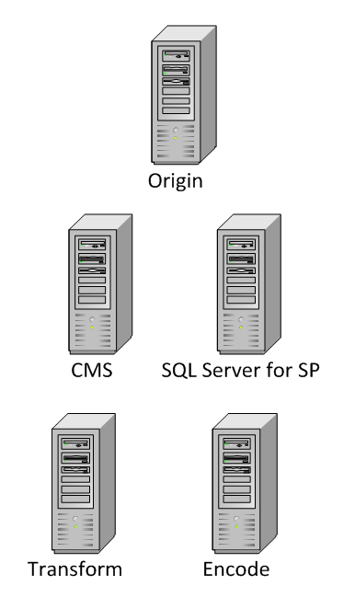
  4. MMPCM - Recommended deployment
  + Origin
    - Publishing Point infrastructure
    - VOD exposure
    - Thumbnails exposure
    - Rough Cut Editor
  + CMS
    - SharePoint 2010 Sites
    - Metadata infrastructure
  + SQL Server for SharePoint
  + Transform
    - Transform Manager Jobs
    - Video transcoding
    - Transform Manager custom tasks
  + Encode
    - Expression Encoder

## Can the MMPCM help my organization? How?

* 1. The MMPCM provides a foundation for a Video Content Management System that can be customized to suit needs of numerous kinds of organizations. Leveraging the features of **SharePoint 2010**, entire systems can be built around a MMPCM installation. We will present **three fictional examples** of rather different types of organizations. This way you can decide whether to adopt the MMPCM, and even get some ideas to start building your own Video infrastructure around it.

### Educational Institute

* 1. The **Contoso University** has decided to implement a new site for their students that will host information for the University courses, including recordings of every lecture given.
  2. They have used the **MMPCM** as the foundation for the site, which, out of the box, has provided the **Contoso University**:
  + The ability to easily encode lecture recordings to different formats.
  + The ability to export lecture recording data to a file, and to post that file to different servers.
  + The ability to categorize assets.
  + SharePoint 2010 features
  1. Having the **MMPCM** as foundation, the **Contoso University** has successfully launched **The Contoso Online University**, a portal for its students that provides access to hundreds of recorded lectures, related documents, course staff information and lecture schedules, among others.
  2. The **Contoso Online University** allows students to search for specific materials, review missing lectures, or even watch them again before taking a mid-term. Thanks to the tags, looking for specific information has become a lot easier for students.
  3. The organization also took advantage of the collaborative SharePoint platform improving the interaction between students and professors.
  4. Also, some students have developed a **Windows Phone 7** application, which, using the **MMPCM** export metadata feature, allows the students to watch lectures on their mobile devices (encoded in the corresponding presets).

### Public Broadcasting Network

* 1. The **Contoso Sports Broadcasting Network (CSBN)** is a newborn Internet-based sports network. They broadcast live events and sport news live on the Internet.
  2. Since its launch a couple of months ago, CSBN has been a huge success among sports fans all over the country. **CSBNs** CEO recognizes that they own much of this success to the **MMPCM**.
  3. The network created their infrastructure leveraging the following **MMPCM** features:
  + Multi-angle live event broadcasting.
  + Ad insertion.
  + Assets metadata.
  + Live event schedule export.
  + Smooth streaming adaptive streaming.
  + Rough Cut Editor
  1. In this case, the **MMPCM** acts as a backend administration system, where **CSBN** editors schedule live events, and creates highlights of the transmissions to be transmitted later, as parts of the sport news shows. Also there is an operator that is in charge of insert ads during the events, which in turn, is the main economic mainstay of the network.
  2. **CSBN** uses the export metadata feature to consume event data from their public website that has a third party player configured to read data from the schedule file generated by the **MMPCM.** Based on that, they have built a custom event schedule for registered users, which adds events to registered user’s **Outlook** according to their preferences that matches categories or even tags. Busy sport fans really enjoy this feature.

### Private Multinational Company

* 1. The **Contoso Software Development Company (CSDC)** was born 20 years ago as a small start-up. During the internet boom, a combination of momentum and great decisions turned **CSDC** into a multi-national, NASDAQ enterprise. **CSDC** founder, **John Doe**, is convinced that internal communication has always been one of the drivers of their success. Given this, he has decided to celebrate **CSDC**’s20th birthday announcing an internal video infrastructure for their employees that will allow board members to broadcast announcements to **CSDC** offices all over the world.
  2. The **Contoso Internal Announcements Infrastructure (CIAI)** has been built around the **MMPCM**, and it takes advantage of the following **MMPCM** features:
  + Live event broadcasting.
  + Smooth streaming adaptive streaming.
  + VOD assets management and storage.
  + Assets metadata.
  + Numerous SharePoint 2010 features.
  1. The broadcasting infrastructure is a single camera encoding solution, located in **CSDC** Headquarters, which will be used to broadcast internal news, announcements, or even season greetings that will then be archived and made available for later viewing. Metadata added to the recordings will help employees locating assets on the **CIAI**.
  2. The **CIAI** was envisioned as a complete platform to communicate internal news to **CSDC** employees, so apart from broadcasting and storing internal video communications, an entire portal was built, including corporate blogs and announcements, powered by **SharePoint 2010**.

# MMPCM Architecture

## High Level Architecture

* 1. The **Microsoft Media Platform Content Manager** relies on **SharePoint 2010** for metadata management. The metadata representation of a video within the MMPCM is known as **Asset**. Assets define attributes such as **Title**, **Description**, **Author**, **Thumbnail**, **Start Time**, **Duration**, **URL**, etc. Assets are divided into **Projects**.
  2. Projects are implemented as **sub-sites** within the MMPCM, and are way of a grouping Assets of the same topic. A Project is also a collaboration infrastructure for publishers and producers managing a common group of Assets, which provides communication means, roles, and workflow activities.
  3. The following diagram shows the MMPCM components and the interaction between them.
  4. 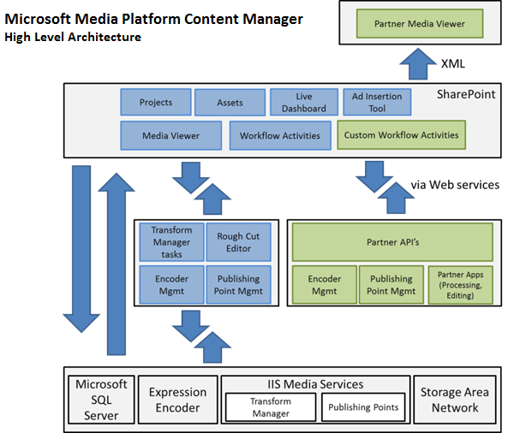
  5. The MMPCM has a **built-in media player** that allows publishers and producers to preview videos, and it can also interact with a third party video player by exporting metadata required for publishing videos (assets metadata is exported into a XML file, so the external player can parse the file and access the information).
  6. The MMPCM provides the infrastructure for managing Live Events. A MMPCM user can **schedule**, **start** and **stop** a Live Event by using the **Live Dashboard**. The dashboard automatizes **Encoders** and **Publishing Points** allowing the user to create, start and stop them from a centralized console. By default, the **Live Dashboard** interacts with **Expression Encoder** or [**Inlet Technologies**](http://www.inlethd.com/) **Encoders** and **IIS Media Services** using Web Services. These Web Services represent an extensibility point, allowing partners to manage their own encoder infrastructure.
  7. The **Ad Insertion Tool** allows users to categorize Assets as **Ads** and air them during the transmission of Live Events. Ads are grouped into **Ad Pods** that are associated to Assets. Using the **Ad Insertion Dashboard**, an operator can insert any of the Ad Pods associated to the asset being broadcasted.
  8. Using **IIS Transform Manager**, the MMPCM is able to add preexisting videos into the system and also transcode them into different targeted platforms. IIS Transform Manager represents another point of extensibility in the system, since it lets you write your own plug-in Tasks to support **custom actions**, **third-party encoders**, or your own encoding applications. An example custom action is provided in the MMPCM, which insert Assets metadata into the system after encoding a preexisting video.
  9. Using the **Microsoft Silverlight Rough Cut Editor** the user can compose a new video, and edit existing **Smooth Streaming** Assets. Users can create a **Highlight** by trimming an Asset, or composing a new Asset by adding two or more of them to the timeline. Once the editing finishes, the MMPCM transforms the output into a **Composite Stream Manifest** and adds it to the asset’s contents.

## Asset Metadata Structure

* 1. MMPCM metadata structure is based on **SharePoint Content Types**. A content type is a reusable collection of metadata (columns), workflow, behavior, and other settings for a category of items or documents in a Microsoft SharePoint 2010 list or document library. Content types enable you to manage the settings for a category of information in a centralized, reusable way.
  2. This diagram shows the Asset content type inheritance structure specifying the attributes for each content type.
  3. 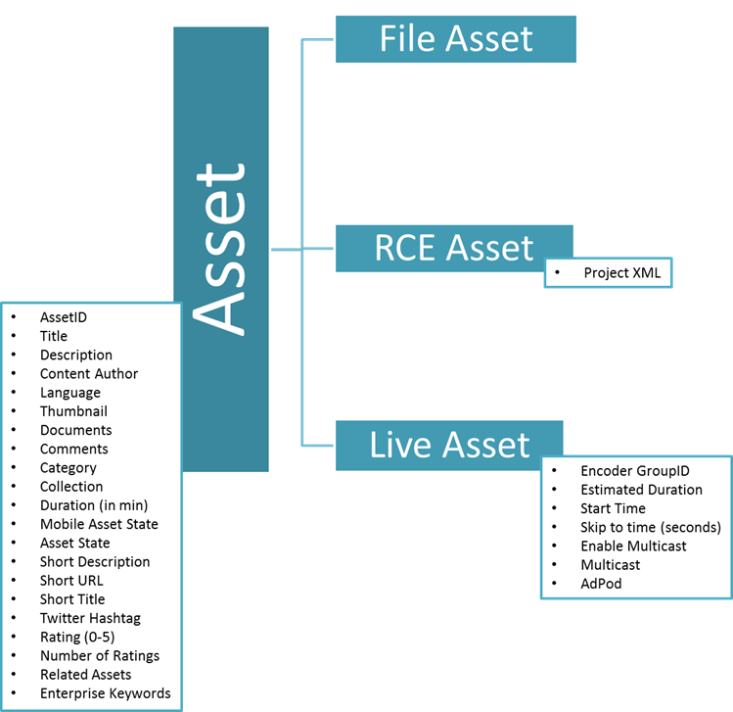
  4. MMPCM – Asset Content Types

### Asset content type

* 1. **Asset** is MMPCM’s main Content Type; all of the specific assets content types inherit from its definition. This is an **abstract** content type, which means no new items of this type can be created.

|  |  |  |  |
| --- | --- | --- | --- |
| Field Title | Field Type | Required | Comments |
| AssetID (Hidden) | Single line of text | Yes | This is an auto-generated unique identifier (GUID) throughout the MMPCM |
| Title | Single line of text | Yes |  |
| Description | Multiple lines of text | No |  |
| Content Author | Single line of text | No |  |
| Language | Choice | No |  |
| Thumbnail | Hyperlink or Picture | No |  |
| Documents | Lookup | No | Documents related to Assets that can be downloaded |
| Comments | Multiple lines of text | No |  |
| Category | Lookup | No | A way of classifying Assets. e.g.: “Ad” |
| Collection | Lookup | No | A way of grouping Assets. e.g.: “Movie”, “Highlight” |
| Duration (in min) | Number | No | Video length in minutes |
| Mobile Asset State | Choice | Yes | Values: NotAvailable (default), Live, VOD |
| Asset State | Choice | Yes | Values: NotAvailable (default), Live, VOD |
| Short Description | Single line of text | No |  |
| Short URL | Single line of text | No |  |
| Twitter Hashtag | Number | No |  |
| Rating | Rating (0-5) | No | SharePoint OOB rating mechanism |
| Related Assets | Lookup | No | Related to itself |
| Enterprise Keywords | Managed metadata | No | A way of tagging |

### File Asset content type

* 1. This asset defines **VOD** files. It has no additional fields.

### RCE Asset content type

* 1. The purpose of this asset is to store items that can interact with **Microsoft Silverlight Rough Cut Editor**. It adds a **Project XML** column that contains a Rough Cut Editor project file in xml format.

|  |  |  |  |
| --- | --- | --- | --- |
| Field Title | Field Type | Required | Comments |
| ProjectXML (Hidden) | Multiple lines of text | No | Contains a Rough Cut Editor project file in xml format |

### Live Asset content type

* 1. This asset type represents those items that will be live streamed.

|  |  |  |  |
| --- | --- | --- | --- |
| Field Title | Field Type | Required | Comments |
| Encoder GroupID | Number | Yes | This ID identifies the encoder that will be automated from the Live Dashboard |
| Estimated Duration | Number | Yes | Estimated live event length in minutes |
| Start Time | Date and Time | Yes | Time when the live event will occur |
| AdPod | Lookup | No | List of associated Ad Pods to be inserted from the Ad Insertion Dashboard |

## VOD Infrastructure

* 1. The MMPCM provides a **Video on Demand** infrastructure, which automatizes the process of uploading videos into the system. Dropping a video to a preconfigured **watch folder** will result in the creation of a new asset in SharePoint, along with a number of contents in different formats (targeted platforms) published in IIS and linked from the MMPCM web interface.
  2. Additionally, the VOD infrastructure provides a built-in task that automatizes the process of creating an edit using **Rough Cut Editor**, re-encoding and publishing the resulting video back in the MMPCM.
  3. Both workflows are based on a series of watch folders, from which a number of built-in **IIS Transform Manager Templates** (a **Template** is a sequential set of **IIS Transform Manager Tasks**) take, process, and put files. Finally, a **SharePoint-hosted WCF Web Service** called **Asset Management Service** creates or uploads the corresponding metadata in **SharePoint**.

### Built-in IIS Transform Manager Tasks included in the MMPCM

* + **Expression Encoder Task**: Given a XML preset file, this task encodes the file in the format specified in the preset, and drops the resulting file in an output folder, named after the targeted platform **GUID** in SharePoint. There can be any number of presets, so the file can be encoded and published in many formats.
    1. 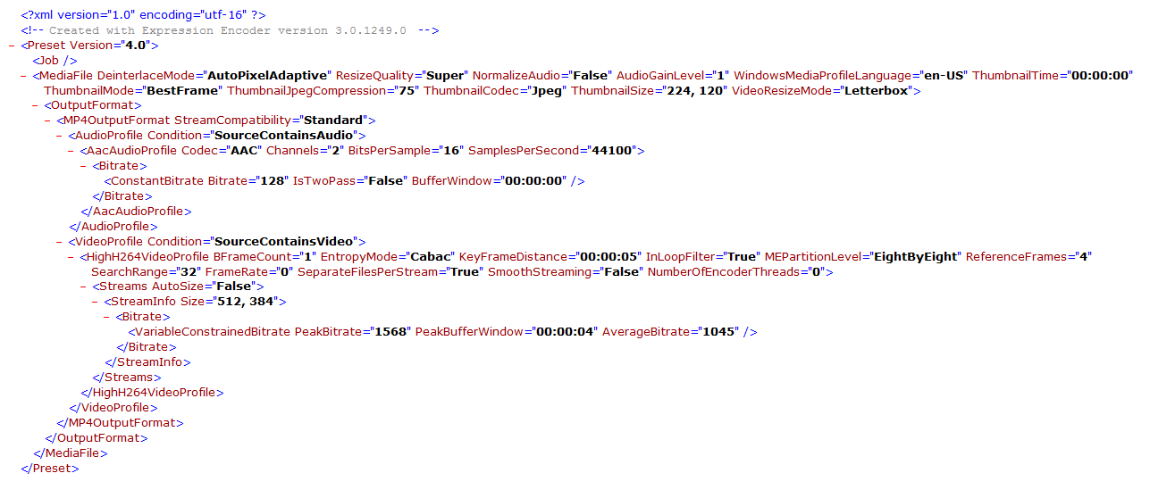
    2. Expression Encoder Task Example
  + **Hosting Message Task**: Given the video files on the targeted platform folders, plus the original video file, it generates a XML message file (and drops it into a watch folder) that contains information required to update the SharePoint site. Finally, it moves the files to a temporal folder.
    1. **Note:** for the original file to be copied to the temporal folder, the file format must be present in the task configuration.
    2. 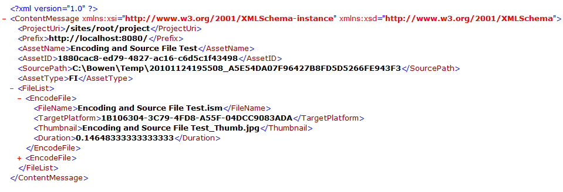
    3. Hosting Message Task Configuration Example
  + **Hosting Job Task**: Moves the encoded files from the temporal folder to its final location on an IIS site. Then, using the data on the XML message file (that triggered its execution), the task makes a call to **Assets Management Service**, which updates the MMPCM SharePoint site, adding the videos metadata, and linking the contents to the files in IIS.
  + **RCE Task**: Reads a **RCE project XML** and produces a **Composite Stream Manifest**, which is dropped on a preset folder.

### File Import Flow

* 1. The File Import flow contains two watch folders: the **File Import Watch Folder**, and the **Hosting Job Watch Folder**. For each of them, a set of tasks is configured, so when a file is dropped, the tasks are executed **sequentially**.
  2. **File Import Watch Folder** has an **Expression Encoder Task** and a **Hosting Message Task** configured. While **Hosting Job Watch Folder** has a **Hosting Job Task** configured.

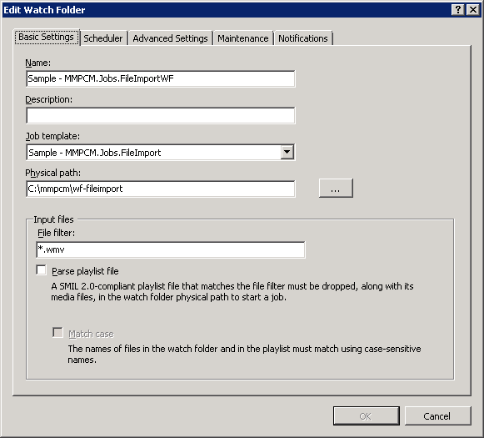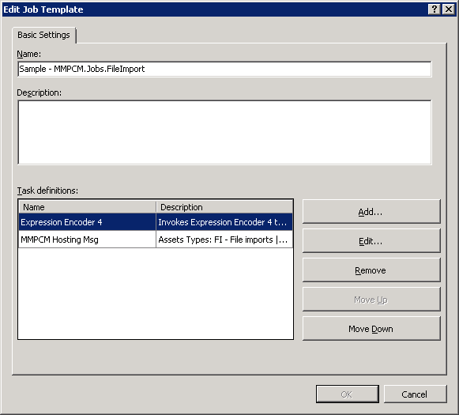

* 1. Job Template and Watch Folder Configuration Dialogs
  2. This flow starts when a MMPCM user drops a video file into the **File Import Watch Folder** (using **Windows Explorer**, a **FTP Client**, or any other mechanism) **(1)**.
  3. The EE Task s encodes the file in the preset formats, and then copies the files to the **Targeted Platforms Folders (2)** (Note that this is not a watch folder, so it does not trigger any task).
  4. Based on the created files, the **Hosting Message Task** creates a **Message XML** file, and drops it into the **Hosting Job Watch Folder**.
  5. The **Hosting Job Task** is triggered **(3)**. It moves the encoded files to the **IIS VOD Folder**, and using the message file information calls the **Assets Management Service (4)**, which updates the MMPCM metadata, linking the videos location.
  6. 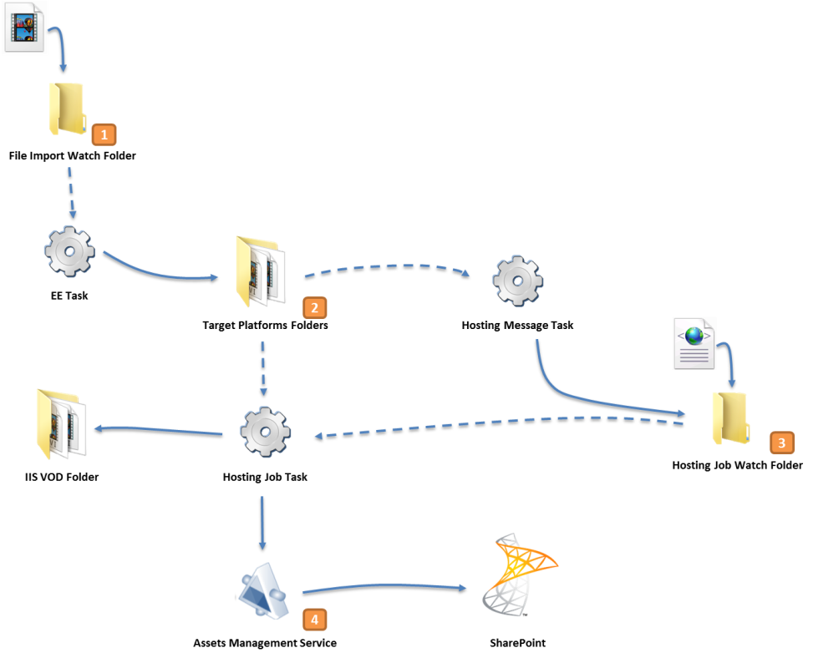
  7. File Import Flow Diagram

### RCE Import Flow

* 1. The RCE Import flow contains two watch folders: the **RCE Magic Folder**, and the **Hosting Job Watch Folder**.
  2. **RCE Import Watch Folder** has an **RCE Task** and a **Hosting Message Task** configured. **Hosting Job Watch Folder** has a **Hosting Job Task** configured.
  3. **RCE Import Flow** starts when a MMPCM editor sends a RCE video asset for approval. An **Event Receiver** inside SharePoint drops the **Project XML** into the **RCE Import Watch Folder** **(1)**.
  4. The **RCE Task** creates a **Composite Stream Manifest**, and then copies it to the **CMS Folder (2)** (Note that this is not a watch folder, so it does not trigger any task).
  5. Based on the created file, the **Hosting Message Task** creates a **Message XML** file, and drops it into the **Hosting Job Watch Folder**.
  6. As in the **File Import Flow**, The **Hosting Job Task** is triggered, which moves the **CSM** to the **IIS VOD Folder**, and using the message file information calls the **Assets Management Service (4)**, which updates the MMPCM metadata, linking the videos location.
  7. 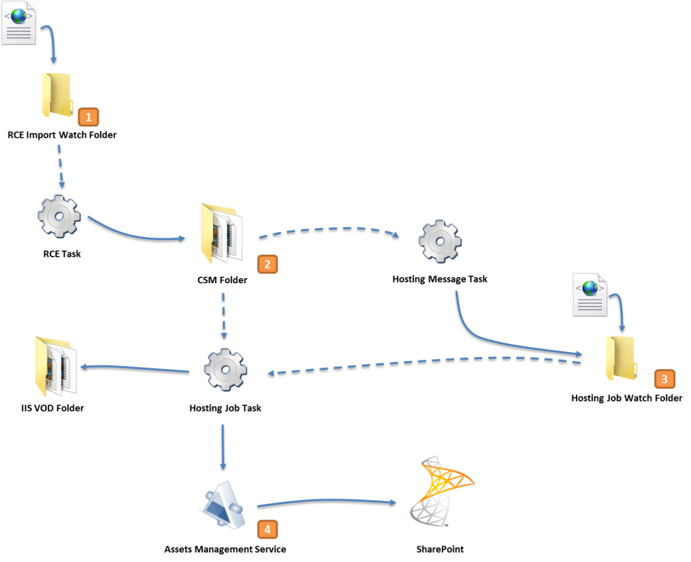
  8. RCE Import Flow Diagram

## Live Infrastructure

* 1. The live infrastructure provides the necessary functionality for live event broadcasting. It is composed of four services and the **Live Dashboard**, which orchestrates the broadcasting flow, executing the service calls.

### Encoder Automation Service

* 1. This service has to be hosted on the **Encoder** server role.It manages the installed **Expression Encoder**, and has two operations:
  + **Start,** which starts the encoder.
  + **Stop,** start’s reciprocal. Stops the encoder.
  1. The video source can be set on the **web.config** file. The encoder can stream video either from a live or a file source.
  + To stream from a live source, the service needs the names of the video and audio devices (If any of these values is missing, the default encoder parameters are used).
  + When a file source is set, its complete path is required.
    1. 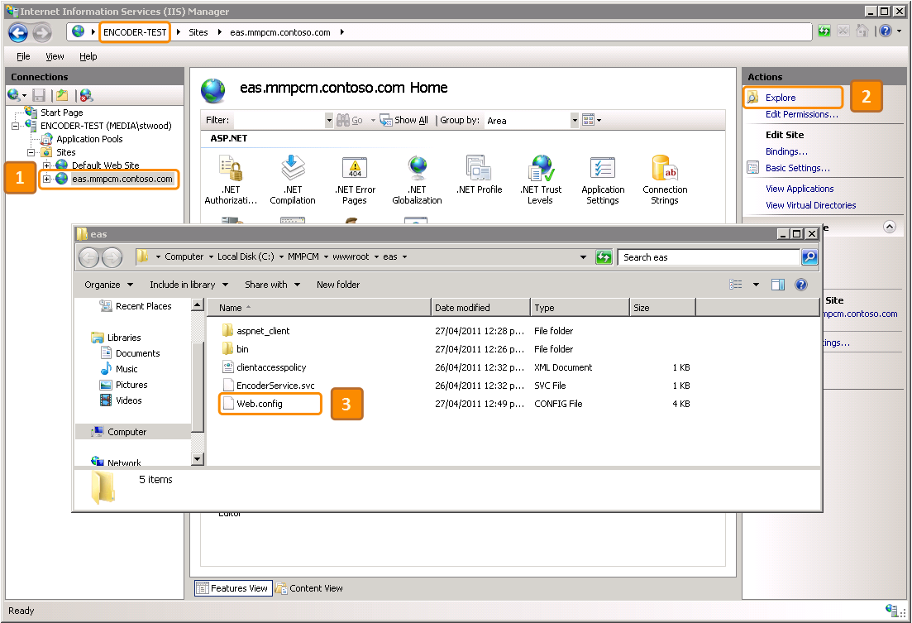
    2. 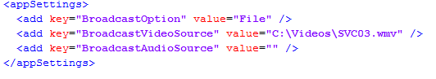
  1. **Note:** In an **Inlet** environment, this service is replaced by the **Spinnaker Message Service**.

### Encoder Manager Service

* 1. This service is usually hosted on the **VOD** server role. It creates the publishing points and manages the available encoders.
  2. The following parameters can be customized on the **web.config** file:
  + **liveStreamingServiceEndPoint**: **Live Streaming Service**’s endpoint. This service creates the publishing points.
  + **publishingPointDNS**: DNS address used by the publishing point (e.g: *http:// publishingPointDNS/example.isml*).
  + **encoderStatusServiceEndPoint**: **Encoder Status service**’s endpoint. This service updates the encoder status on SharePoint Encoder Status list.
  + **SiteName**: IIS site name where the publishing points are created.
  + **VirtualPath**: IIS virtual path where the publishing points are created.
  + **VODDestinationPath**: path where the resulting VOD files are stored.
  + **ArchiveFolder**: folder where the media services store the encoder files. This folder has to be shared and accessible throughout the network.

1. 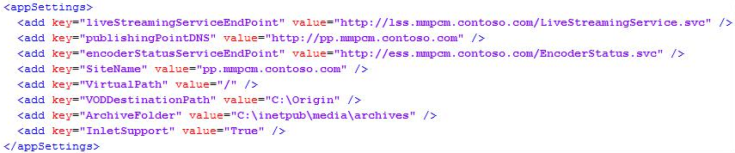

### Encoder Status Service

* 1. This service inserts and updates the encoder status in **SharePoint**. Its parameters are:
  + Group ID: identifies a group of encoders in the same endpoint.
  + Event ID: GUID that identifies an event, must match the asset ID in SharePoint
  + Status: encoder status, possible values are **started** and **stopped**.
  1. The **Encoder Manager Service** uses this service to set the encoder status in SharePoint after starting or stopping the actual encoder. The **Live Dashboard** uses the information present in SharePoint to enable or disable some of its buttons:
  2. If the encoder status is **started**, **Live Dashboard**’s **On Air** button is enabled.
  3. If the encoder status is **stopped**, all of the buttons are disabled.

### Schedule Xml Service

* 1. This service generates a XML file with the contents of the **MMPCM**. Once done, the file is posted to a preset FTP server folder, where a third party player or application can parse and use the data.
  2. This service is called by the **Live Dashboard**, when an operator clicks **On Air / Off Air** buttons, thus updating the current asset information in the schedule.

### Live Dashboard

* 1. The **MMPCM** **Live Dashboard** is a **Silverlight 4** web part, which allows the MMPCM users to broadcast live events following a simple procedure. Under the hood, the **Live Dashboard** orchestrates the services involved in the broadcasting workflow.
  2. 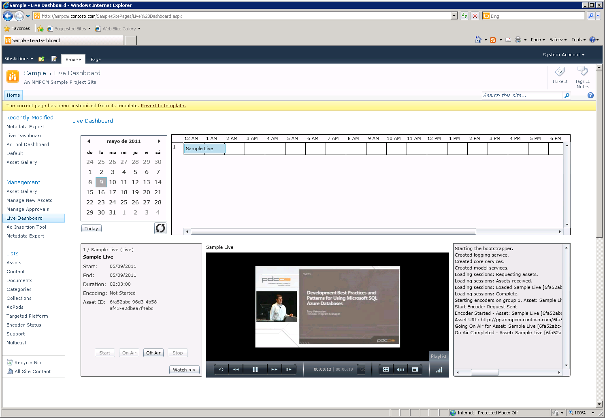
  3. The MMPCM Live Dashboard
  4. The dashboard’s time line lists all the Live Event assets that were already approved. The asset is highlighted in one of three colors, representing its state: **Gray**, when the event is ready to start; **Green**, when the event is started and **Blue** when the event finished and is available as a **VOD**. Each row in the time line represents an **Encoder Group ID**.
  5. Double clicking on an event in the time line, loads its information, the video source, and enable or disable the corresponding dashboard buttons, according to the event’s status.
  6. Clicking on **start** button causes the **Live Dashboard** to call the **Encoder Manager Service** (1). It creates the publishing points on the **Origin Server** (2), and starts the corresponding **encoder** (3). The encoder status is also updated on the **Encoder Status SharePoint list**.
  7. 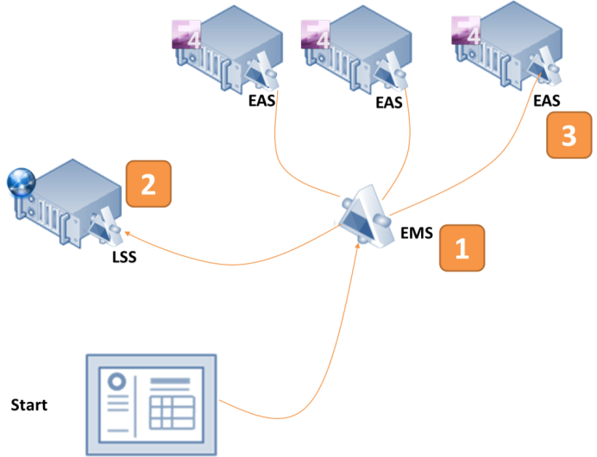
  8. Live Dashboard – Start Button Workflow
  9. **On air** button starts the following workflow: the **Live Dashboard** changes the asset’s state from **Not Available** to **Live** and calls the **Schedule XML Service(1)**. It then creates a XML file listing all the events, and copies it to a FTP server path, configured on the **Project list** **(2)**.
  10. 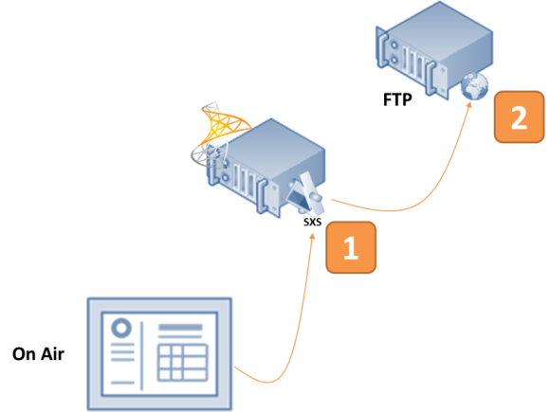
  11. Live Dashboard – On Air Button Workflow
  12. The same flow takes place when **off air** button is clicked, but this time the asset state goes from **Live** to **VOD** instead: The **Live Dashboard** changes the asset state from **Live** to **VOD** and then calls the **Schedule XML Service** **(1)**. Again, it publishes a XML file in the FTP server **(2)**.
  13. 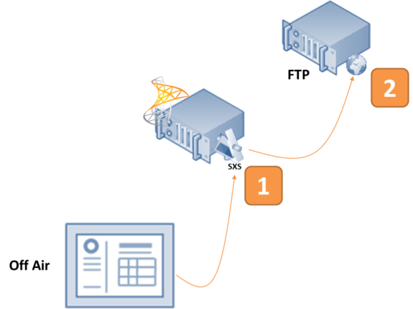
  14. Live Dashboard – Off Air Button Workflow
  15. Finally, **stop** calls the **Encoder Manager Service** (1), which stops the encoder – using the **Encoder Automation Service** (2); then it publishes the video as **VOD** (copying the encoded video to an IIS folder).
  16. 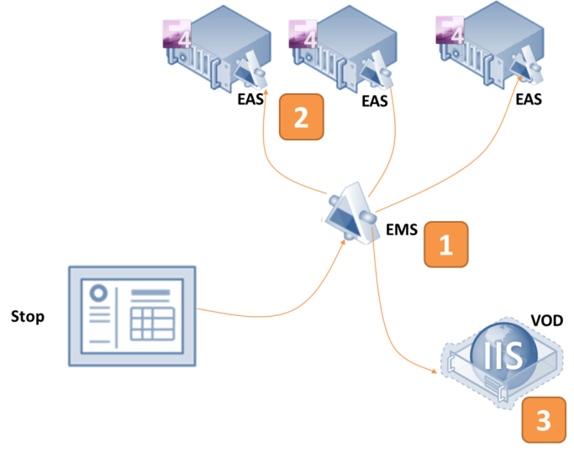
  17. Live Dashboard – Stop Button Workflow

# Installing the MMPCM

## Hardware and Software Requirements

* 1. The following table shows the minimum hardware requirements for each server role.

|  |  |  |  |
| --- | --- | --- | --- |
| Machine | Processor | RAM | Hard Drive |
| Origin | 64 bits, 2 cores | 4 GB | Primary: 150 GB (minimum)  SATA (7200 RPM)  Secondary: 1 TB  SATA (7200 RPM) |
| CMS | 64 bits, 2 cores | 8 GB | Primary: 120 GB (minimum)  SATA (7200 RPM)  Secondary: 500 GB  SATA (7200 RPM) |
| SQL Server for SharePoint | 64 bits, 2 cores | 8 GB | Primary: 120 GB (minimum)  SATA (7200 RPM)  Secondary: 500 GB  SATA (7200 RPM) |
| Transform | 64 bits, 4 cores | 8 GB | Primary: 120 GB (minimum)  SATA (7200 RPM)  Secondary: 1 TB  SATA (7200 RPM) |
| Encode | 64 bits, 4 cores | 8 GB | Primary: 150 GB (minimum)  SATA (7200 RPM)  Secondary: 1 TB  SATA (7200 RPM) |

* 1. **Note:** Please refer to [Hardware and software requirements (SharePoint Server 2010)](http://technet.microsoft.com/en-us/library/cc262485.aspx) article, which lists the minimum hardware and software requirements to install and run **Microsoft SharePoint Server 2010**.
  2. The software requisites for each server role are:

|  |  |  |
| --- | --- | --- |
| Machine | Software Pre-requisites | Server Roles |
| Origin | **- Windows Web Server 2008 R2**  **- IIS 7.5**  **- IIS Media Services 4.0**  **- .NET Framework 4** | Web Server (IIS) |
| SharePoint 2010 | **- Windows Server 2008 R2 Standard**  **- SharePoint Server 2010** | - Application Server - File Services - Web Server (IIS) |
| SQL Server for SharePoint | **- Windows Server 2008 R2 Standard**  **- SQL Server 2008 R2 Standard** | None |
| Transform | **- Windows Server 2008 R2 Standard**  **- IIS 7.5**  **- IIS Media Services 4.0**  **- .NET Framework 4.0**  **- Expression Encoder 4 Pro SP1**  **- IIS Transform Manager (beta 1)** | - File Services  - Web Server (IIS) |
| Encode | **- Windows Web Server 2008 R2**  **- IIS 7.5**  **- IIS Media Services 4.0**  **- .NET Framework 4**  **- Expression Encoder 4 Pro SP1** | Web Server (IIS) |

## Unblock the Installation Files

* 1. Windows locks some file types that are considered a potential threat when downloaded from the Internet, such as the **MMPCM** installer ones. To prevent errors on the installation, unlock the files following this procedure:
  2. Right click the **MMPCM** Installer Package file on **Windows Explorer**. Click **Properties**.
  3. On the **General** tab, locate the **Security** field, and click **Unblock**.
     1. 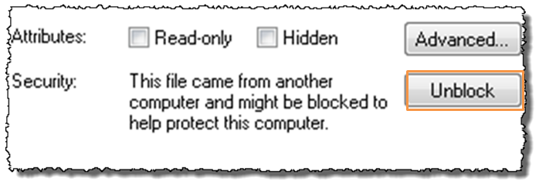

## Automated Installation Process

* 1. The **MMPCM Wizard** decides the features to install based on a set of questions. This allows you to customize the MMPCM installation, fitting your organization needs.
  2. 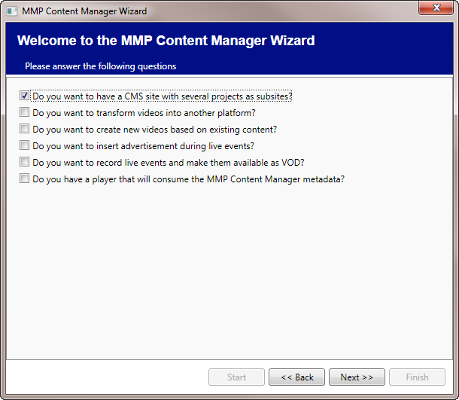
  3. MMPCM Installer – Initial Questions
  4. Performing a basic installation of the MMPCM in a SharePoint environment is pretty straightforward. It boils down to running the MMPCM Wizard and an installation script afterwards that will deploy and activate all necessary features for the system to work.
  5. As an example, we will review the installation process for an organization that needs a **CMS site with multiple projects**.
  6. Run the MMPCM Wizard. Press the **Start** button.
     1. 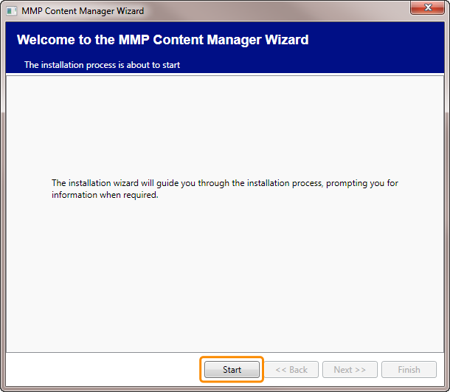
  7. Check the first question in the screen.
  8. Press Next.
     1. 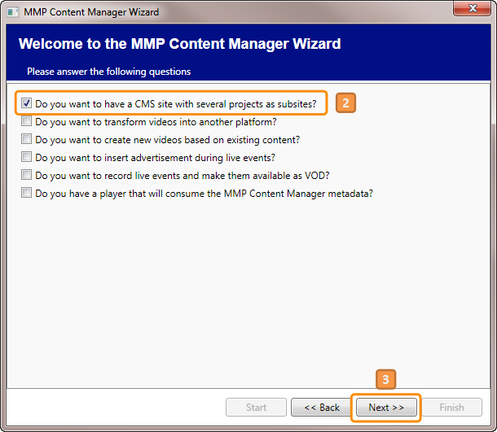
  9. The **Site Template** feature will have been selected for you.
  10. Press **Next**.
  11. 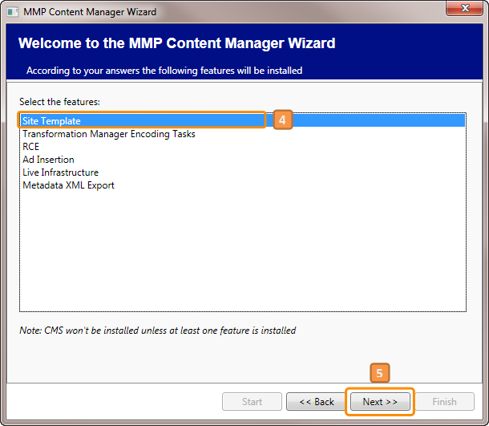Some information and options must be selected in this screen.

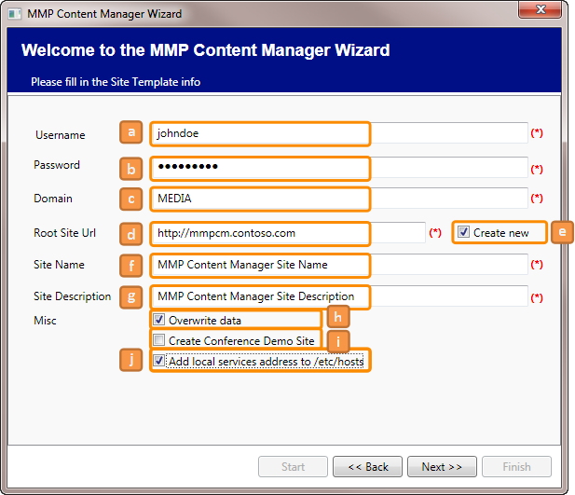

* + 1. User name of the SharePoint Farm Administrator (suggested by the Wizard)
    2. User password
    3. Network domain (suggested by the Wizard)
    4. MMPCM Root site: This will be the URL of the MMPCM Root site where the Sample MMPCM Project will be created. It must be inside a valid and existing SharePoint Web Application. Inside it, it could be located anywhere, in a Root Site Collection or a Web Site.
    5. If selected, the Wizard will create a new MMPCM Root site for you.
    6. Name of the MMPCM Root site.
    7. Description of the MMPCM Root site.
    8. If selected, and there’s an existing website or site collection in the previously specified URL, it will be overwritten by the installer with the MMPCM Root site.
    9. If selected, a new Conference demo site will be created in the MMPCM Root site specified previously.
    10. If you are using a host mapped URL in your local environment, check this box.
    11. 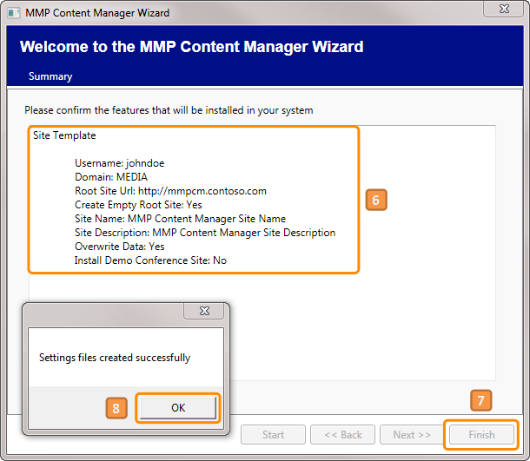
  1. A small summary indicating what you’ve selected and some of the entered information will be shown.
  2. Click **Finish**.
  3. Settings for each MMPCM Package installer will be created. Click **OK**, and the Wizard will be closed.
  4. This Wizard creates 4 xml files inside 4 different folders, one file per folder. Each of those folders should be copied to a different machine in the MMPCM environment. If all MMPCM features will be installed in a single machine, then all folders should be copied to that particular machine.
  5. The folders are:
  + MMPCM.Encoder
  + MMPCM.Origin
  + MMPCM.SharePoint
  + MMPCM.TransformManager
  1. 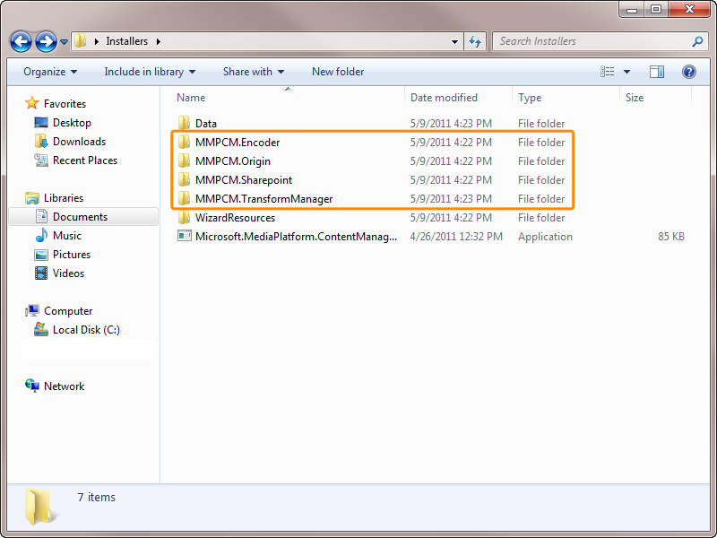
  2. Inside each folder, there are several files and a couple of folders.
  3. 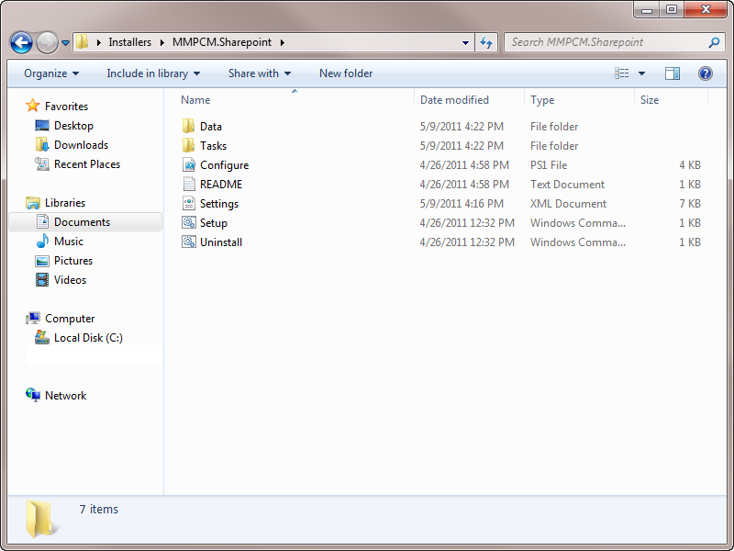
  + Data (exists only in the MMPCM.SharePoint folder)
  + Tasks
  + README.txt
  + Setup.cmd
  + Configure.ps1
  + Settings.xml
  1. 
  2. In this case, only the **MMPCM.SharePoint** folder is required, since no other feature than the Site Template was selected. If the machine where the Wizard was run is not the SharePoint one, that folder should be copied or moved.
  3. Follow these steps:
  4. Copy the folder to the SharePoint machine.
  5. Open a console as Administrator.
     1. 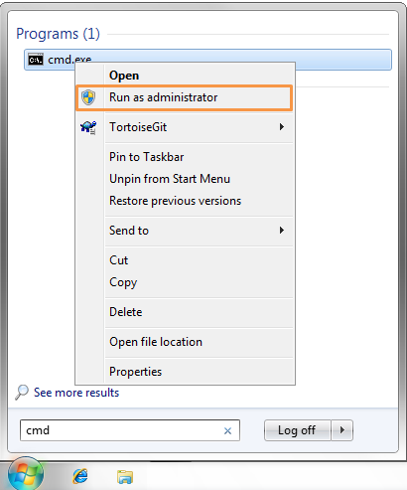
  6. Change directory to wherever you dropped the installation folder.
  7. Type **.\Setup.cmd**, and press enter.
     1. 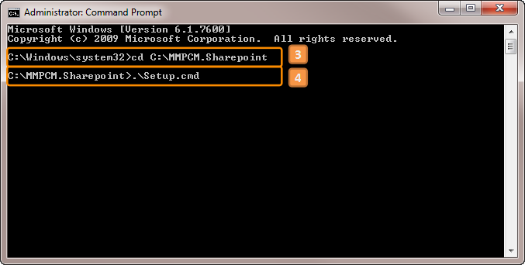
  8. The MMPCM Site Template will be installed and a shortcut placed in the desktop, from where it’ll be accessible for any authorized user to log in.
     1. 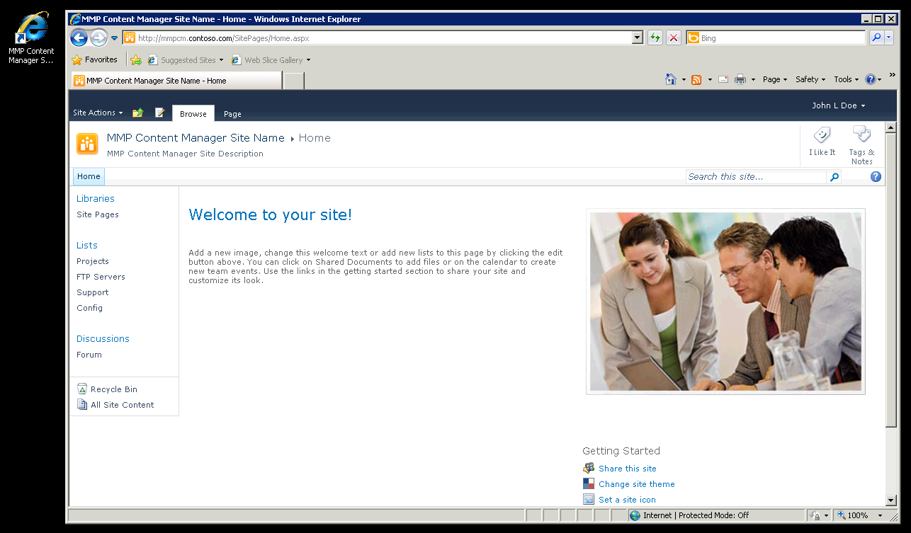

### Enabling Watch Folders

* 1. **Transform Manager**’s watch folders need to be enabled and started before they can be used.
  2. To Start a Watch folder,
  3. Open Internet Information Services (IIS) Manager.
  4. Expand the Transform Manager, click Watch Folders.
  5. Select the watch folder to start.
  6. Click Enable.
     1. 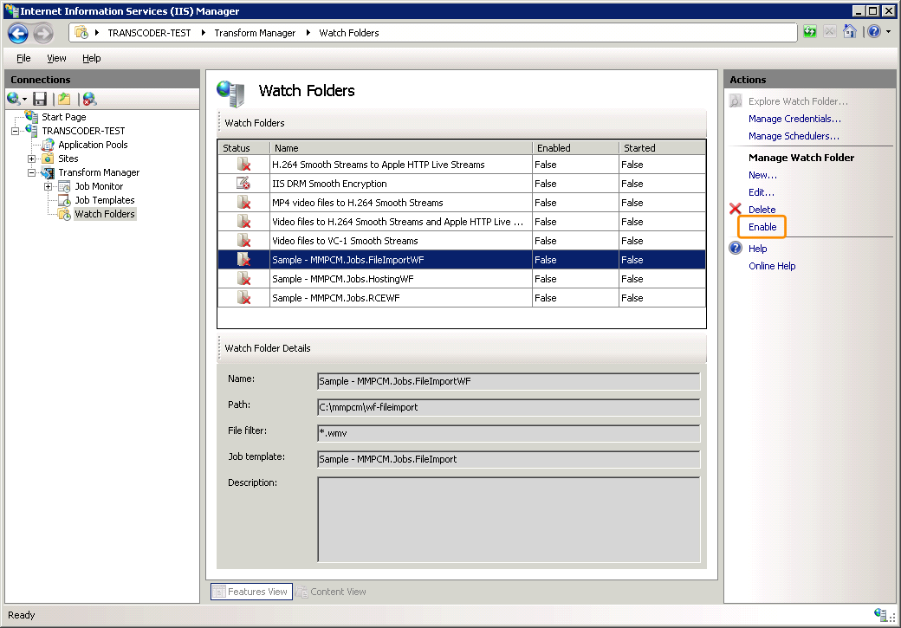
  7. Click **Start**.
     1. 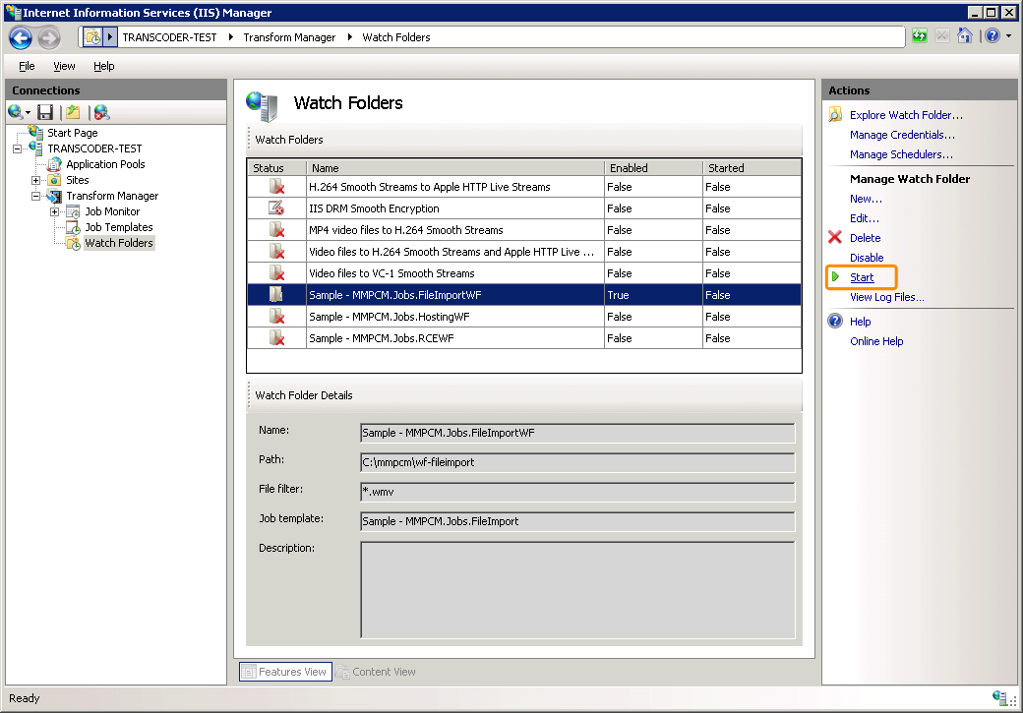

### Using a host header

* 1. If you decide to install the **MMPCM** in a local web application that uses a host header (e. g. **MMPCM.contoso.com**), you will not be able to login into the web application due to a loopback security check feature included in **Windows** since **XP SP2**. If the custom host header doesn't match the computer name, authentication fails.
  2. To fix this, follow these steps:

1. Click **Start**, click **Run**, type **regedit**, and then click **OK**.
2. In Registry Editor, locate and then click the following registry key:
3. **HKEY_LOCAL_MACHINE\SYSTEM\CurrentControlSet\Control\Lsa\MSV1_0**
4. Right-click **MSV1_0**, point to **New**, and then click **Multi-String Value**.
5. Type **BackConnectionHostNames**, and then press ENTER.
6. Right-click **BackConnectionHostNames**, and then click **Modify**.
7. In the **Value data** box, type the host name or the host names for the sites that are on the local computer, and then click **OK**.

### How to configure Search service

* 1. **Note:** This is step is **optional**.
  2. The following section is a simple tutorial to configure **Search Services** on SharePoint 2010. You will be able to search across your Project sites by following the next steps.

#### Steps

* + Go to **Central Administration** and click on **Manage service applications** link under **Application Management section**
    1. 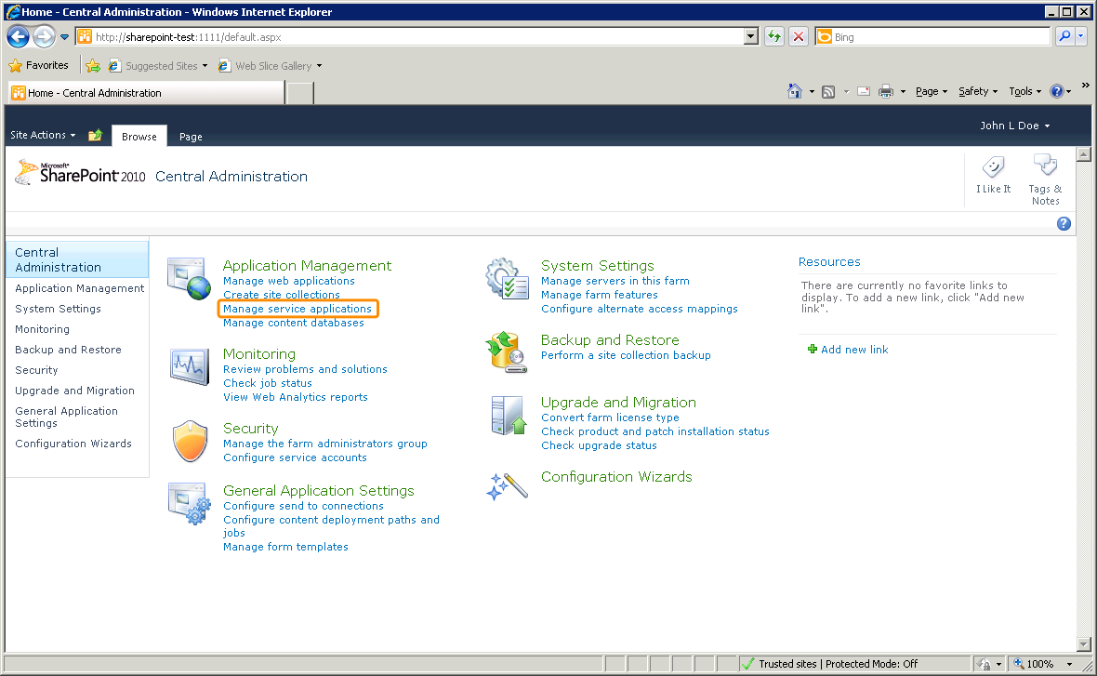
  + Click on the **Search Service Application** link
    1. 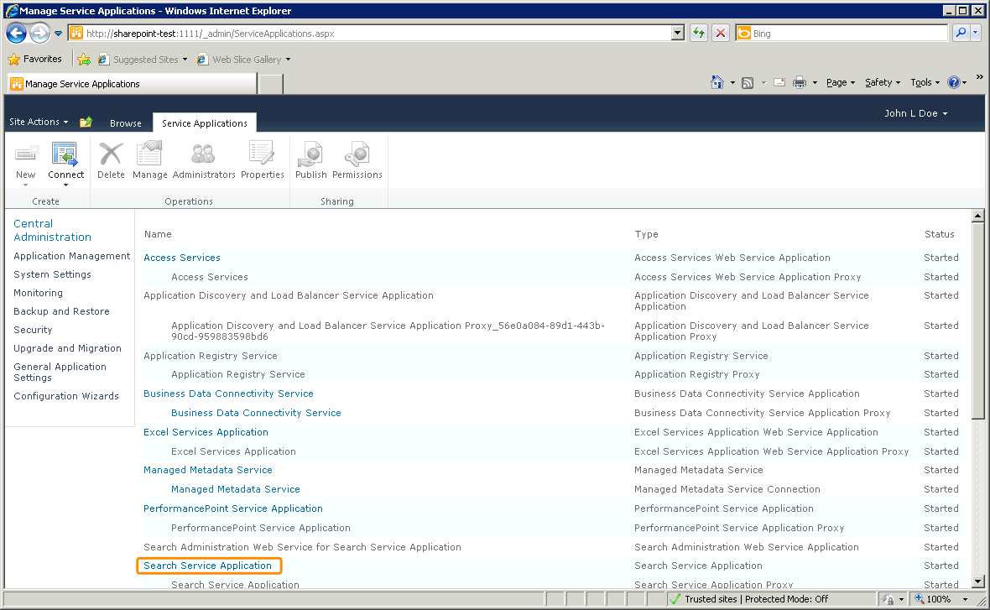
  + Click on **Content Sources** under **Crawling** section on the left navigation bar. (Notice that if it is the first time configuring the search service, then the System status section will show that SharePoint has 0 Searchable items)
    1. 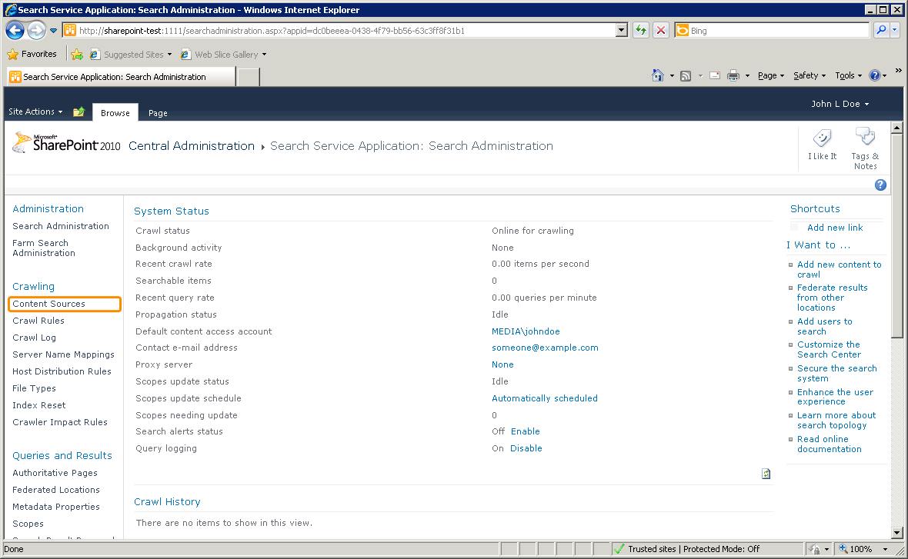
  + Click on **Local SharePoint sites**
    1. 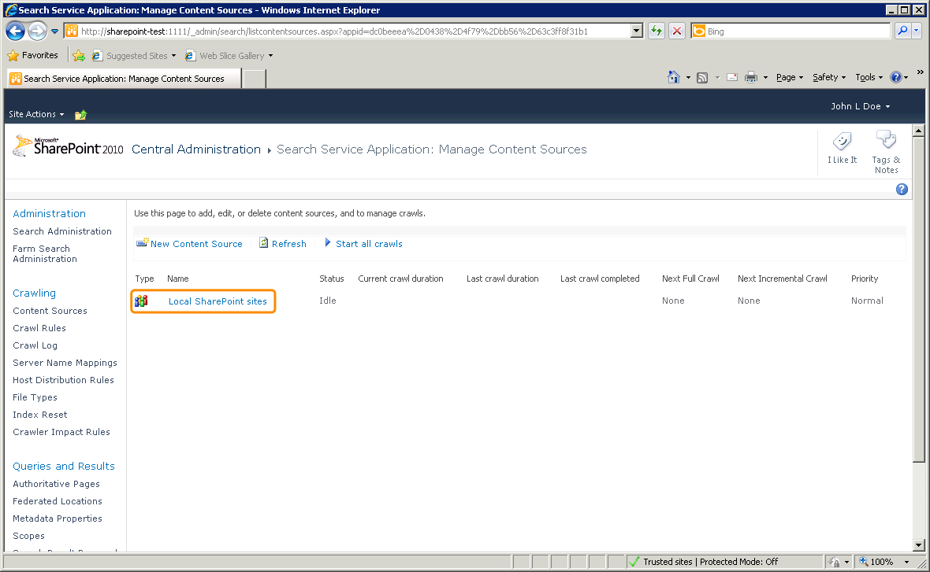
  + The **Type start addresses** section allows you to configure the web application that will be included in the crawl
    1. 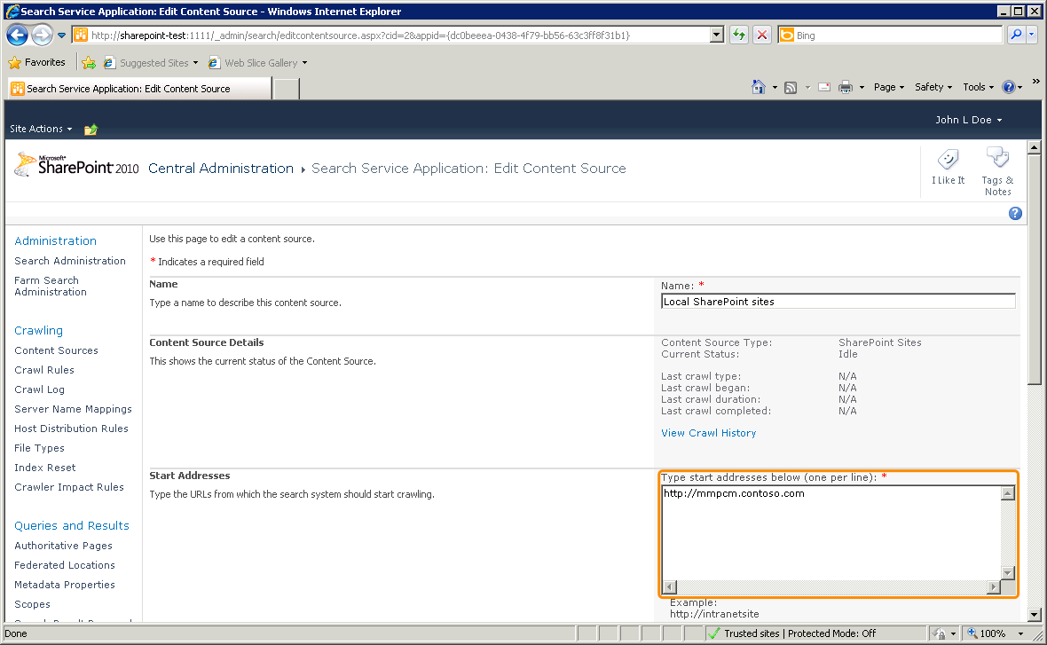
  + Create a schedule to run an **Incremental Crawl** as convenient and verify that **Start full crawl of this content source** checkbox is checked
    1. 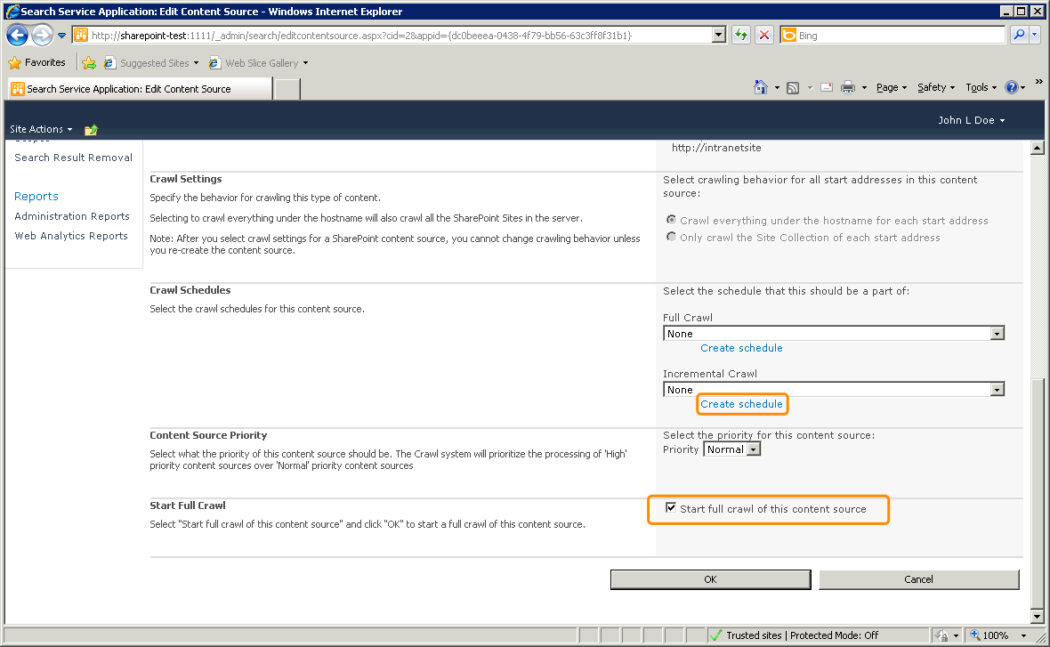
  + In **Content Sources** page the status of Local SharePoint sites should be **Starting**
    1. 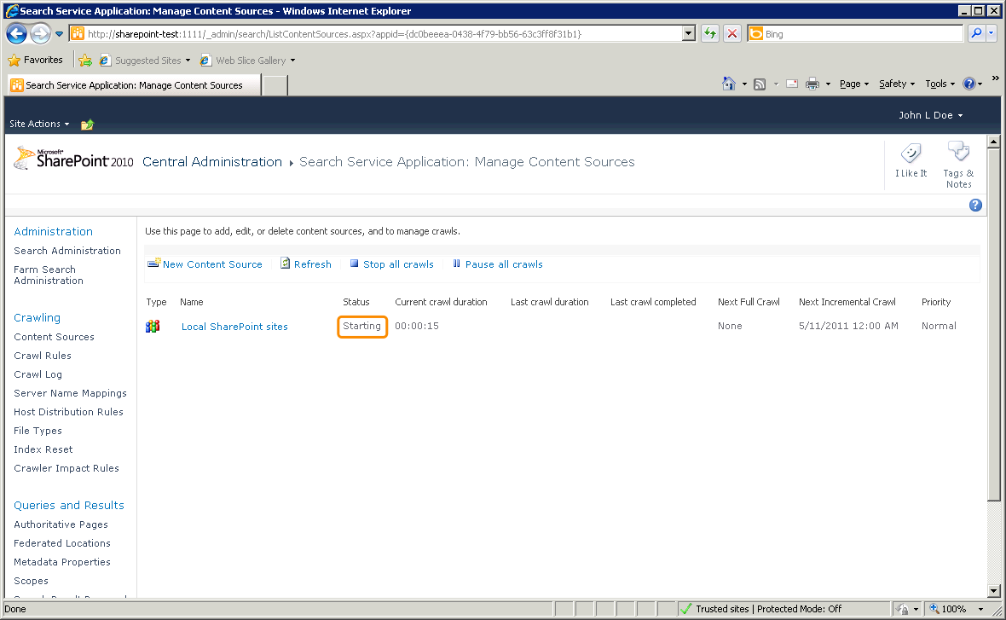
* At the end of the process SharePoint will have added many Searchable items to the index and you will be ready to perform a search.

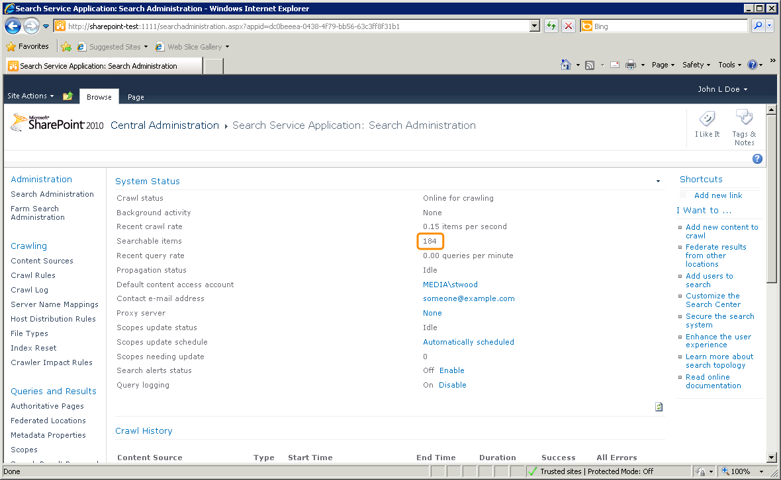

#### Verification

* 1. Go to the **Assets list page** and try to search for a term, for example **rabbit.** The search service should work and the results page should show some items.
  2. 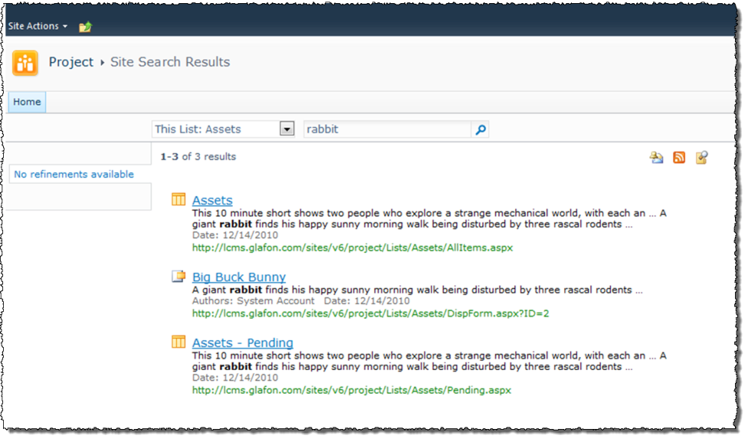

# Getting to know the MMPCM – First Run Experience

* 1. There are several features in the MMPCM. An end user may choose to install all of them, or just a subset. This section will proceed to overview each of the features included on the basic **Site Template**.

## Site Template

* 1. 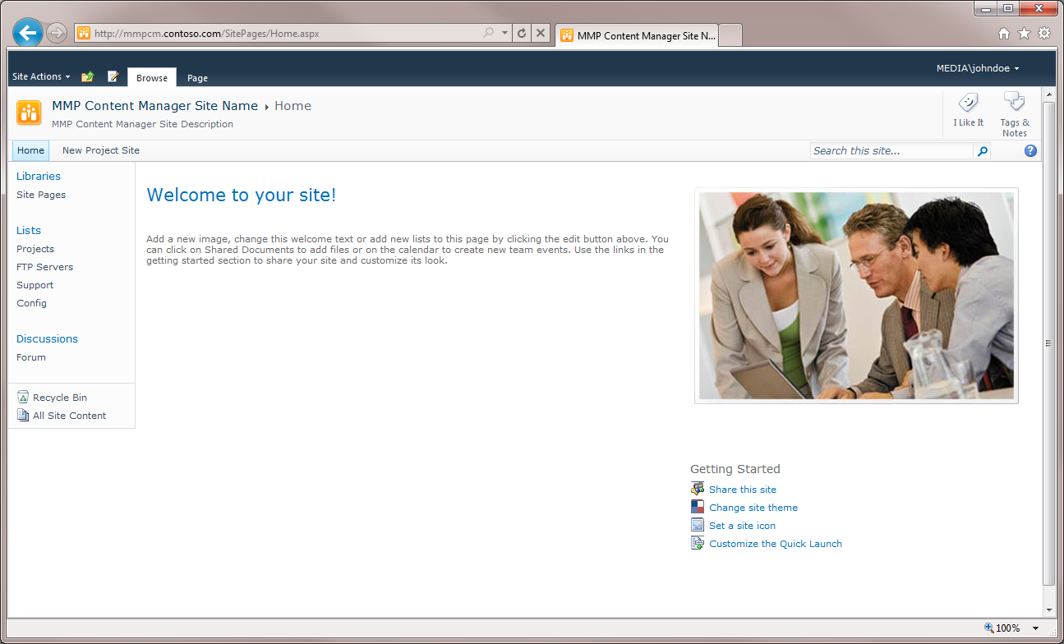
  2. Once logged in the main root site, the landing page will appear, and there’ll be some lists accessible and ready to be used.
  + **Projects**: A list with links to every project site this particular instance of the MMPCM is hosting. There’s also some configuration, particular for each project, like the FTP Server used or the RCE watch folder.
    1. 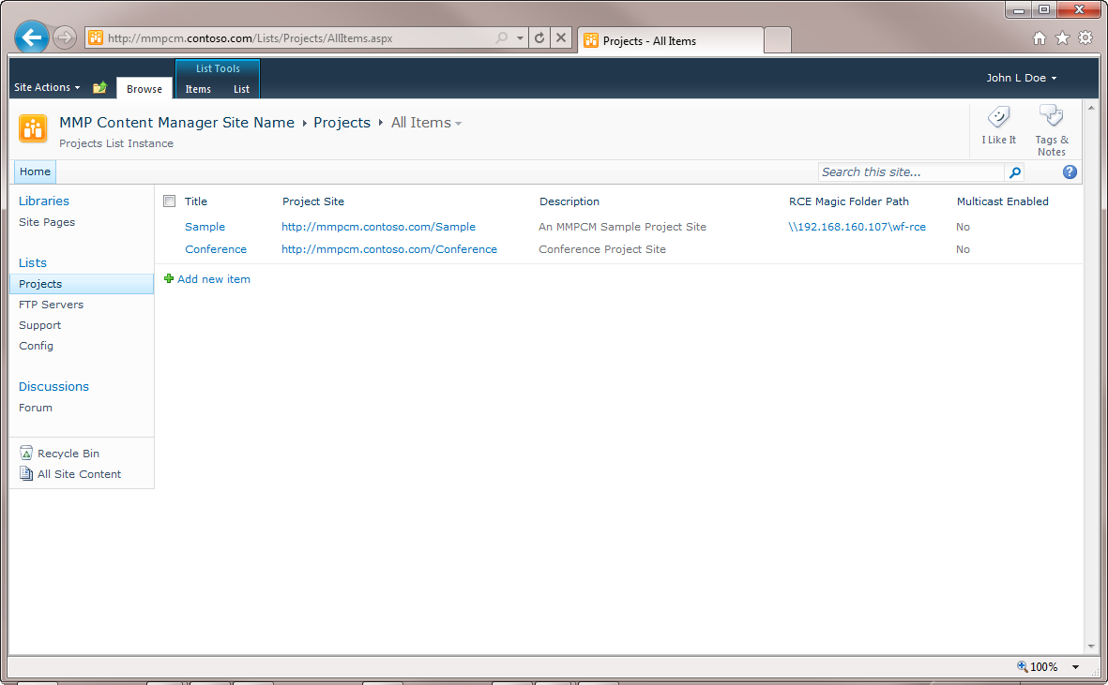
    2. **FTP Servers**: A list with username, password and URL for FTP servers used in one or several projects. This list is used specifically by the Metadata Export feature, but is available for any other customized feature a user may add.  
       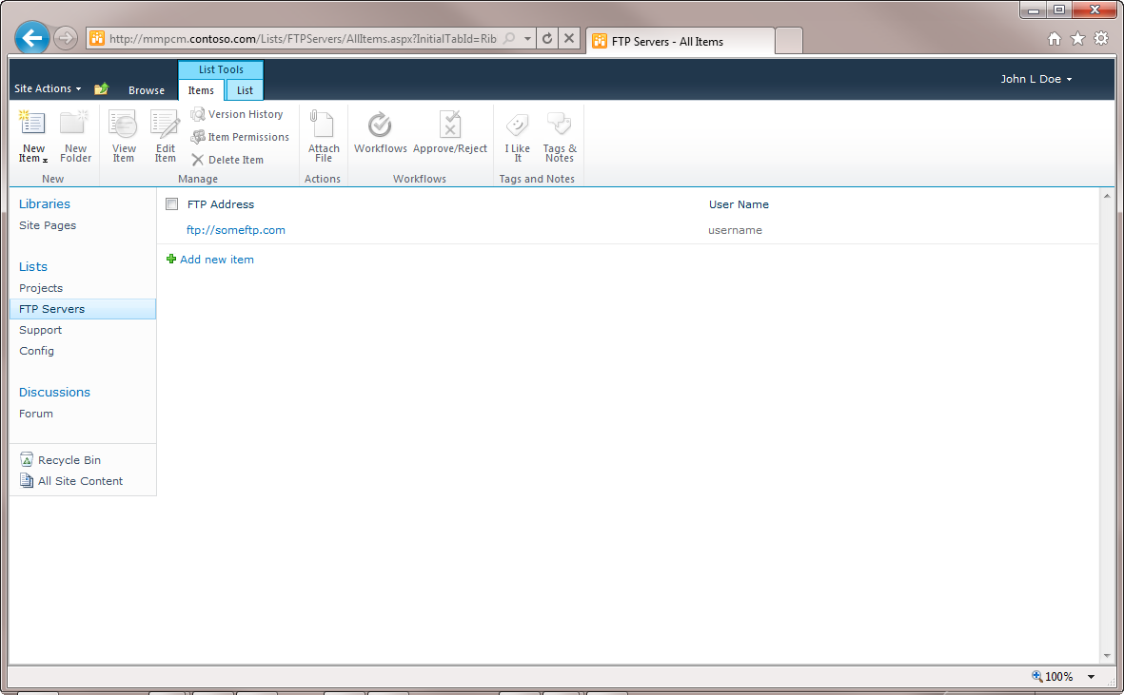
* **Support**: A list for issues to be added by the MMPCM users, and where MMPCM administrators may answer and track pending questions or problems users may have.
  + 1. 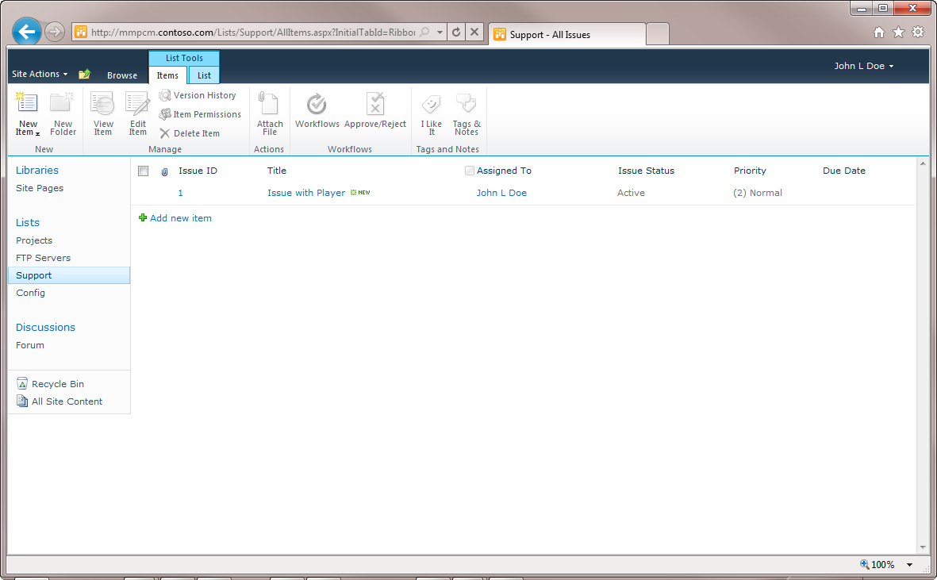
  + **Config**: A list for MMPCM configuration purposes. All values here are configured automatically by the MMPCM installer.
    1. 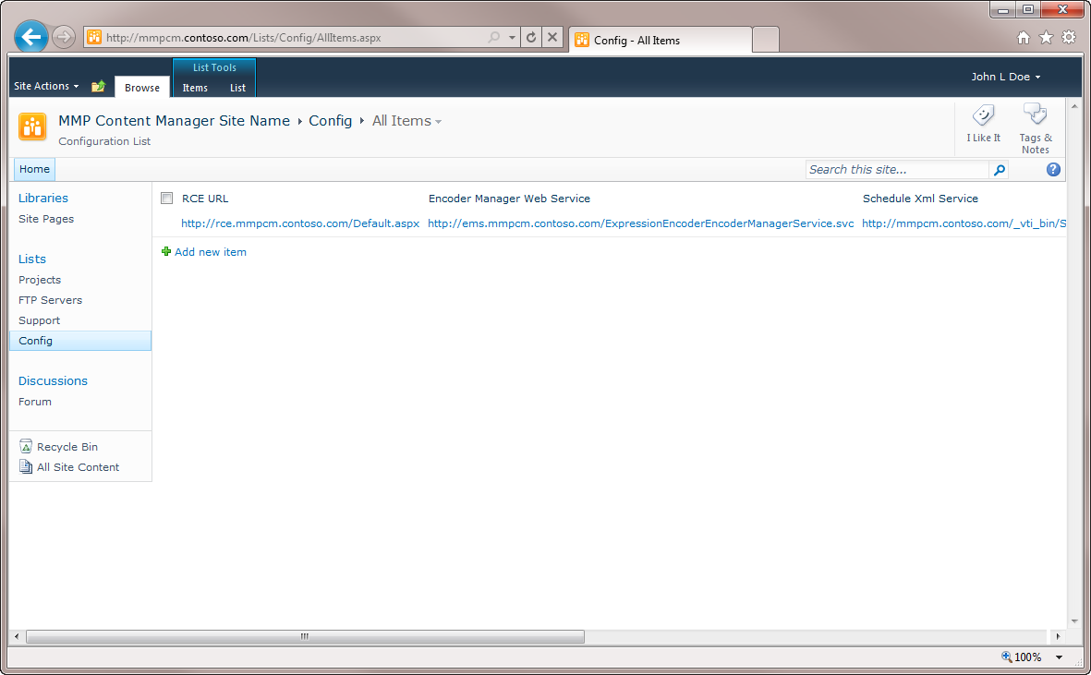
  1. Once inside a project site, you may find several useful lists for managing video assets.
  2. 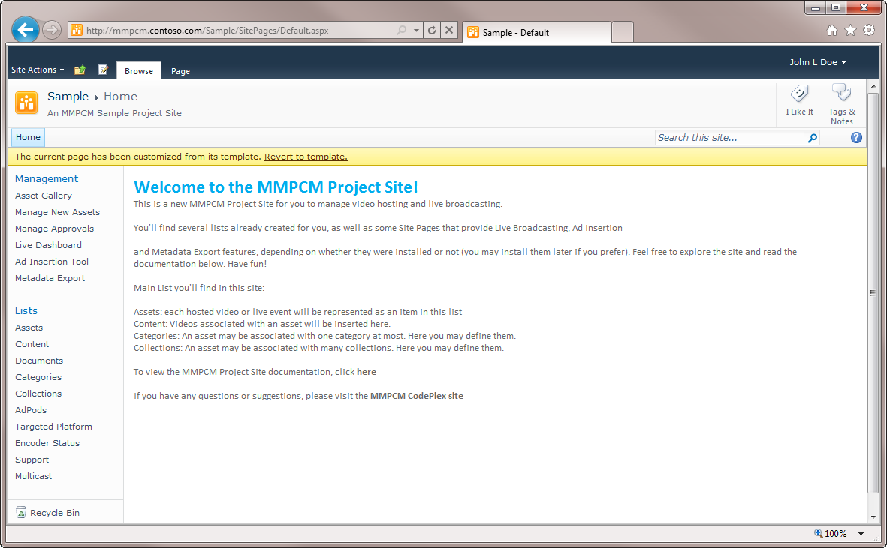
  3. The most relevant are:
  + **Assets**: The most important list of the MMPCM. Here is where every video asset of a particular project site is represented. You may find three types of assets: **File asset**, **RCE asset**, and **Live asset**. Each has different properties, and will be explained further later on.
  + **Content**: Content references a specific video file or stream, with its corresponding targeted platform associated. Each asset can have one (also zero) or more related content.
  + **Categories**: A way of filtering assets. Each asset can be in zero or one category at most.
  + **Collections**: A way of categorizing assets. Each asset can be in zero, one, or more collections.
  + **Targeted Platforms**: A targeted platform can be, **Smooth Streaming**, **WMV**, **H.264**, etc. Each item of the Content list has one, and only one associated targeted platform.
  + **Multicast:** Multi-cam MMPCM support configuration. Associating a multicast configuration to a **Live asset** causes its encoder to be started with multicam support.
    1. **Note:** The encoder must support multicast for this configuration to work properly.

## Live Broadcasting

* 1. One of the type of assets an end user may create, are called **Live**. This kind of assets can be managed from a special site page inside each project site, called **Live Dashboard**.
  2. 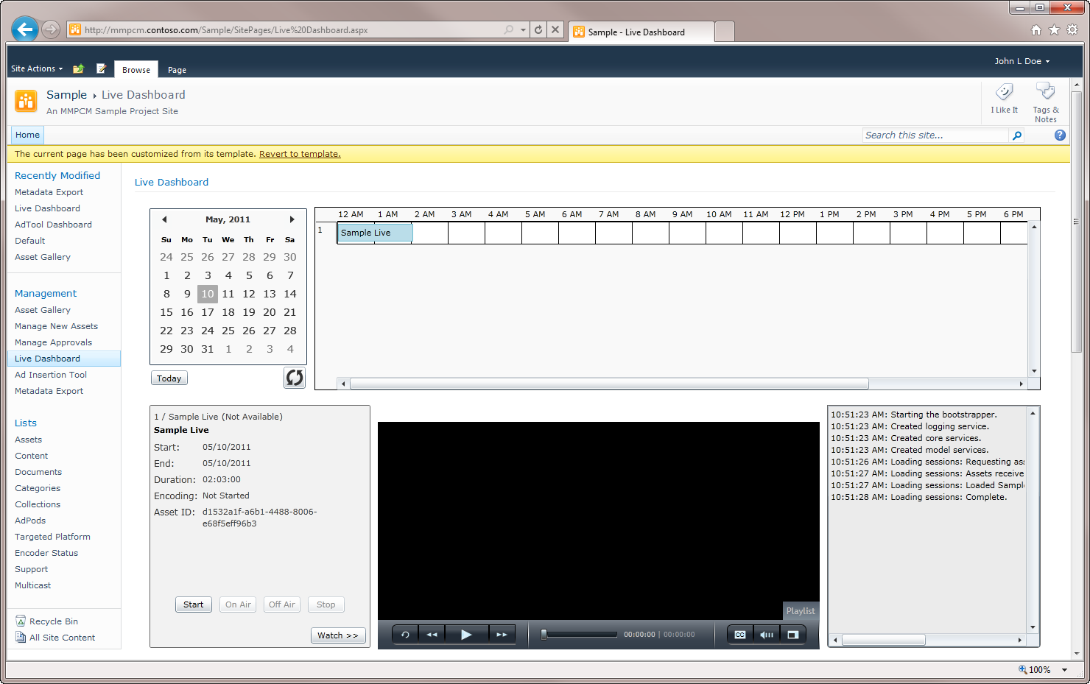
  3. MMPCM Live Dashboard
  4. In this site page, you’ll be able to manage **Live** assets, starting and stopping broadcasting, and converting them to **VOD**.

## Ad Insertion Tool

* 1. If **Live Broadcasting** has been installed, this feature may be installed as well. Using the **Ad Insertion Dashboard**, advertisements can be inserted during the streaming of live events.
  2. 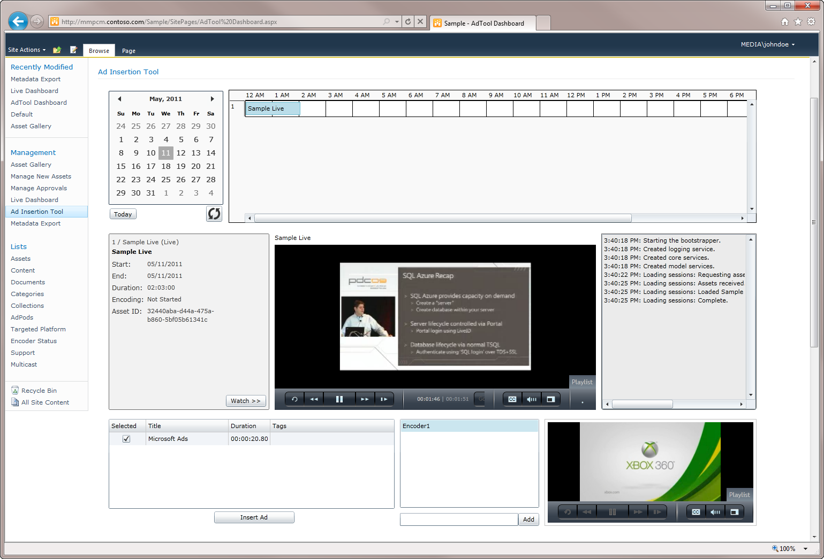
  3. MMPCM Ad Tool

## Metadata Export

* 1. It allows an end user to export the information regarding any type of asset, to an XML file, so that any external player can pick it up and consume it. Fairly easy to set up, all it needs is an FTP server to save the XML file. The **Live feature** will automatically export this file, so it’s required to work properly. It can also be exported manually from the **Metadata Export** site page.
  2. 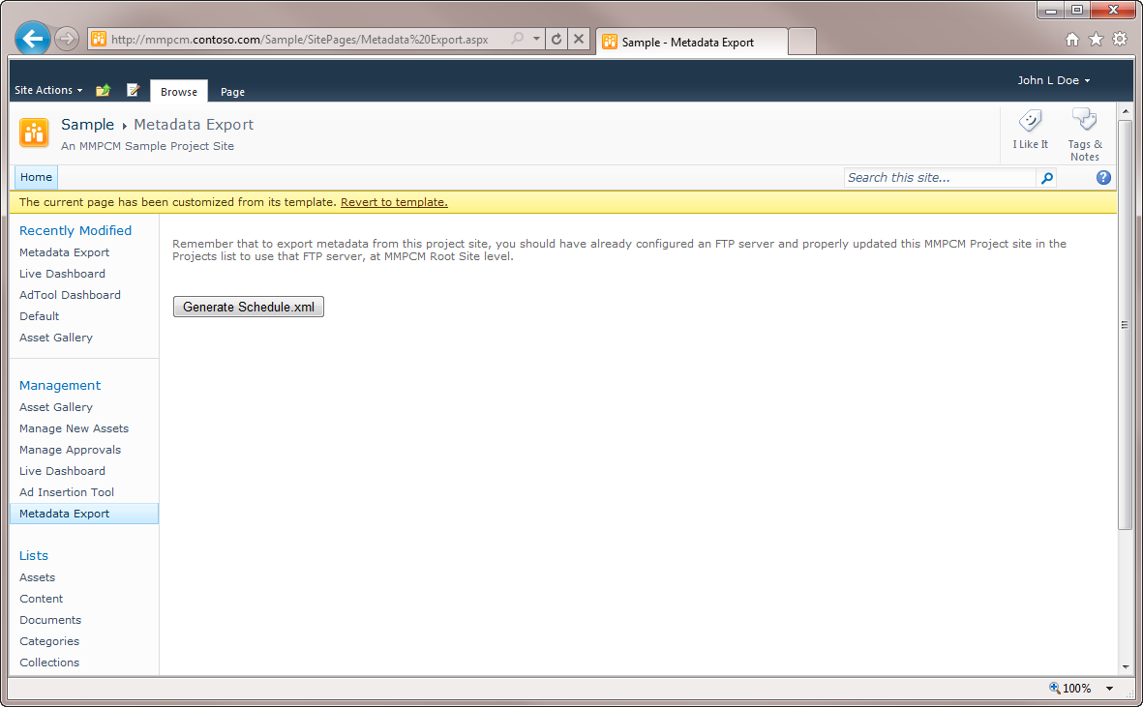
  3. MMPCM Metadata Export Webpart

## Asset Gallery

* 1. A nice way to explore all assets in the MMPCM is through the **Assets Gallery**. It provides an easy way to filter through collections, and see a thumbnail associated with each asset.
  2. 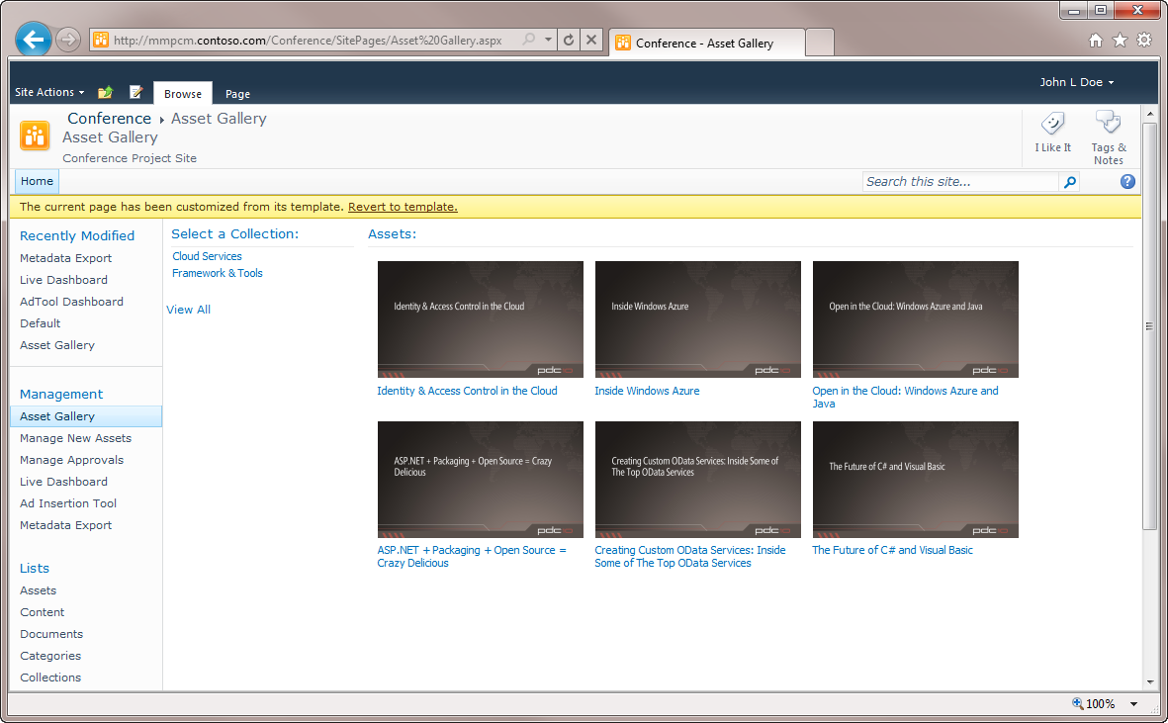
  3. MMPCM Asset Gallery

## Rough Cut Editor

* 1. Another feature of the MMPCM is the **Rough Cut Editor**. When installed, an MMPCM user can create a new RCE Asset, and using this feature, craft a new video based on existing smooth streaming assets.
  2. 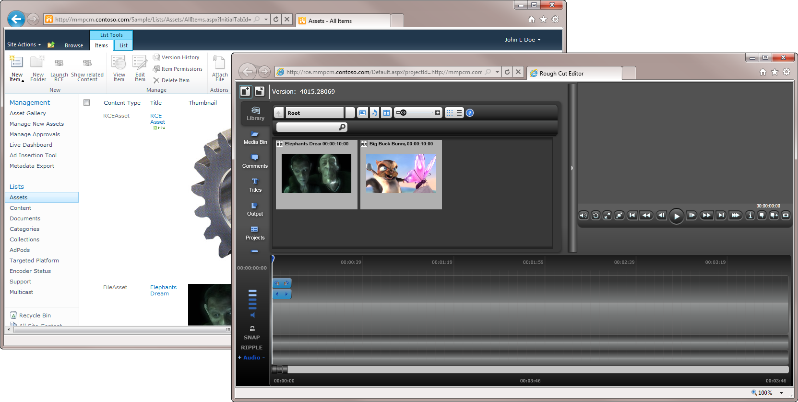
  3. Microsoft Rough Cut Editor is integrated in the MMPCM
  4. **Note:** this feature requires the **Transform Manager Tasks** to work properly and transform rough cut edits into smooth streaming assets.

## Transform Manager Tasks

* 1. This feature requires the **Transform Manager** to be installed, which is not included with the MMPCM. It works by providing the user with a couple of **Magic Folders**, where it may drop videos to be encoded automatically into several targeted platforms, and uploaded to the MMPCM. One of those magic folders is the one the **Rough Cut Editor** uses to encode videos once they’ve been edited.

# Working with the MMPCM

* 1. The following section will explain how to carry out some of the common MMPCM tasks, in a set of simple **how to** tutorials.

## How To – *Create a Project Site*

* 1. **Note:** This task requires Full Control Credentials.
  2. Browse the MMPCM root site.
  3. Click **Site Actions**, then **New Site**
     1. 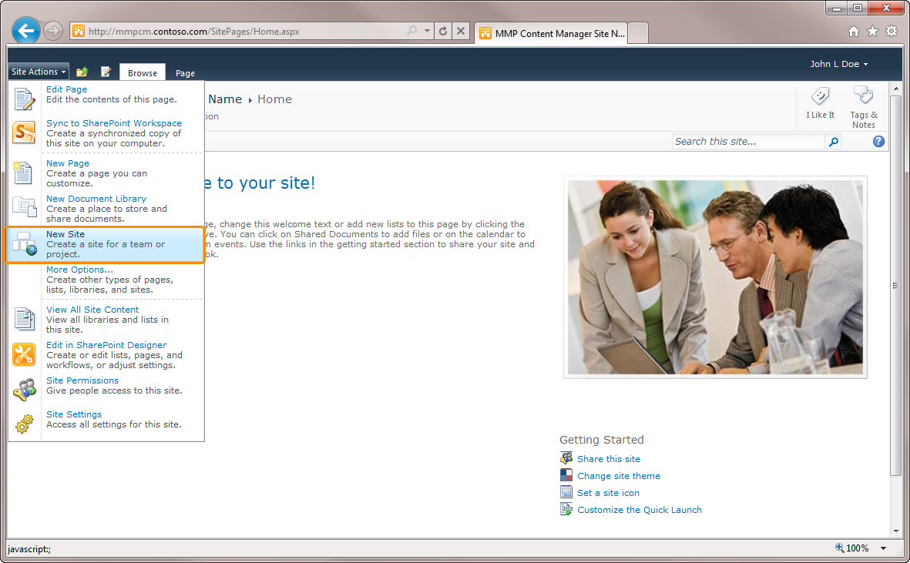
  4. The **Create Dialog** pops up. From the left categories bar, select **MMPCM Templates**. Select **MMPCM Project Site**.
     1. 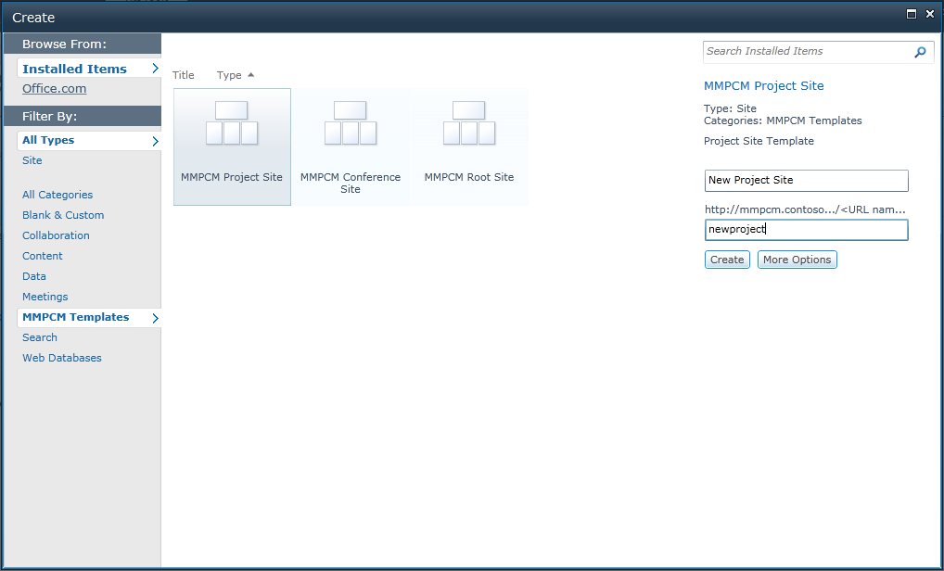
  5. Enter a **Title** for your project site, and an **URL**.
  6. Verify the presence of the new project site on the **Root Site Projects list**.
     1. 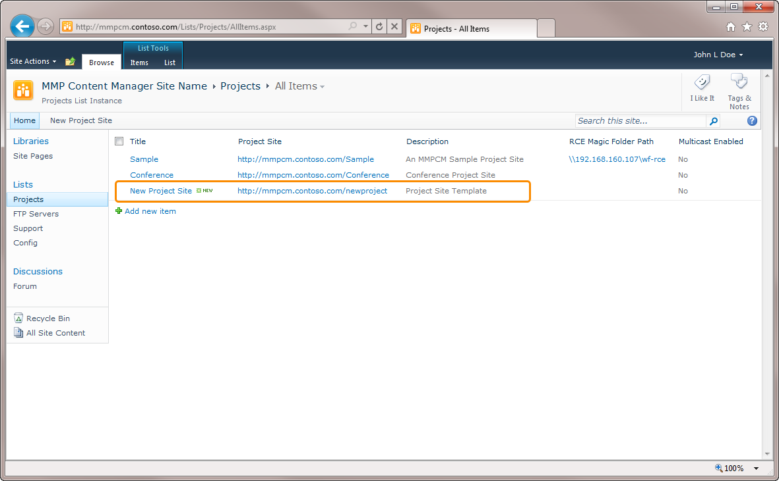
     2. **Note:** if you delete a project site, you will need to manually remove the entry on the **Root Site Project list**.

## How To – *Create Video on Demand Assets*

* 1. There are three ways of creating **VOD** content in the **MMPCM**:
  + Creating the asset and its respective content manually in **SharePoint**
  + Using the **Transform Manager**
  + Using the **Import Tool**

To add a VOD asset manually:

* 1. **Note:** as a prerequisite, you must have the video and thumbnail available in a public location.
  2. Browse the **MMPCM Assets list**.
  3. Open the **Items** tab in the ribbon, and click the arrow under **New Item**. Click **File Asset**.
     1. 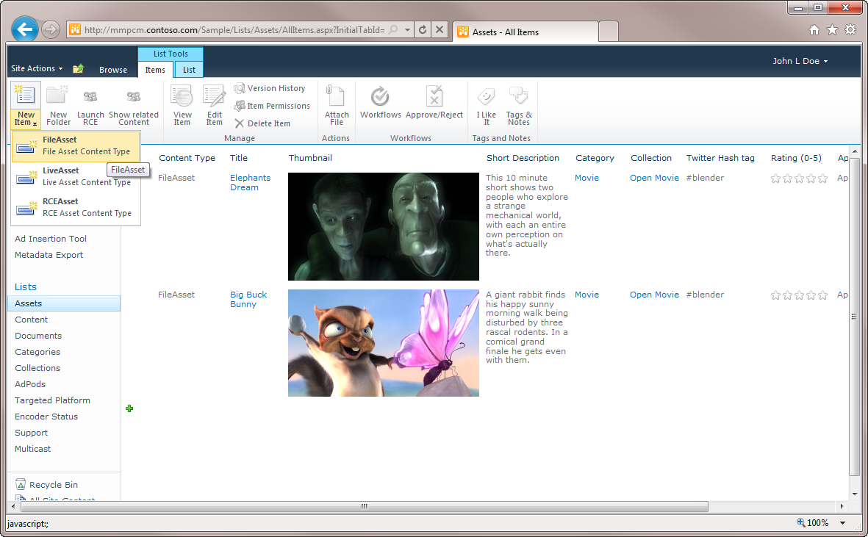
  4. Complete the metadata in the form. Click **Save**.
     1. 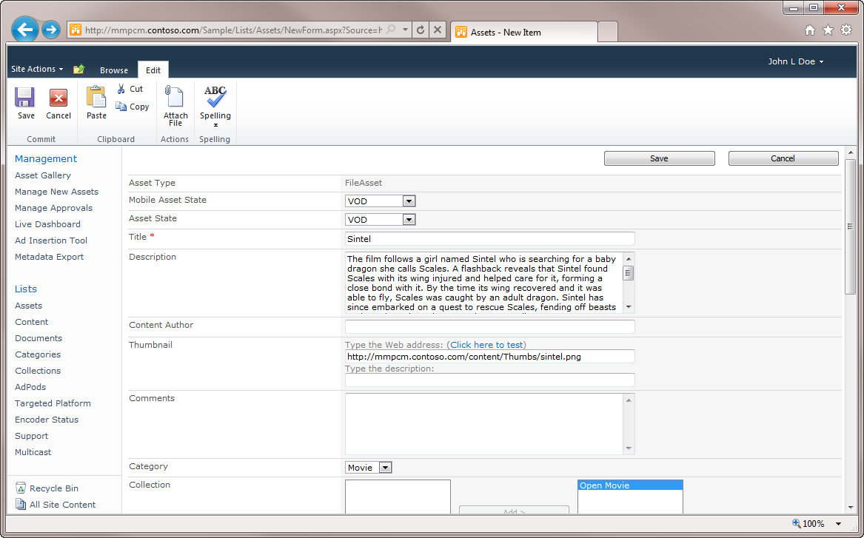
     2. 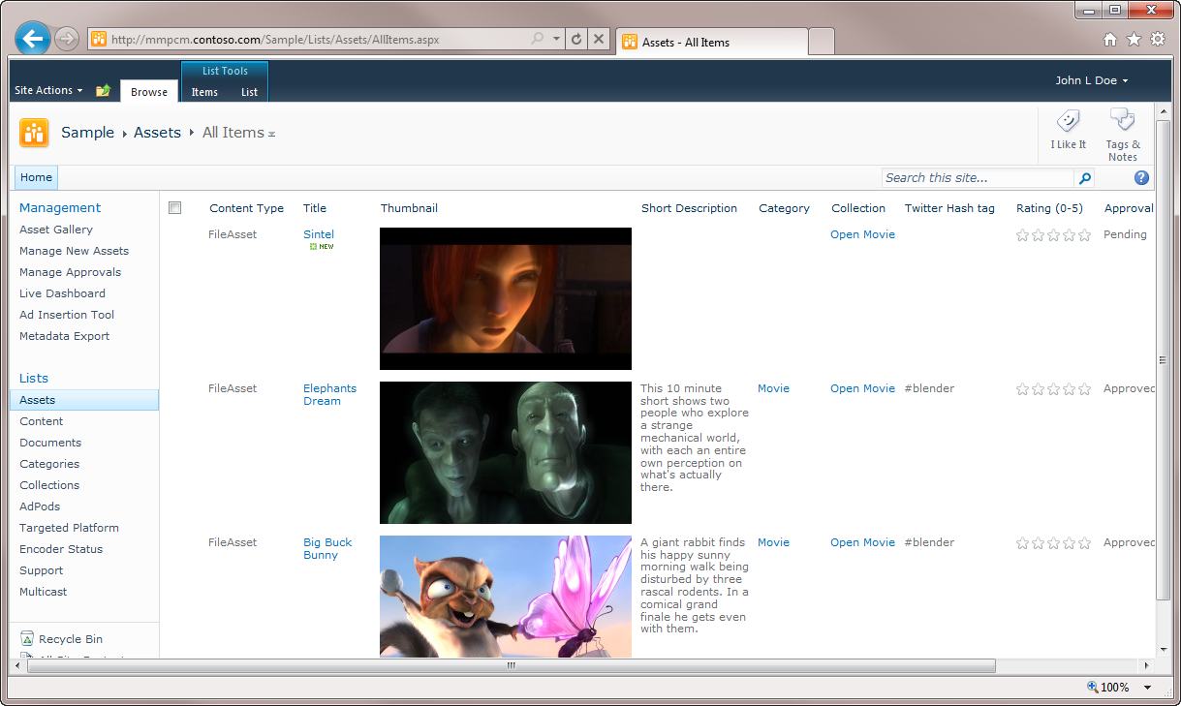
  5. Browse the **Content** list.
  6. Open the **Items** tab in the ribbon, and click **New Item**.
  7. Complete the following fields, and click **Save**:
     1. Asset that the content will belong to.
     2. URL of the file.
     3. Helps third party applications identifying mobile content.
     4. Targeted platform must match file format.
        1. 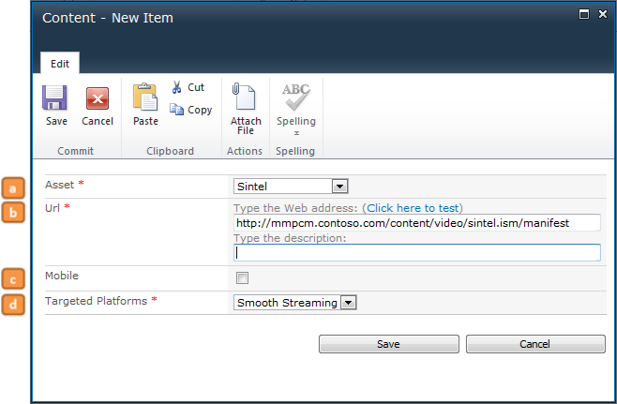
  8. To use the **Transform Manager**:
  9. Copy the desired file to the **File Import Watch Folder**.
     1. 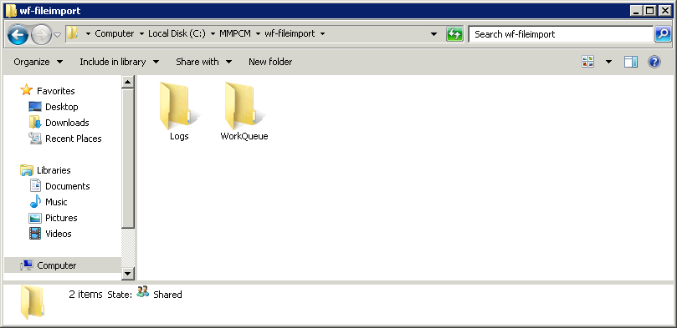
  10. Browse the Project Site’s **Assets** list, and locate the asset that corresponds to the video you uploaded.
      1. **Note:** The asset will be uploaded when the encoding finishes. Since this is a processor intensive operation, it might take some time until the asset appears in SharePoint.
  11. Select the Asset, which it’s Title will be the video file name, and click **Edit Item** button in the Ribbon. Add the data of your choice, and click **Save**.
      1. Note: Fields marked with * are required.
      2. 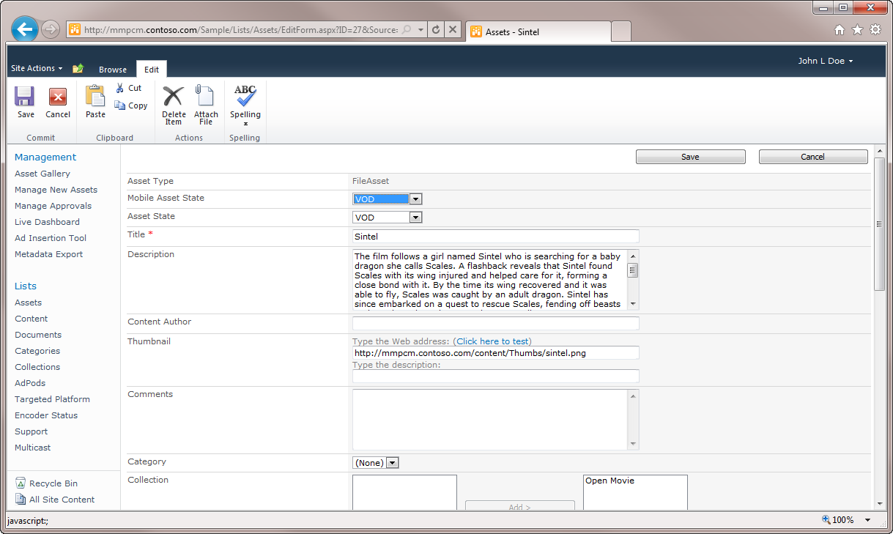
  12. To submit the asset for approval, select it, and click the **Workflows** button.
      1. 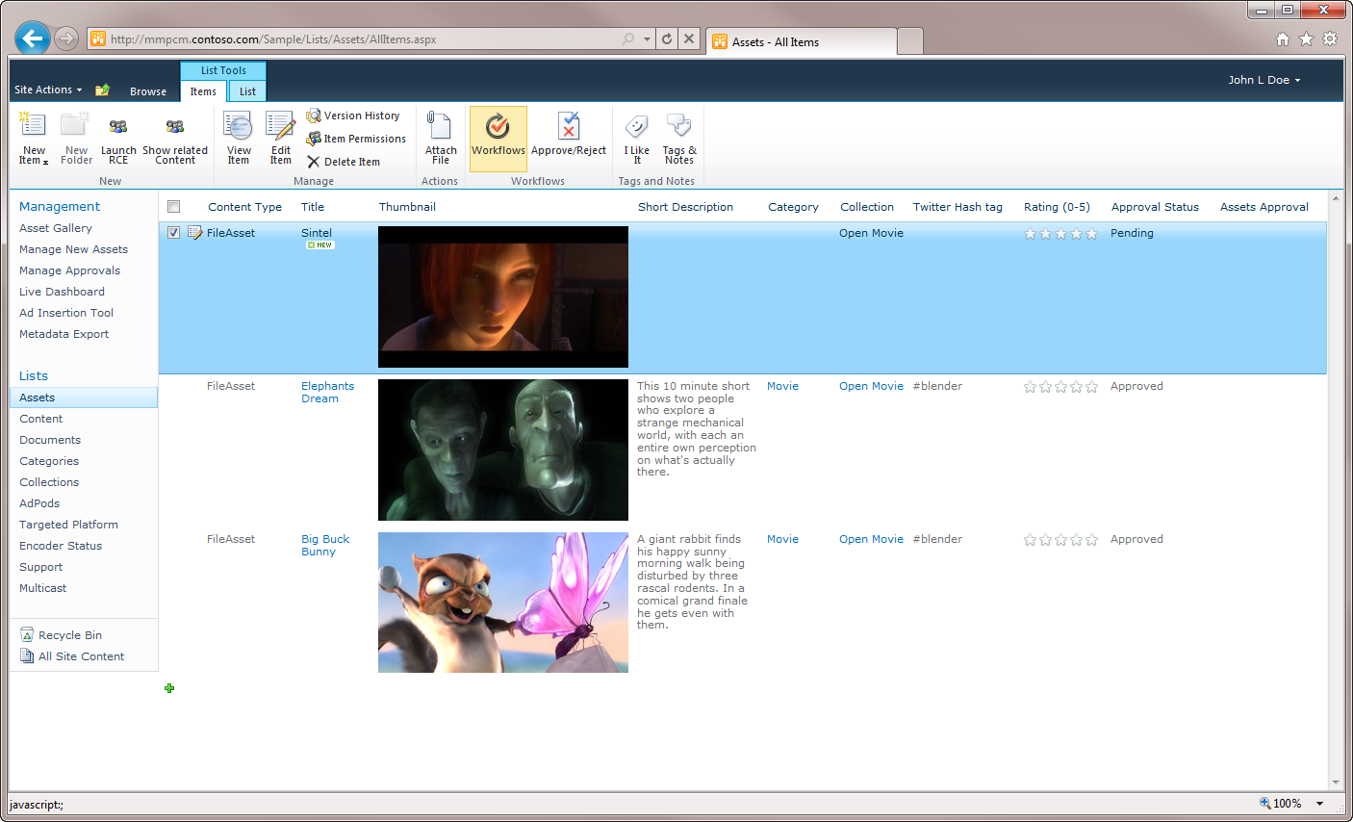
  13. Click **Assets Approval**.

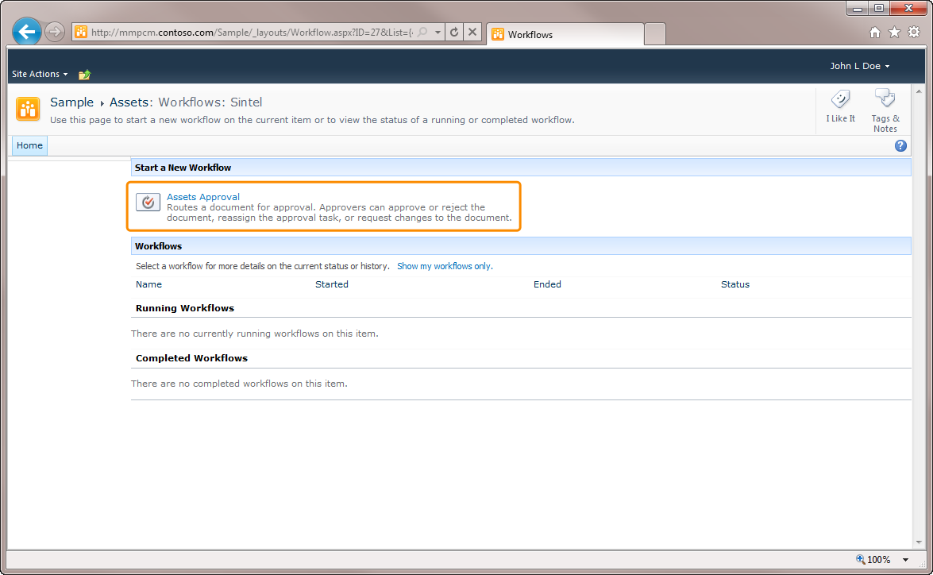

* 1. Enter the name of the producer **(a)** (**Approver**, in the project context) or group of users (role), and click **Start**. You can also write a **Request** message **(b)**, set a **Due Date** for approval **(c)** and **Carbon Copy** **(d)** other users that must be notified of new approvals in the system.
     1. 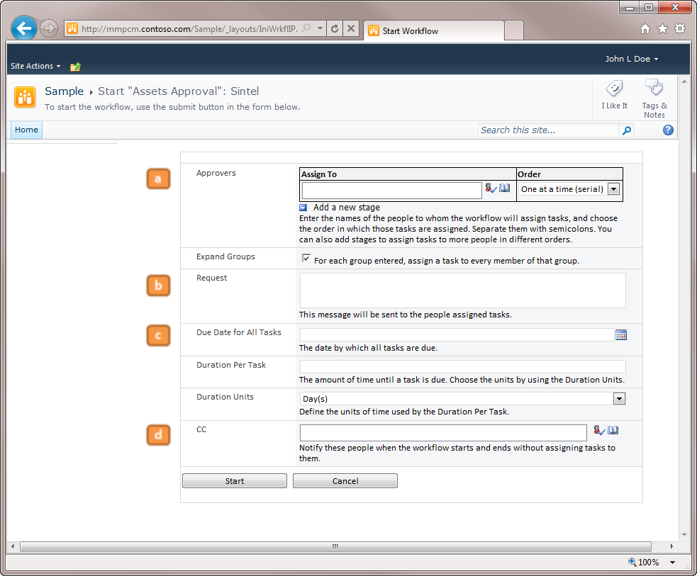
  2. Another way to create VOD assets is batch uploading its metadata using the Import Tool.

## How To – *Create RCE Assets*

* 1. Browse the Project Site’s **Assets** list.
  2. From the Ribbon, click the arrow button under **New**, and click **RCE Asset**.
     1. 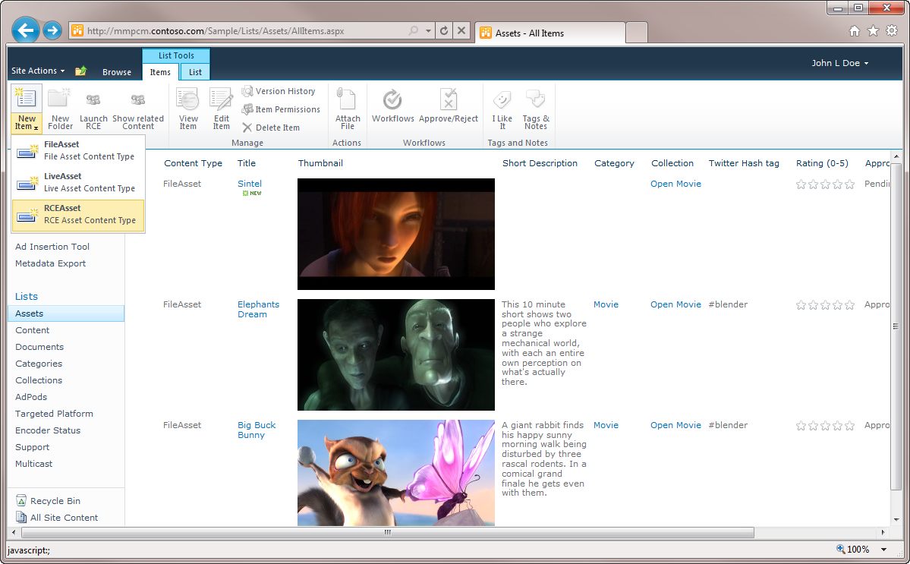
  3. Add the data of your choice, and click **Save**.
     1. 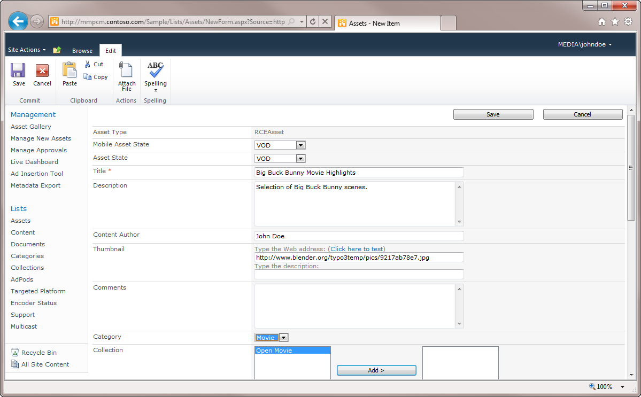
     2. **Note:** Fields marked with * are required.
  4. Select the asset from the list, and click **Launch RCE** button from the ribbon. This will launch the **Rough Cut Editor**, allowing the online edition of the asset. To save the changes back to **SharePoint**, click **Save**.
     1. 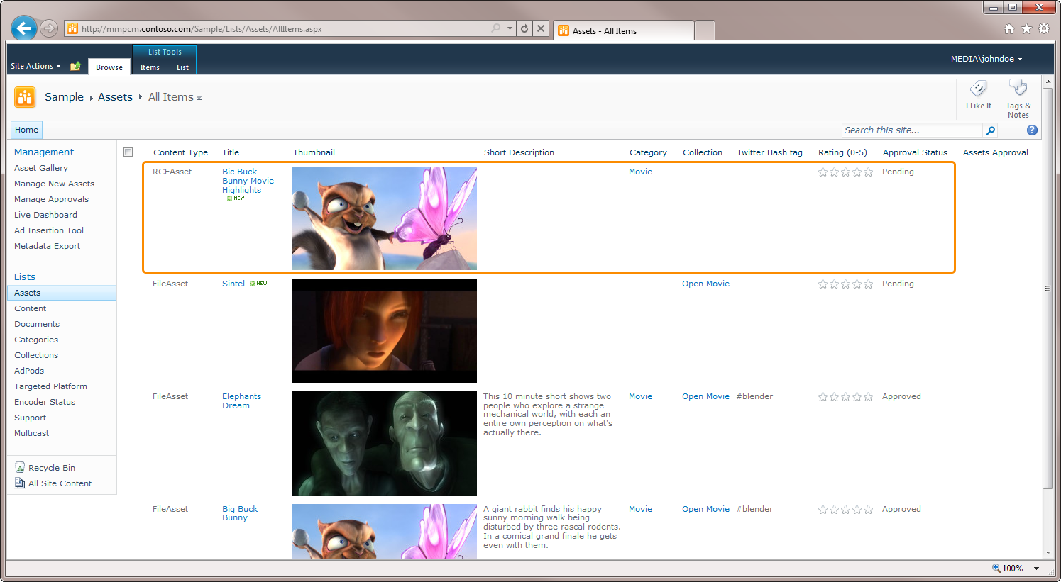
     2. 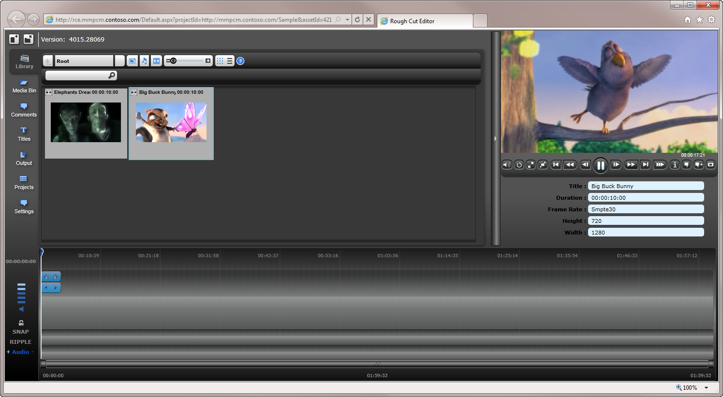
     3. **Note:** a RCE asset can be edited as many times as you want, until you submit the asset for approval.
  5. To submit the asset for approval, select it, and click the **Workflows** button.
  6. Click **Assets Approval**.
  7. Enter the name of the producer (at least), and click **Start**.

## How To – *Manage Live Events*

* 1. Browse the Project Site’s **Assets** list.
  2. From the Ribbon, click the arrow button under **New**, and click **Live Asset**.
     1. 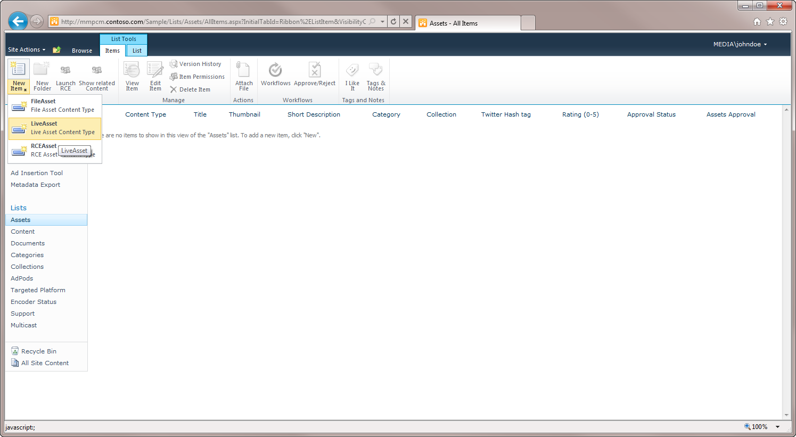
  3. Add the data of your choice, and click **Save**.
     1. **Note:** Fields marked with * are required.
     2. 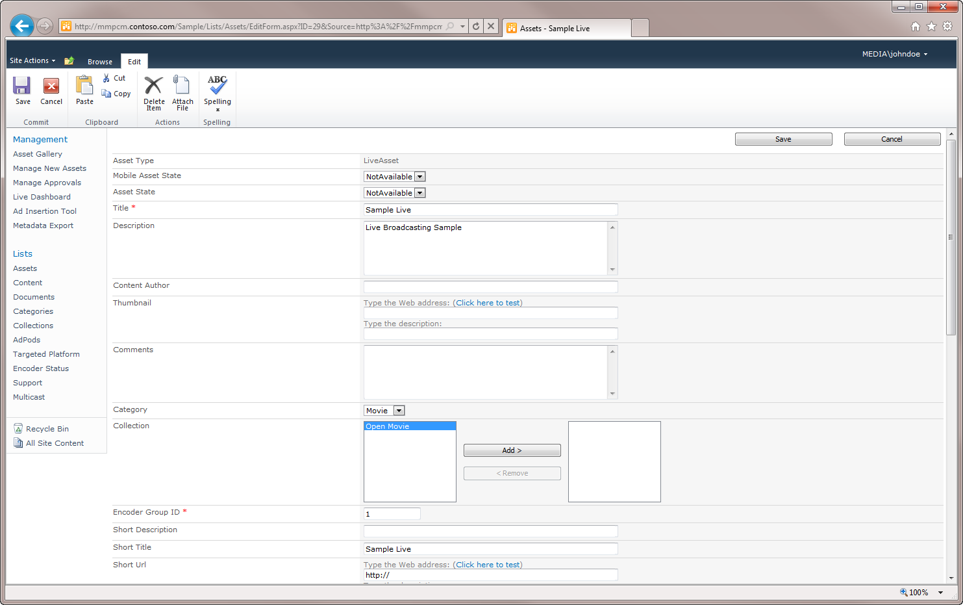
     3. 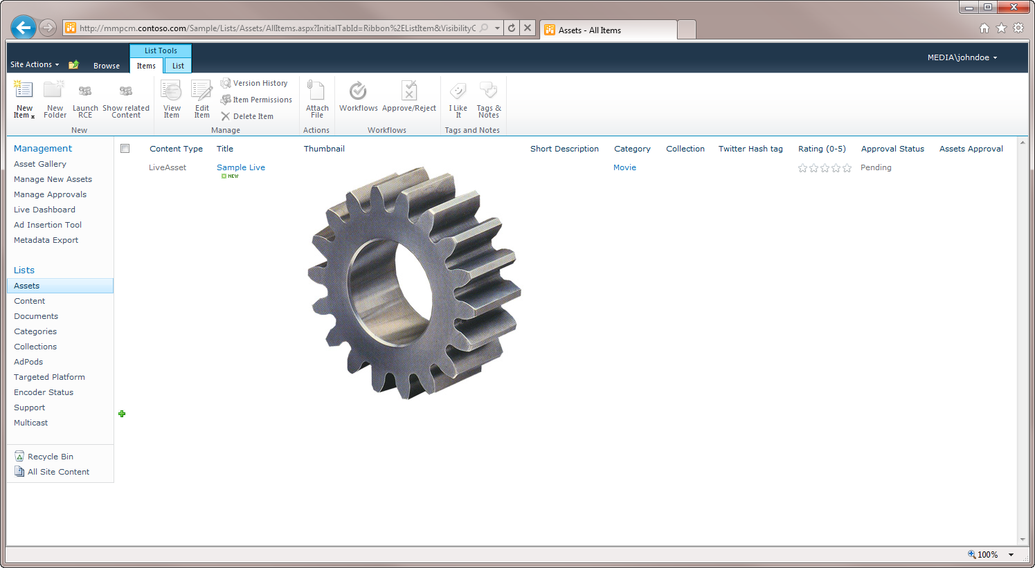
  4. To submit the asset for approval, select it, and click the **Workflows** button on the ribbon.
  5. Click **Assets Approval**.
  6. Enter the name of the producer **(a)** (**Approver**, in the project context) or group of users (role), and click **Start**. You can also write a **Request** message **(b)**, set a **Due Date** for approval **(c)** and **Carbon Copy** **(d)** other users that must be notified of new approvals in the system.
     1. 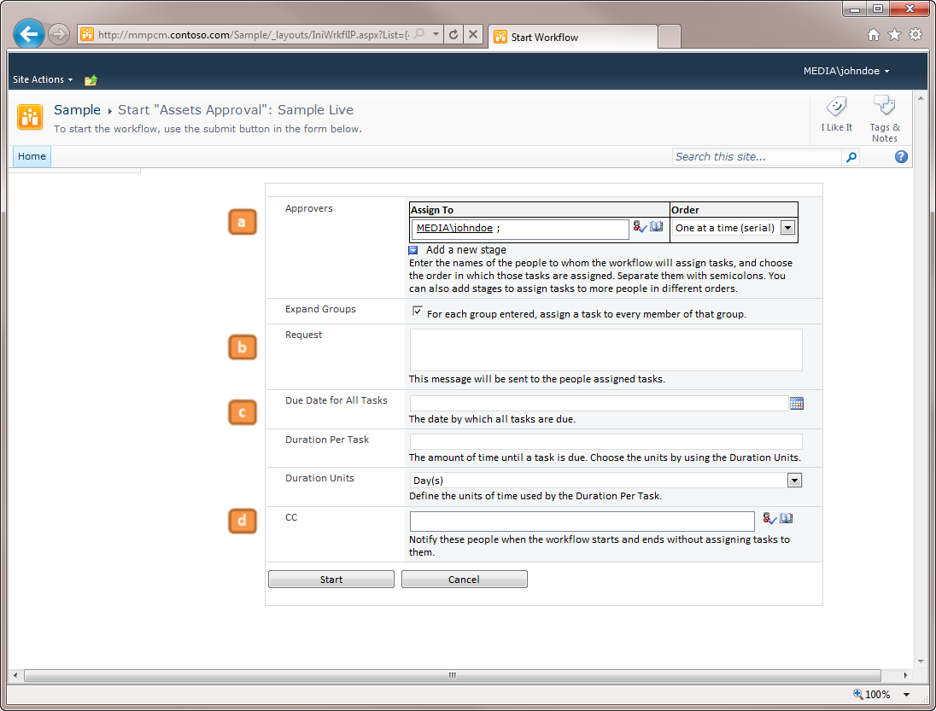
  7. Once the asset is approved, browse the **Live Dashboard** page.
     1. 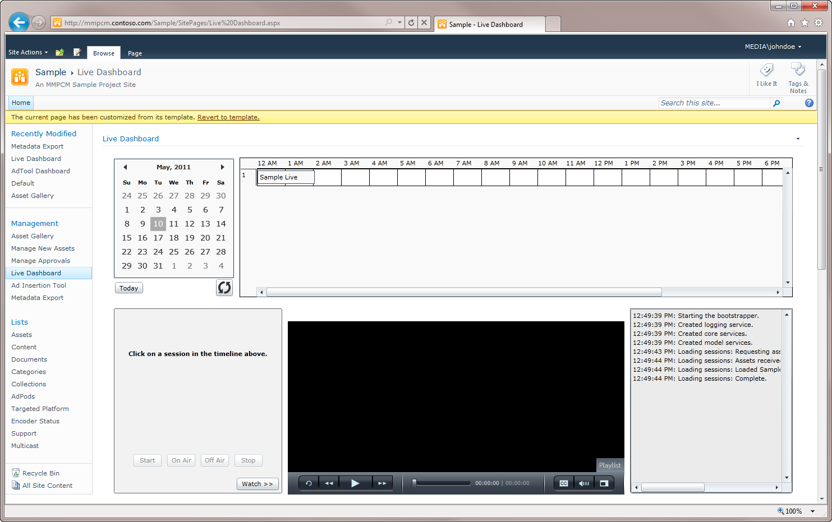
  8. Using the timeline, locate the asset and click it. The asset data is loaded.
     1. 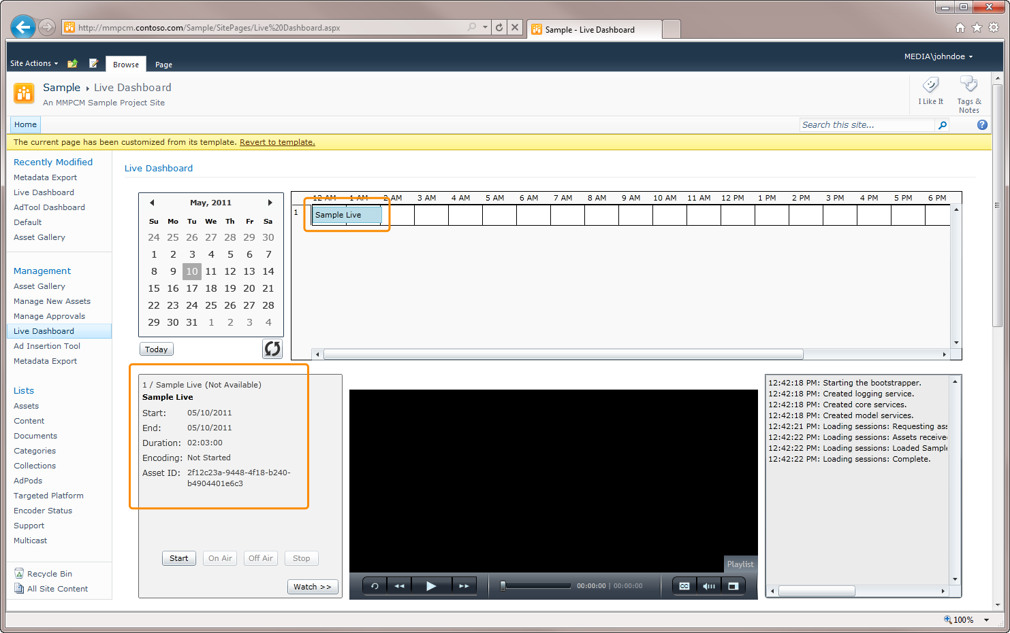
  9. To start the encoder, click **Start**. **Start** button:
     + Creates a Publishing Point
     + Starts Expression Encoder
     + Sets Encoder Status to Started
       1. 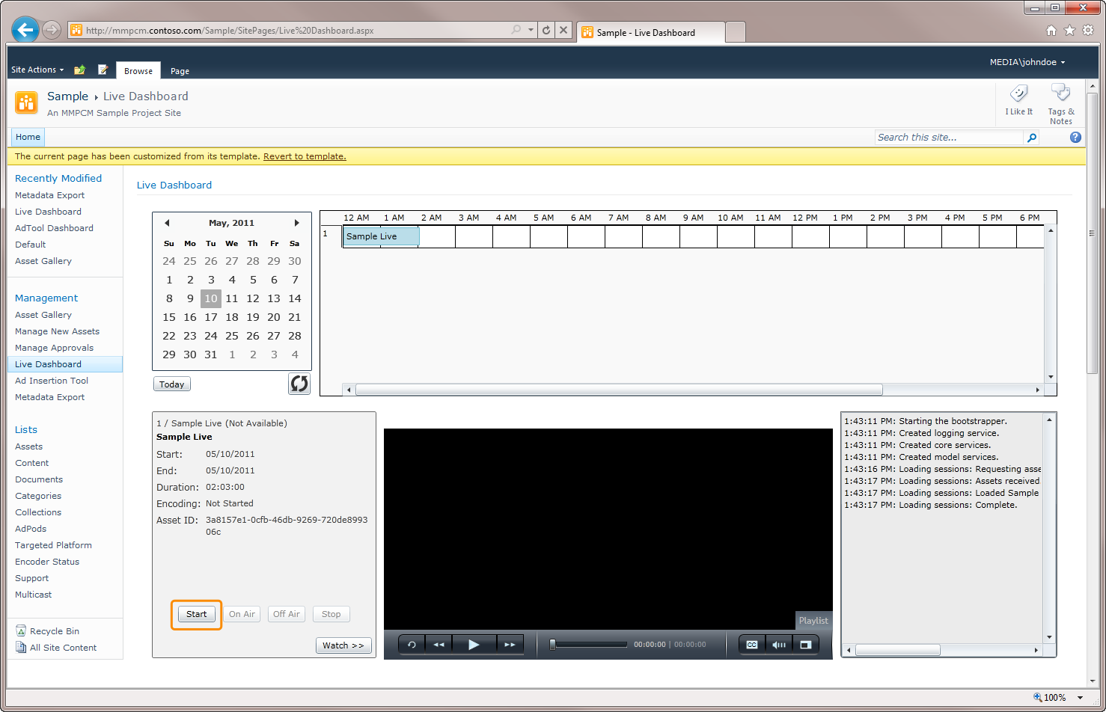
  10. To make the broadcasting available for **MMPCM** and third party player users, click **On Air**. **On Air** button:
      + Sets asset state to **live**
      + Creates content associated with the asset
      + Generates **Schedule.xml**
        1. 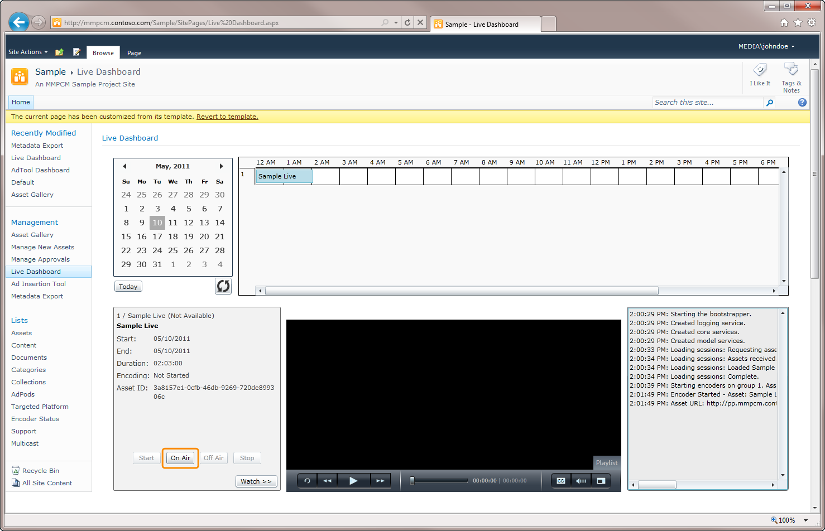
  11. To end the broadcasting, click **Off Air**. **Off Air** button:
      + Set asset state to **VOD**
      + Updates content’s URL
        1. 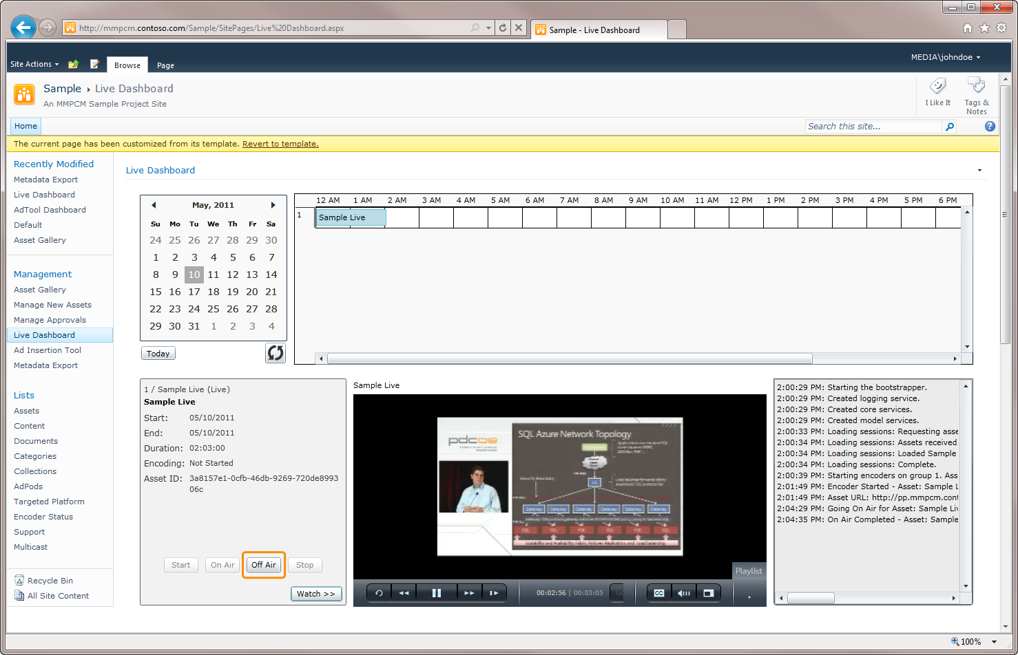
  12. To stop the encoder, and make the recording available in the **MMPCM** as **VOD** content, click **Stop.** **Stop** button:
      + Stops Expression Encoder
      + Sets Encoder Status to Stopped
        1. 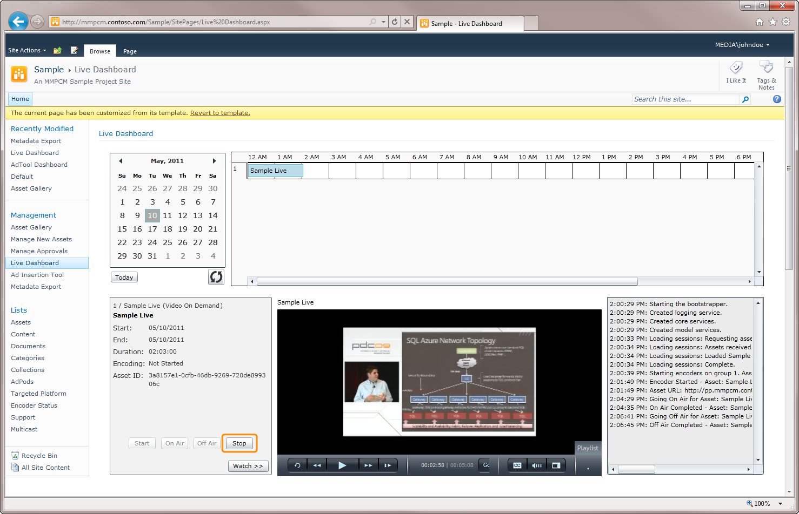

## How To – *Categorize Assets*

* 1. MMPCM enables users to categorize video assets using numerous mechanisms, including **categories**, **collections** and **tags**. Categorizing the assets allows users to filter, sort and search for documents matching a user defined criteria.

### Categories

* 1. Categories allow users to group videos according to a criterion of their choice. This might be helpful in numerous situations, both inside SharePoint and using third party interfaces consuming MMPCM metadata. For example:
  + A third party UI consuming XML exported data showing related videos.
  + A third party UI consuming assets RSS feed data showing related videos.
  + Custom SharePoint webparts added to MMPCM UI using SharePoint built-in filtering capabilities.
  + Sorting and filtering in SharePoint list forms in MMPCM UI (OOTB or custom).
  1. Browsing the assets view you can see an example of sorting and filtering by clicking the downwards arrow besides **Category** header. This will pop a dropdown menu including sorting and filtering options. Clicking in any option will display the result in the list form.
  2. 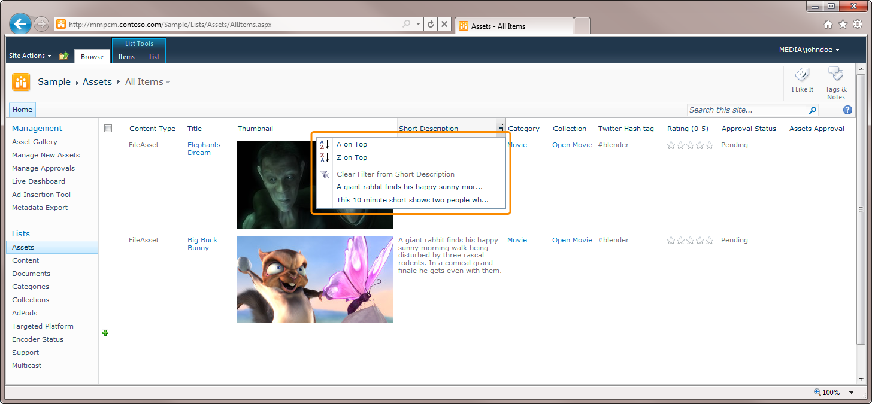
  3. To assign an asset to a category,
  4. Select the asset, and click **Edit Item** button in the ribbon.
  5. Locate **Category** field, and add the item to the category of your choice selecting it from the dropdown box.
     1. 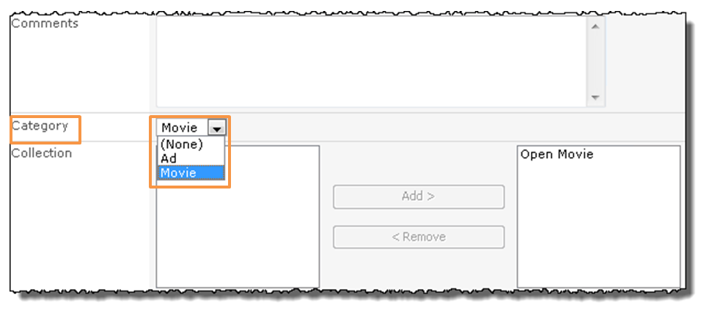
     2. **Note:** assets can belong to zero or one categories.
  6. To add a new category,
  7. Browse **Categories** list (you can do this clicking the link on the left navigation bar).
  8. Click **Add New Item** link below the list (optionally, click **New Item** button on the ribbon).
     1. 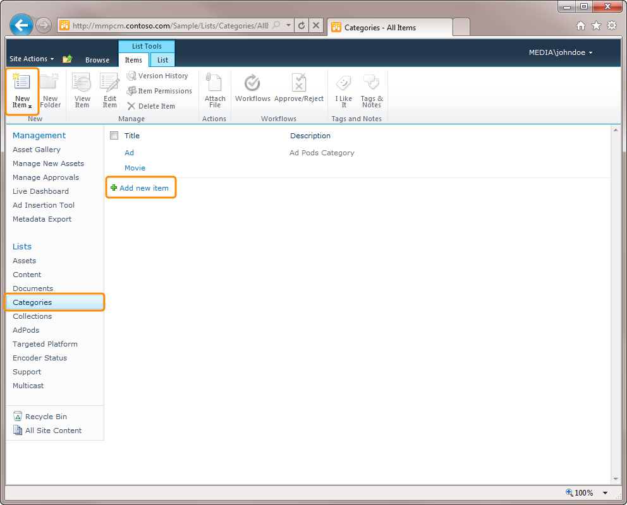
  9. Fill in **Title** and **Description**, and click **Save**.
     1. 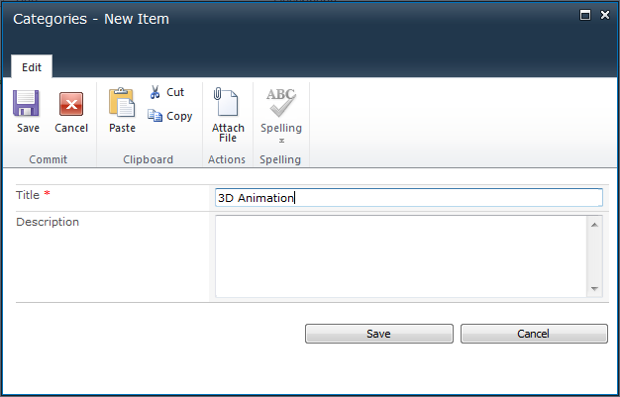
  10. You can verify the new addition by re-categorizing an existing asset.
      1. 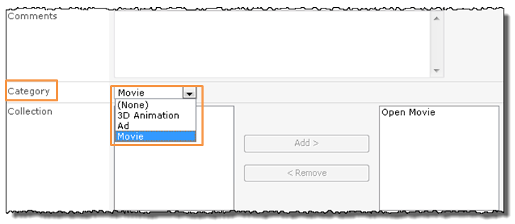

### Collections

* 1. Collections have a semantic similar to categories’. Once again the idea is providing a mechanism to help MMPCM (and third party application or webpages serving MMPCM contents) users find, sort and filter videos.
  2. The main difference between categories and collections resides in their cardinality. While an asset can belong to a single category, it can be part of many collections.
  3. Creating collections and assigning assets to them can be done following the steps listed in the categories section. Note that the control to add and remove collections from an asset is slightly different from the dropdown box to assign a category. Clicking **Add** and **Remove** buttons while selecting a collection will cause an asset to be included or excluded from it, respectively.
  4. 

### Gallery View

* 1. The **Gallery View** is an example of filtering using interconnected web parts. The left column displays the existing collections **(a)**, while the right panel shows the assets thumbnails **(b)**. Clicking on a collection name will cause the right panel to display assets from the selected collection. The **Gallery View** can be browsed from the left navigation bar **(c)**.
  2. 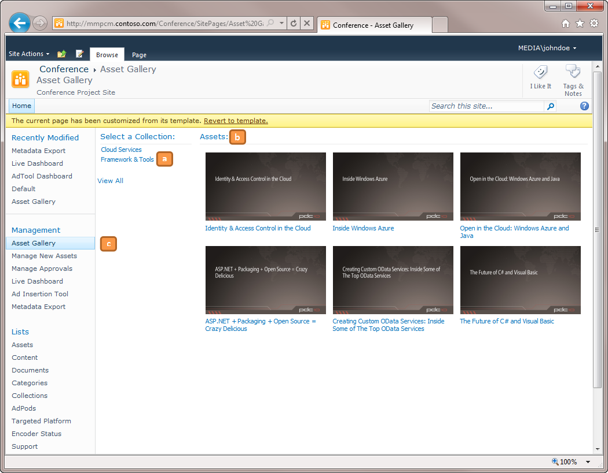

### Tags

* 1. Tags allow users to describe an asset using a set of non-hierarchical keywords. They help describe videos and, as categories and collections, they allow finding an asset by searching or browsing. In general, tags are chosen informally and personally by the editor. For example, a set of assets for **Big Buck Bunny** could be: **Movie**, **Animation**, **3D**, **All Audiences**, **Kids**.
  2. **Note:** Tagging in the MMPCM uses **SharePoint 2010** **Enterprise Keywords**, which are only available in **Windows 2008** installations.
  3. To add tags to an asset,
  4. Select the asset, and click **Edit Item** button in the ribbon.
  5. Locate **Enterprise Keywords** field, and add any number of tags.
     1. 

## How To – *Configure Targeted Platforms*

* 1. Configuring a **Targeted Platform** in the MMPCM causes a new **VOD** content with the format specified to be created every time a video is dropped in the **File Import Watch Folder**.
  2. A targeted platform must be configured in the MMPCM SharePoint site as well as in the **Transform** **Manager tasks**.
  3. **Note:** in order to gain a deep understanding of the **MMPCM VOD infrastructure**; please refer to the VOD Architecture section of the document.

### Creating a Targeted Platform in SharePoint

* 1. Browse the Targeted Platforms list.
  2. Click Add New Item, and fill the Title field (format name is recommended).
  3. Note that a Targeted Platform ID is auto-generated.
     1. 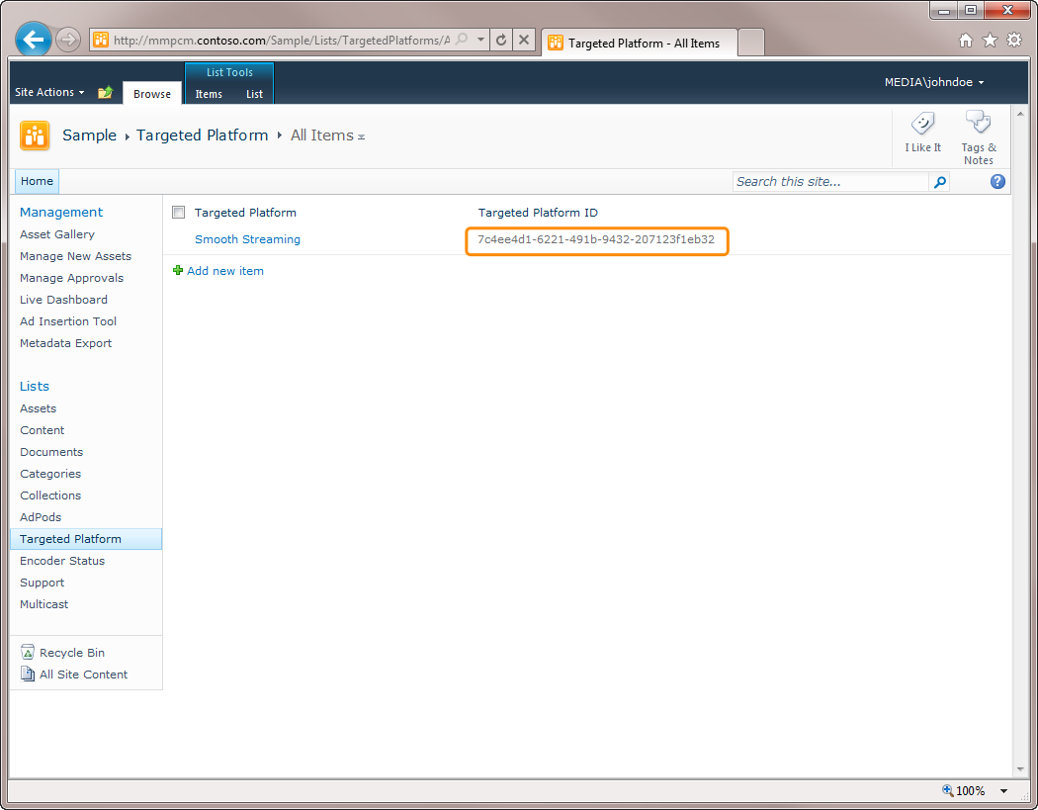

### Configure a Targeted Platform output folder in a Transform Manager preset

* 1. **Open** Internet Information Services (IIS) Manager**.**
  2. **Open the** Transform Manager**.**
  3. **Locate the** Job Templates tab **and open it. Open the desired template.**
  4. **From the** Tasks Definition list**, select or create the corresponding** Expression Encoder Task**.**
  5. Configure the **Targeted Platform ID** as the name of the task’s **Output folder name**, and the **Preset** corresponding to the chosen Targeted Platform.
     1. 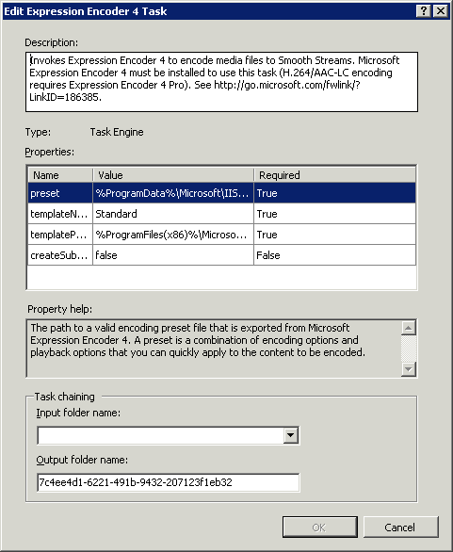

## How To – *Enable multicast support for Live Events*

* 1. The MMPCM supports Smooth Multicast, which combines traditional multicast with Smooth Streaming, providing best-quality end user experiences with low network overhead.
  2. To enable multicast support in a live asset,
  3. Browse the **Multicast** list in SharePoint.
  4. Add a new item to the list, byclicking **Add New Item** link.
  5. Fill the values in the fields.
     1. 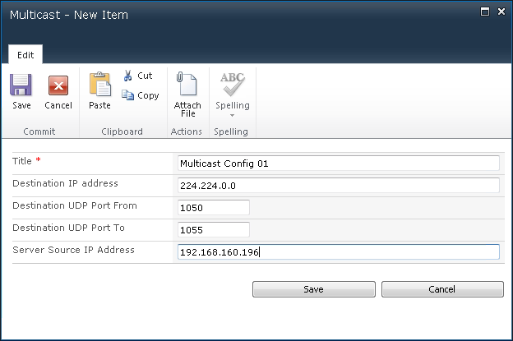
  6. Edit the Live Asset that will be broadcasted with multicast. Browse **Assets** list, select the asset and click **Edit Item** button in the ribbon.
  7. Locate **Enable Multicast** checkbox, and check it.
     1. 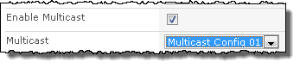
  8. Select the multicast profile you configured.
  9. When the Live asset is set to start in the **Live Dashboard**, a different call to the encoder will be issued, starting a multicast broadcast, instead of a regular one.

## How To – *Approve Items*

* 1. **Editors** in the MMPCM are able to create and edit asset metadata, but it is up to **producers** to **approve** or **reject** assets. An asset with a status other than **Approved** will not appear neither on the **Live Dashboard** nor in the **Assets Gallery** and will not be exported to the **Schedule XML file**. Also, the item will not be eligible for being part of **RCE Projects**.
  2. To approve or reject an asset, as a producer:
  3. Browse Manage Approvals page.
  4. Click on the title of the task you want to review. Note that the task must be assigned to you to be able to approve or reject it.
     1. 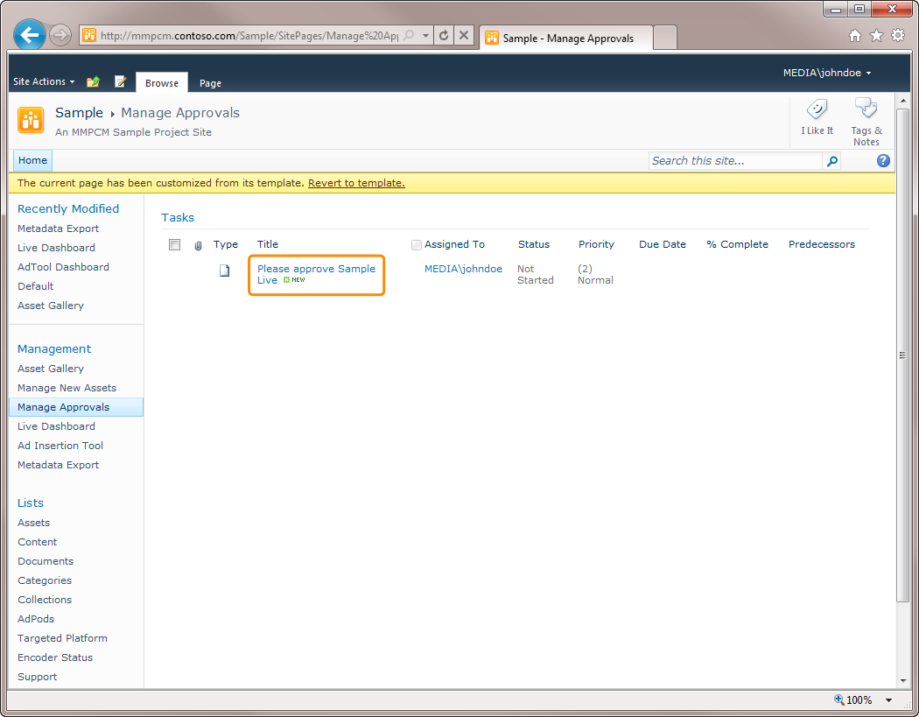
  5. The **Workflow Task** form is displayed. From within this form, you can review the item the workflow applies to **(a)**, and who requested the item’s approval **(b)**. After reviewing the item, you can decide to **Approve** **(c)** or **Reject (d)** it. Also, you can ask for a change to be made in the item **(f)**, or even **Reassign the Task** to another producer. Cancelling the task **(e)** will render no change on its status.
     1. 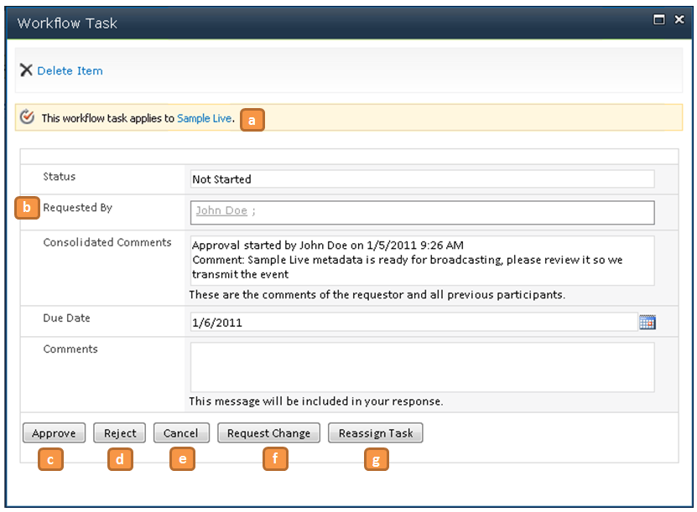

## How To – *Insert Ads In a Live Event*

* 1. This module is meant to perform advertisement insertion on Live Events. The inserted ads will be shown in audience players.

### Architecture

* 1. The diagram below shows the tool’s components organization:
  2. 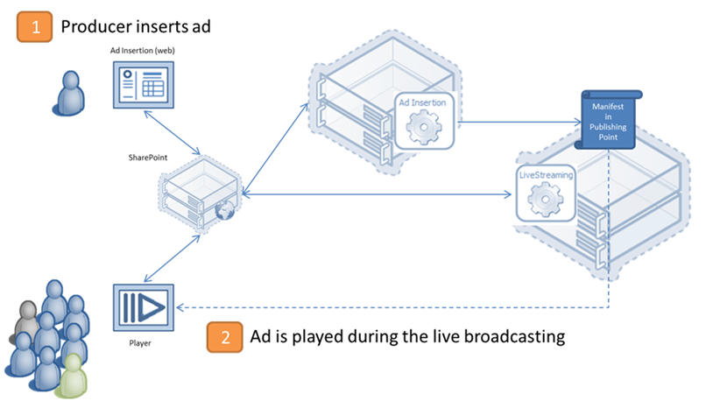
  3. Ad Insertion Workflow

#### Component description:

* + **Ad Tool GUI:** A **Silverlight** Web Part that allows users to manage ad insertion on live events.
  + **Player:** Plays live content and Ads.
  + **SharePoint Server:** the SharePoint server hosts the MMPCM site.
  + **Ad Insertion Service:** it is responsible of adding Ad data into the Publishing Point Manifest. This service is shown hosted in a dedicated server in the diagram, but can be hosted in SharePoint server or even in the Origin server if desired.
  + **Origin:** an **IIS Media Services** dedicated server that hosts the publishing points where the **Ad Insertion service** will introduce the Ad chunks.
  + **Live Streaming Service:** service that manages some IIS features, and retrieves information from it. It must be installed in the **origin** server.

### How does Ad Insertion works?

#### An overview of the flow

* 1. 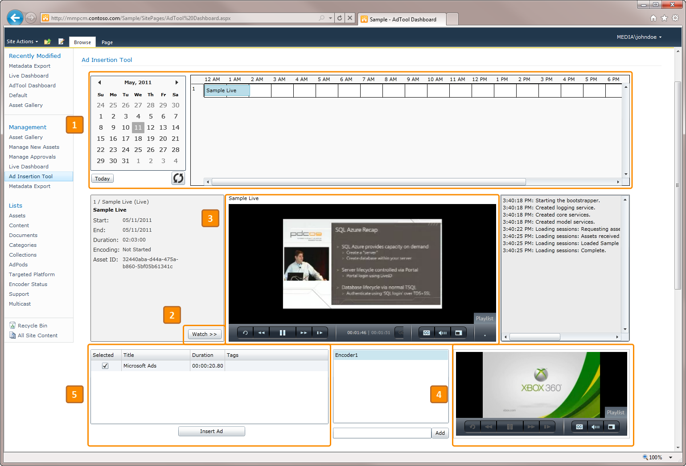
  2. The **Ad Tool** loads the approved events that are currently **being broadcasted** in the time line **(1).**
  3. The editor selects the one where he wants to insert ads by clicking it. The **Watch button** becomes enabled, and the asset data is displayed in the left pane.
  4. The editor clicks the **watch button (2)** and the event playback starts in both dashboards’ players. The bigger one**(3)** shows live video streaming, while the smaller **(4)** shows the stream the audience is watching (which is the same signal, but delayed a few seconds **- see note below**). Also the **Streams** **list box** **(5)** is populated with the available input streams on the current publishing point (provided by **Live Streaming** service), and the ad pods available for this event are displayed in the grid. The **Insert Ad** **button** is enabled as well.
  5. The editor selects an Ad pod, then a stream from the list, and clicks the **Insert Ad button** whenever he wants it to be played.
  6. The tool calls the **Ad Insertion service** that inserts the ad into the manifest. The second player and every client player detect the insertion and schedule the Ads that comprise the ad pod. When the insertion time stamp is reached, the Ads are played and, afterwards, the player goes back to streaming the live event.
     1. **Note:** The second player is delayed to make it possible for the editor to watch not only the live event, but also the video being broadcasted to client players.

#### How to Create Ads

* 1. Every Asset is categorized. This feature is useful to conceptually group them. For listing file assets as Ads, they must be categorized as **Ad**.
  2. **Note: Ad category should not be deleted, since the Ad Pods are built based on its existence. Deleting the category will result in the impossibility of inserting ads during live event transmissions.**
  3. 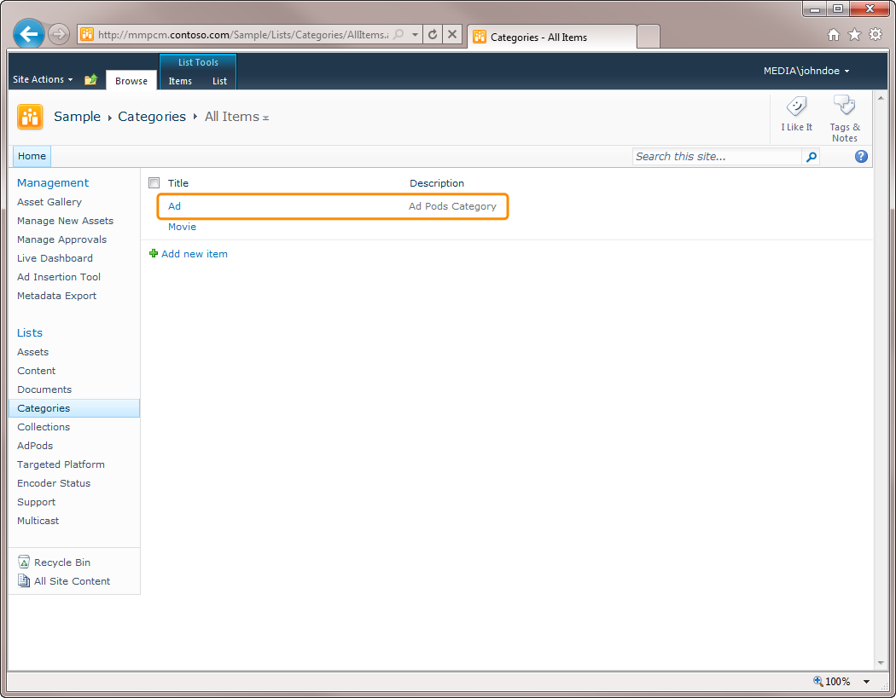
  4. To create an **Ad**:
  5. Browse the Assets list, click the arrow below **New** Item button in the ribbon, and then click **File Asset.**
     1. 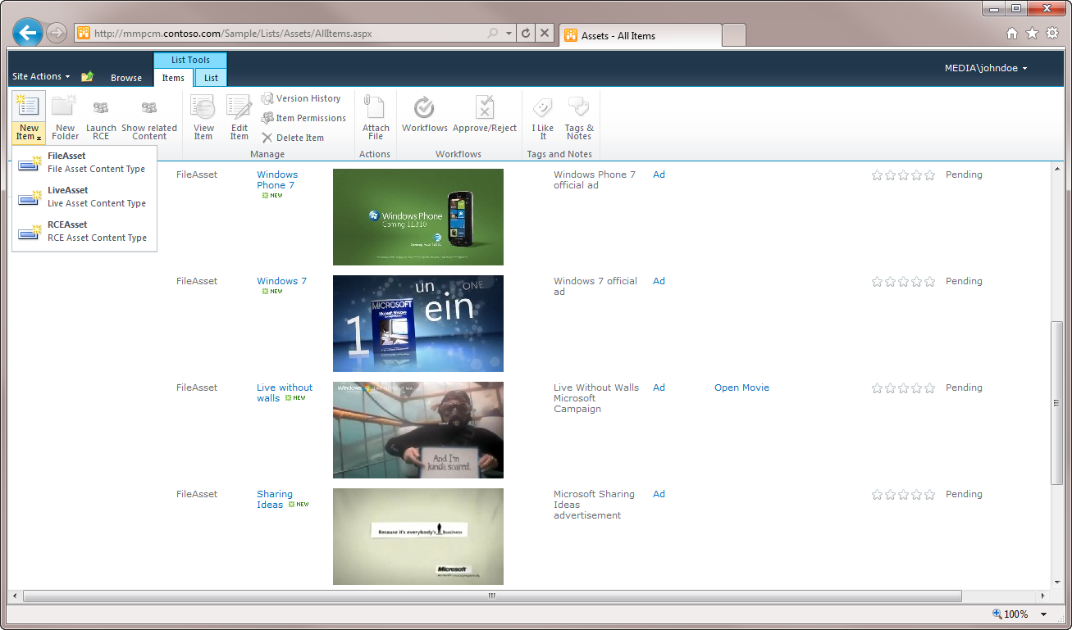
  6. **Title** is required, and **Category** must be set to **Ad**. Remaining fields are not mandatory.
     1. 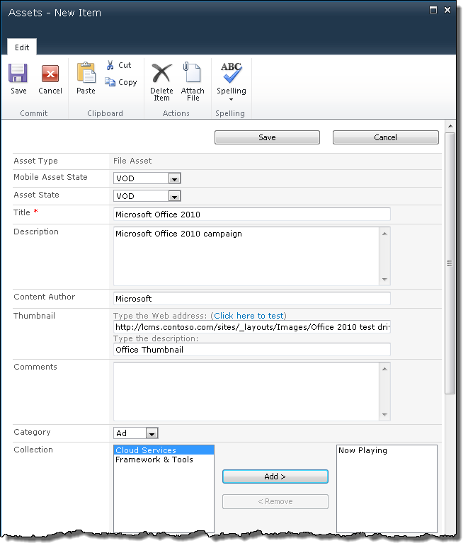
     2. 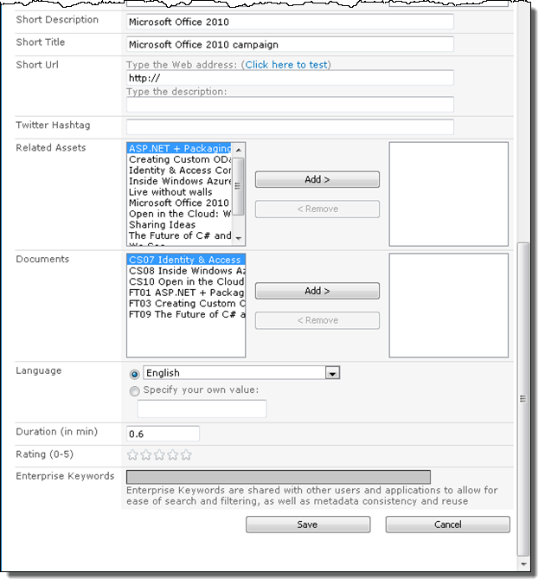
  7. The ads are displayed in the Assets list:
  8. 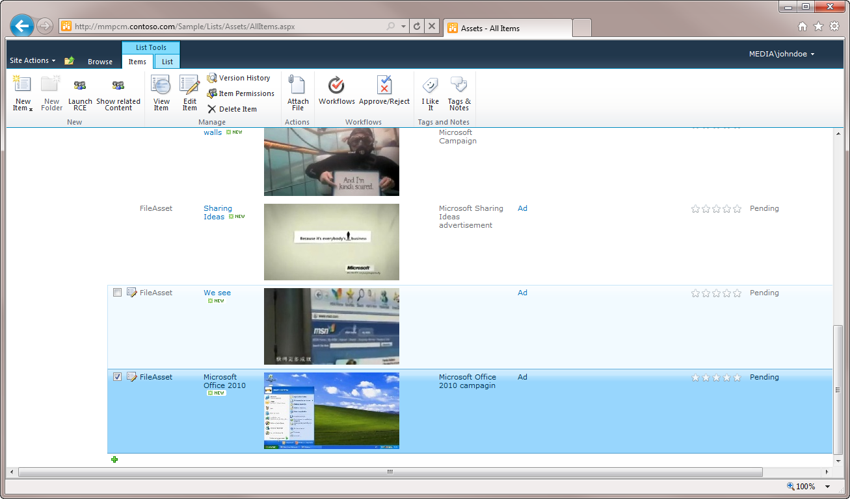

#### How to group Ads – Ad pods

* 1. Items in the Ad Pods list group Ads that will be played together. The same Ad can be part of many ad pods.
  2. This is the Ad Pods list, after creating some ad pods: 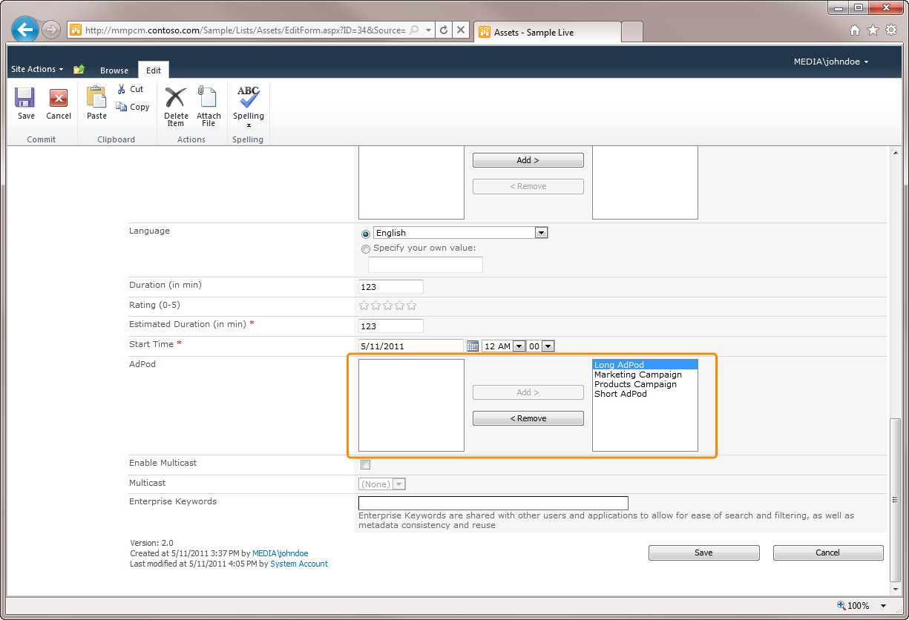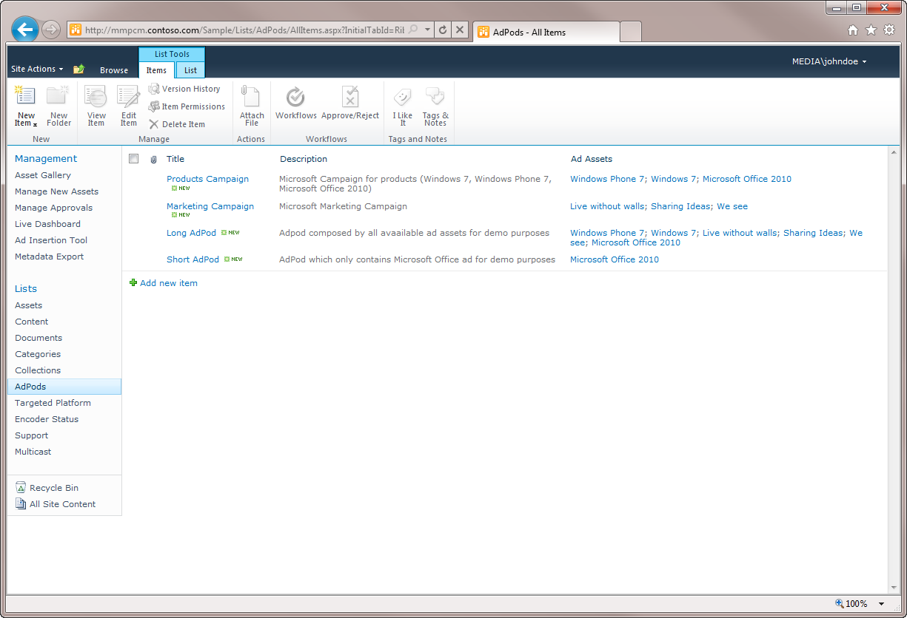
  3. To make an Ad Pod available for a specific Asset, browse the **asset** in the **Assets list**, select it and click **Edit** button in the ribbon, and then add the desired ad pods as shown in the picture below:
  4. 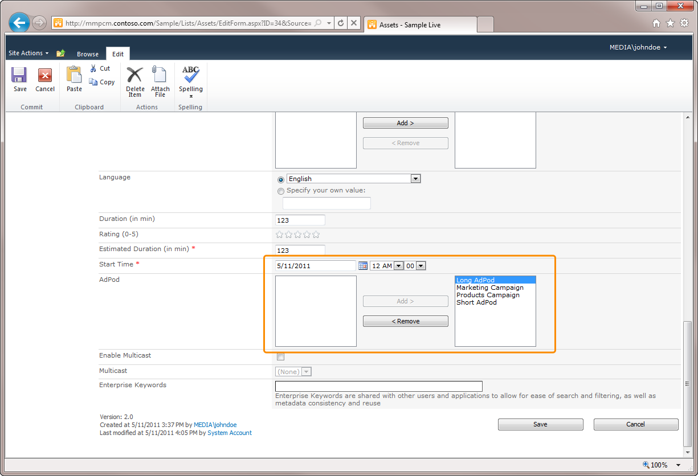
  5. **Save** and **Approve** the **Asset**, and the ad pods will show up in the dashboard when the event is loaded.

#### Inserting Ads with the tool

* 1. Go to the **Ad Tool Page**. A Timeline displaying the assets being broadcasted will be shown:
     1. 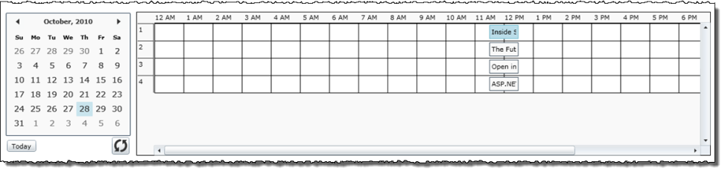
  2. Use the calendar and scrollbars to locate the **Event** where you want to insert the ads and click it. The Tool will start playing the event in both players, and will load the **Streams List Box (1)** with the available Input Streams for the currently playing event, fill the **Ad Pods Grid (2)** with the available **Ad Pods** and enable the **Insert Ad button (3)**. The tool will be ready to perform ad insertions:
     1. 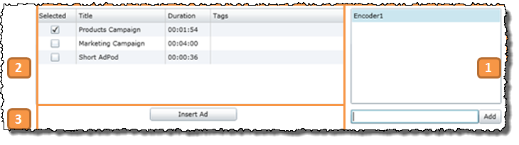
  3. Ad Pods can be inserted at any time. Check the Ad Pod you want to insert, and click **Insert Ad**. The application will insert the ad pod information in the selected stream’s manifest and log the insertion. When the player on the right reaches the ad pod start time, it will be played as shown in this pic:
     1. 
     2. **Note:** The Ad Pods list works like a circular list (i. e. when an Ad Pod is inserted, it is moved to the bottom of the list afterwards) as long as the checked Ad Pod is the first. Otherwise, the selected Ad Pod is inserted, but its position in the list does not change.
     3. **Note:** Have into account that the ads will play not only on the tool´s right player, but also in every client that is playing the live event as well. Note also the ad pods order and mark changes.

## How To- *Configure RCE Magic Folder*

The RCE Magic Folder is a Transform Manager watch folder that triggers two tasks. The RCE Magic Folder path shouldn’t be changed once the application is installed. But the path can be configured at two places, the installation wizard (as shown on the first image below) or by editing each project inside SharePoint.

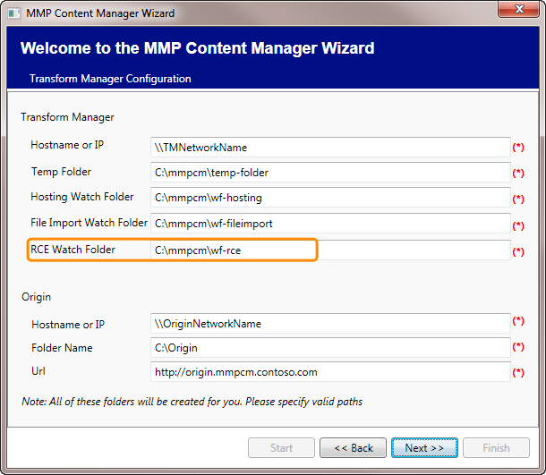

*MMPCM Installation Wizard*

Following is a step by step guide showing how to configure the RCE Magic Folder.

1. **Browse** to the root site (e.g. mmpcm.contoso.com)
2. Click **Projects** inside the Lists section at the left pane.
3. Select the project you want to edit by clicking the checkbox.
4. Click **Edit Item** on the ribbon

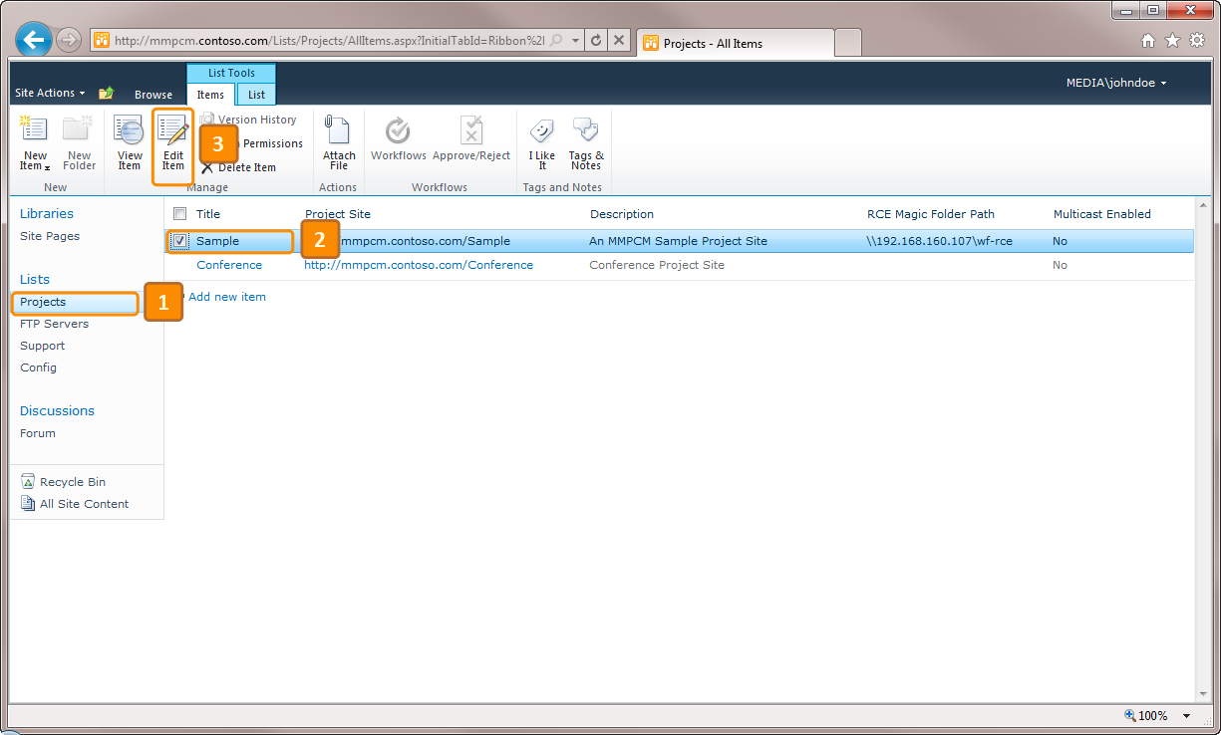

1. Edit the **RCE Magic Folder Path** text field

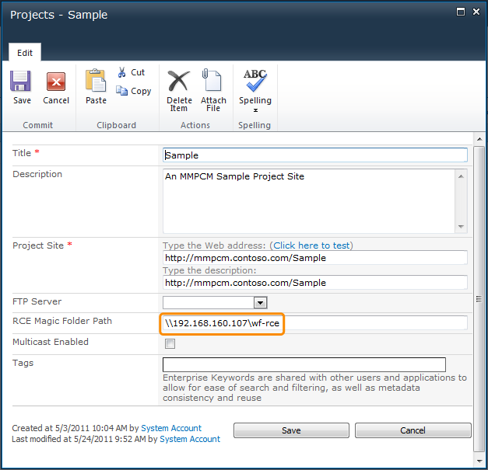

*Edit Project Dialog*

1. Click **Save**

## How To – *Import Data From an Excel Spreadsheet*

* 1. The MMPCM provides an Import Tool that will allow users to bulk upload video metadata to theCMS.

### CMS Import Tool

* 1. This console utility was designed to import data from a **Microsoft Excel spreadsheet** into the MMPCM. The import operation iterates through the data inserting items in the lists according to a data definition file.
  2. **Note:** The tool is ready to be extended by adding new providers, but **Excel** is the only one supported so far.

#### Command line parameters

* 1. The following list describes the parameters needed to invoke the Import tool from a command line:
  + **DataDefinition:** Indicates the path to the XML file containing the data structure definition and the operations for each list. Please find the syntax specification below**. Required.**
  + **SourceType: Path to Excel spreadsheet. Required.**
  + **SiteUrl:** URL of the site where the data should be imported to. (e. g. http://MMPCM.contoso.com /sample).
  + **ModerationStatusType:** Sets the **Moderation Information Status** after the items are updated or inserted. Status can be set to: **Approved**, **Pending or Rejected.**
  + **VerboseMode**: forces the application to output additional execution data. Useful to track issues during the import process.
  + **CleanLists**: Tells the application to wipe the list items before inserting the new ones.
  + **CleanListsDeep**: This will not only wipe the target lists items, but also the items in the lookup lists declared in nested **GenericLists** (to understand the concept of **nested Generic Lists**, please refer to this example).
  + **CommitChanges**: Forces the application to write the changes. If it is not present, the process becomes a simulation. **Required**.
    1. **Note:** However, if you don’t commit changes when inserting rows in a list which has lookup columns to lists where the tool needs to insert items too, the main list will not be able to reference them, resulting in an exception.
  + **nop** – The tool will do nothing. It can be useful to disable lines in a script.

#### Required Excel spreadsheet data organization

* + The file must be a xlsx.
  + The data must be organized as a table:
    - The first row must contain the titles.
    - The data must start in the column **A**. The spreadsheet should not contain any other data outside the table, because it could result in a mismatch.

#### Data Definition file Specification

* 1. Because the application is recursive, it has the ability of inserting N levels of lookup data. This leads to the need of having a tree-shaped specification (**XML** was used).

#### Supported tags:

* 1. **<GenericList>:** Indicates a list. Its allowed attributes are:
  + ***ListName:*** The list to be populated. Must match the **MMPCM** list name.This attribute should be only placed in the root level **<GenericList>** tag. The others are inferred from lookup associations.
  + ***Operation:*** Must be always **Import**. The tool will use this parameter to determine the operation to apply in each list. It must be specified at root level, and it will be cascaded to the other GenericList tags, which are not allowed to have an Operation parameter.
    1. **Note:** the **Import Tool** can be easily extended to support other operations, such as **update**.
  1. **<Fields>:** Every **<GenericList>** must have a **Fields** tag that will group the **Field** tags for the current list.
  2. **<Field>:** This is the most complex tag of the structure, because it can contain a whole **<GenericList>** definition when it is a lookup field. Note that types are not included, because they are inferred from SharePoint list metadata. It has following attributes:
  + ***Source*** *(****required****)****:*** name of the field in the data source.
  + ***Target*** *(****required****)****:*** external name of the field in SharePoint list.
  + ***Dictionary*** *(****optional****):* name of the dictionary that will be applied to data extracted from Source field before it is inserted in the Target list field.
  1. **<Dictionaries>*:*** **<GenericList>** Tags can hold a **<Dictionaries>** tag, that will group the <**Dictionary>** tags.
  2. **<Dictionary>**: A dictionary of equivalences. In runtime, this will help to automatically replace text in the specified fields. **Name** is a required attribute for dictionaries.
  3. **<Entry>*:*** Entries for the dictionary definition. They must have two attributes:
  + ***ConvertThis:*** Specifies the string to be replaced.
  + ***IntoThis:*** Specifies the string that will replace the one specified in ***ConvertThis*** attribute.

#### Import Data Definition file examples: Documents list

* 1. 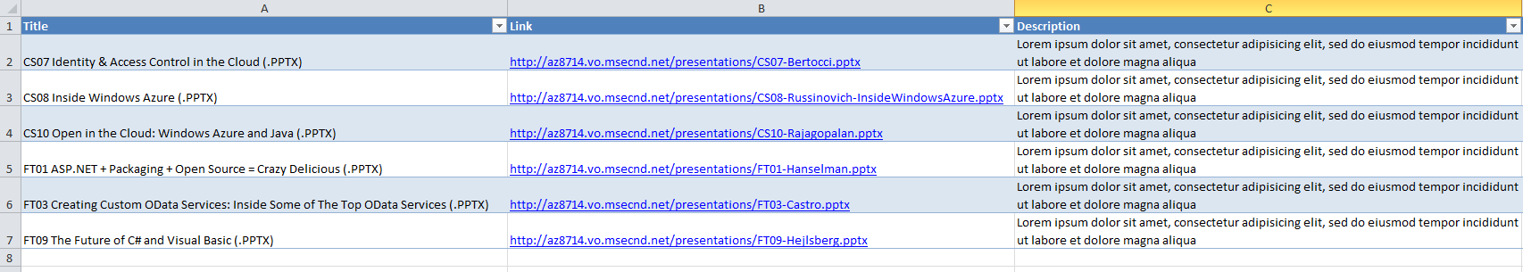
  2. **Documents** Data Definition: This file describes the target data structure in the Documents List and how it matches the source columns in the spreadsheets. It will fill three columns: **Title**, **Link** and **Description**. The **Source** indicates the Excel spreadsheet column name. The target is the visible name of the field in the SharePoint list.
  3. XML
  4. <?xml version="1.0" encoding="utf-8" ?>
  5. <GenericList ListName="Documents" Operation="Import" >
  6. <Fields>
  7. <Field Source="Title" Target="Title" />
  8. <Field Source="Link" Target="Link" />
  9. <Field Source="Description" Target="Description" />
  10. </Fields>
  11. </GenericList>
  12. The following command line will clean the list and then import the data:
  13. Windows Command Prompt
  14. SPIOTool.exe -DataDefinition:"Documents.xml" -SourceType:Xlsx -File:"Documents.Xlsx" -SiteUrl:"http://MMPCM.southworks.net/Sample" -ModerationStatusType:Approved -CleanLists -VerboseMode -CommitChanges

#### An example with two multi lookup column: Content list

* 1. 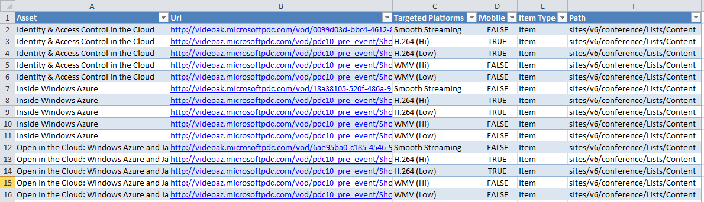
  2. The **Content** Data Definition file will fill four columns: **Url** and **Mobile** are not lookups and work like the previous example. **Asset** and **Targeted Platforms** are lookup columns, and their definition is different. It consists of a sub generic list indicating the **Title** column that will be used to check the existence of the item in the Assets/Targeted Platform lists. If it doesn’t exist, it will be created, and specified fields will be filled as usual. In the Targeted Platforms list, **Targeted Platforms** is the renamed **Title** column, so it will act as Title in the Asset column example.
  3. XML
  4. <?xml version="1.0" encoding="utf-8" ?>
  5. <GenericList ListName="Content" Operation="Import" >
  6. <Fields>
  7. <Field Source="Asset" Target="Asset" >
  8. <GenericList>
  9. <Fields>
  10. <Field Source="Asset" Target="Title" />
  11. </Fields>
  12. </GenericList>
  13. </Field>
  14. <Field Source="Url" Target="Url" />
  15. <Field Source="Targeted Platforms" Target="Targeted Platforms" >
  16. <GenericList>
  17. <Fields>
  18. <Field Source="Targeted Platforms" Target="Targeted Platform" />
  19. </Fields>
  20. </GenericList>
  21. </Field>
  22. <Field Source="Mobile" Target="Mobile" />
  23. </Fields>
  24. </GenericList>
  25. The first field’s definition will cause the tool to lookup **Identity & Access Control in the Cloud** in the **Assets** list. Also Smooth Streaming will be looked up, in Targeted Platforms list. This is because the tool needs to build the current **Content** Item before it is inserted.
  26. **Note: Smooth Streaming targeted platform should not be deleted, since most of the built-in Transform Manager tasks rely on its existence. Moreover, the Rough Cut Editor will render useless, since it builds the gallery of available videos selecting Smooth Streaming videos.**

#### Assets list example

* 1. 
  2. **Assets** Data Definition: This example is slightly complex, but watching closely you will notice that the only difference from the others is the amount of fields.
  3. XML
  4. <GenericList ListName="Assets" Operation="Import">
  5. <Fields>
  6. <Field Source="Title" Target="Title" />
  7. <Field Source="Content Type" Target="Content Type ID" />
  8. <Field Source="Description" Target="Description" />
  9. <Field Source="Short Description" Target="Short Description" />
  10. <Field Source="Short Title" Target="Short Title" />
  11. <Field Source="Thumbnail" Target="Thumbnail" />
  12. <Field Source="Category" Target="Category">
  13. <GenericList>
  14. <Fields>
  15. <Field Source="Category" Target="Title" />
  16. </Fields>
  17. </GenericList>
  18. </Field>
  19. <Field Source="Collection" Target="Collection">
  20. <GenericList>
  21. <Fields>
  22. <Field Source="Collection" Target="Title" />
  23. </Fields>
  24. </GenericList>
  25. </Field>
  26. <Field Source="Language" Target="Language" />
  27. <Field Source="Content Author" Target="Content Author" />
  28. <Field Source="Duration (in min)" Target="Duration (in min)" />
  29. <Field Source="Short Url" Target="Short Url" />
  30. <Field Source="Twitter Hash tag" Target="Twitter Hash tag" />
  31. </Fields>
  32. </GenericList>

## How To – *Suggested Security Schema*

* 1. The following image shows the suggested security setting for the CMS, listing roles and their granted permissions.
  2. 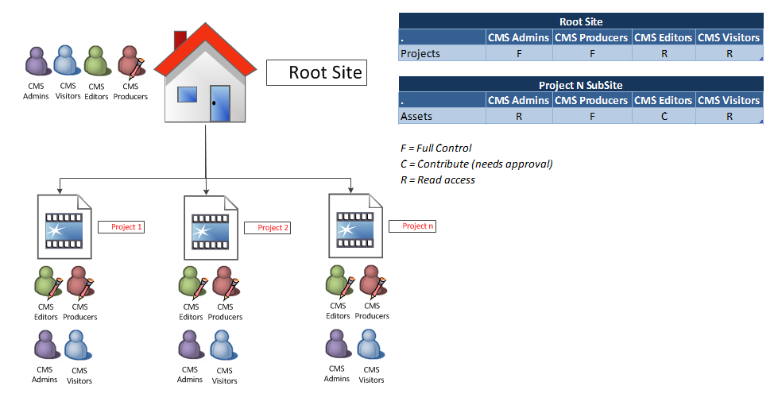
  3. MMPCM – Suggested Security Schema

### Administrator

* 1. A **CMS Administrator** has rights to introduce any changes on any list at MMPCM Root Site level. This user is in charge of maintaining general data such as Targeted Platforms, FTP Servers and Config lists.

### Producer

* 1. A **CMS Producer** is able to introduce changes only to MMPCM Project sites he is responsible of. This includes any configuration that is at MMPCM Root Site level in the Projects list. A Producer is responsible for every Asset approval inside those projects, and any changes that may be introduced by a CMS Editor.

### Editor

* 1. A **CMS Editor** is in charge of contributing to the Assets list of an MMPCM Project site. All the information that resides at MMPCM Project Site level should be uploaded by this user, but requires a CMS Producer to approve it.

### Visitor

* 1. This user has permissions to read all content at MMPCM Root Site level and Project Site level, but has no write privileges.
  2. In the MMPCM Root site, every role has read access, but only the CMS Admin role has write permission, as the image shows. As an exception to this rule, a CMS producer may introduce changes to the Projects List. This is graphically shown on the image below, and in the table at the right.
  3. Below the MMPCM Root Site is the MMPCM Project site level. At this level, CMS Editors and Producers have write permissions, but from different perspectives. A CMS Editor may introduce changes that a CMS Producer must approve later. A CMS Producer is able to introduce any changes whatsoever without anyone’s approval, and may approve CMS Editor changes.

## How To – *Configure Third Party Player Access*

* 1. 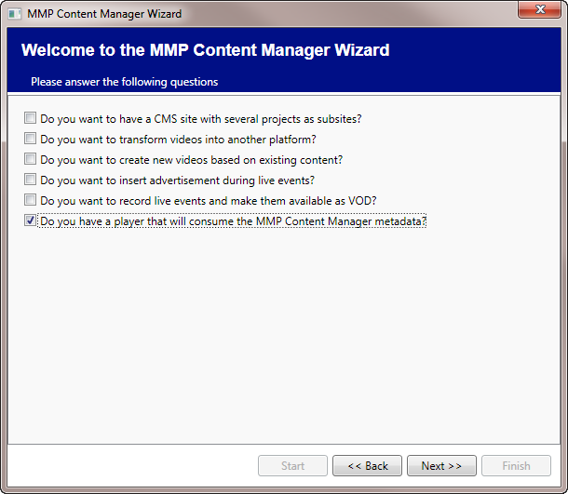
  2. If an external system, like a third party Player, requires access to some of the information stored in the CMS system, there’s a way to provide it through the Metadata XML Export feature. It should’ve been installed when running the MMPCM Wizard.
  3. 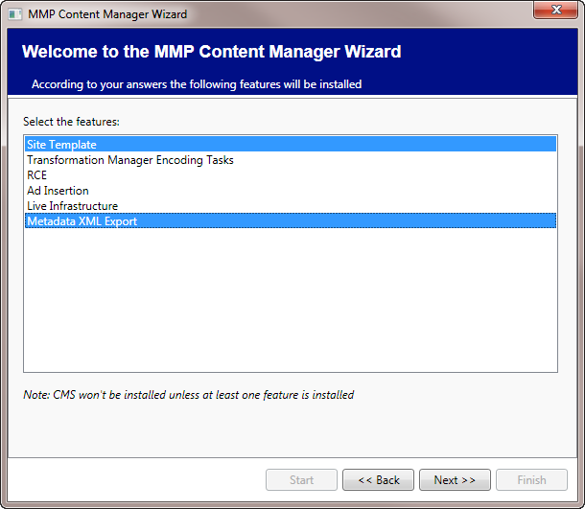

### Metadata XML Export

* 1. Once this feature is installed, there will be a new site page **Metadata Export** in the Sample site, from which it may be tested.
  2. For this feature to work appropriately, an FTP server must be configured for the MMPCM Project, in the MMPCM root site. If the FTP Server was correctly configured when the MMPCM Wizard was ran, there’s no need to add another item to the FTP Servers list, and this step may be skipped.
  3. Go to the root site URL [**http://MMPCM.contoso.com**](http://lcms.contoso.com)(or the URL of your MMPCM root site)
  4. Select the FTP Servers list.
  5. Click the **Add new item** button.
     1. 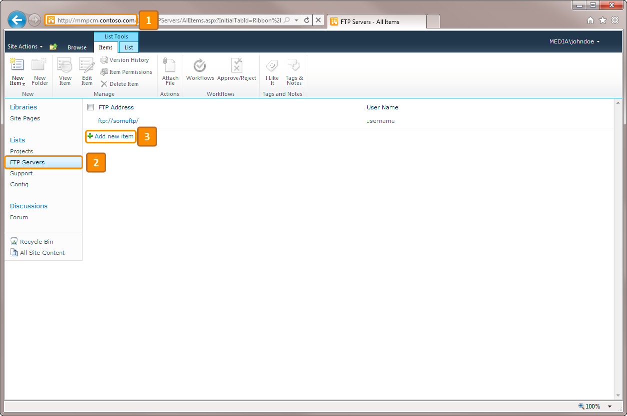
  6. Fill in required information:
     1. FTP Address
     2. User name
     3. Password
  7. Click **Save.**
     1. 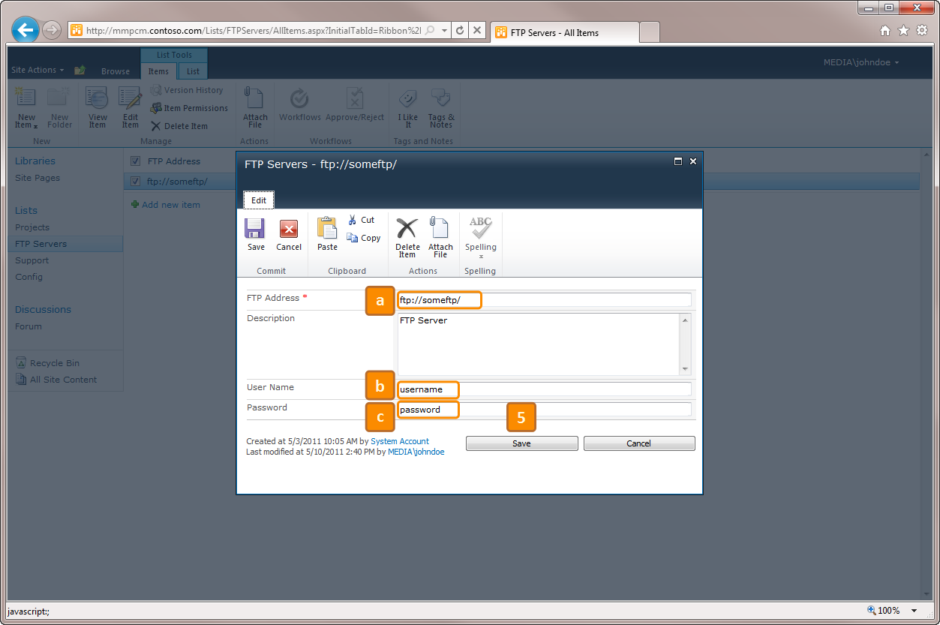
  8. Once we have an FTP Server item in our FTP Servers list, it must be associated with the MMPCM Project site of your choosing.
  9. Go to the **Projects** list
  10. Select the Sample project site (or whichever project you want to use)
  11. Click the **Edit item** button.
      1. 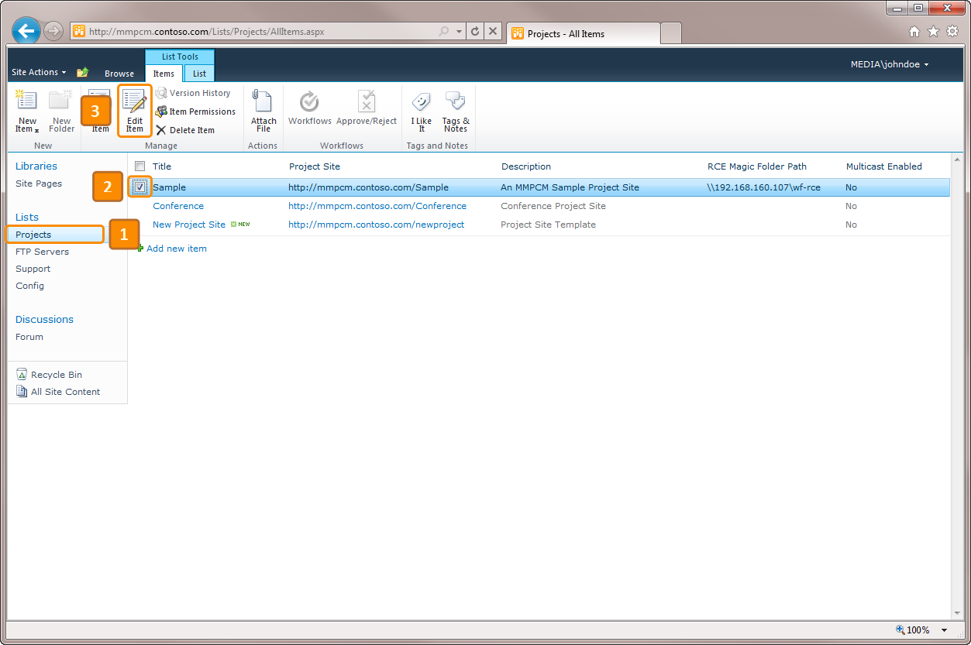
  12. In the **Edit view** of the **Project item** , Click the FTP Server dropdown list and select the FTP Server you want to use for this Project item.
  13. Click **Save**.
      1. 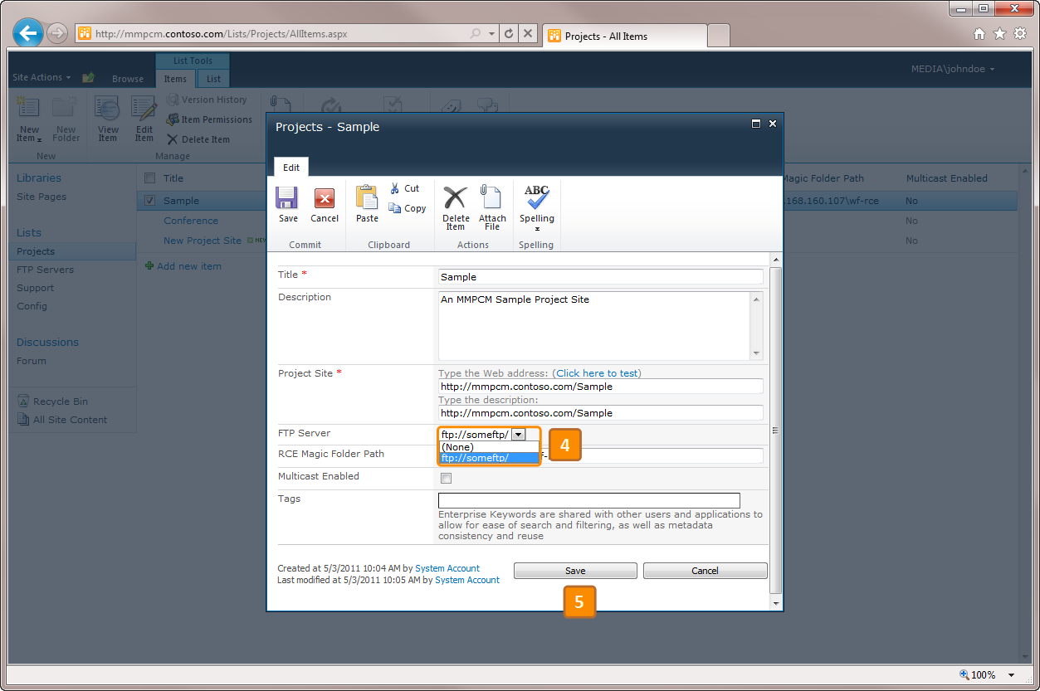
  14. After configuring the previous steps, you’ll be all set to generate a **Schedule XML** file, that’ll be dropped to the FTP server right from SharePoint.
  15. To test this feature, go to the MMPCM Project site, and browse **Site Pages**.
  16. Click on the **Metadata Export** site page.
  17. To export and generate the Schedule.xml file right now, click on the **Generate Schedule.xml** button.
      1. 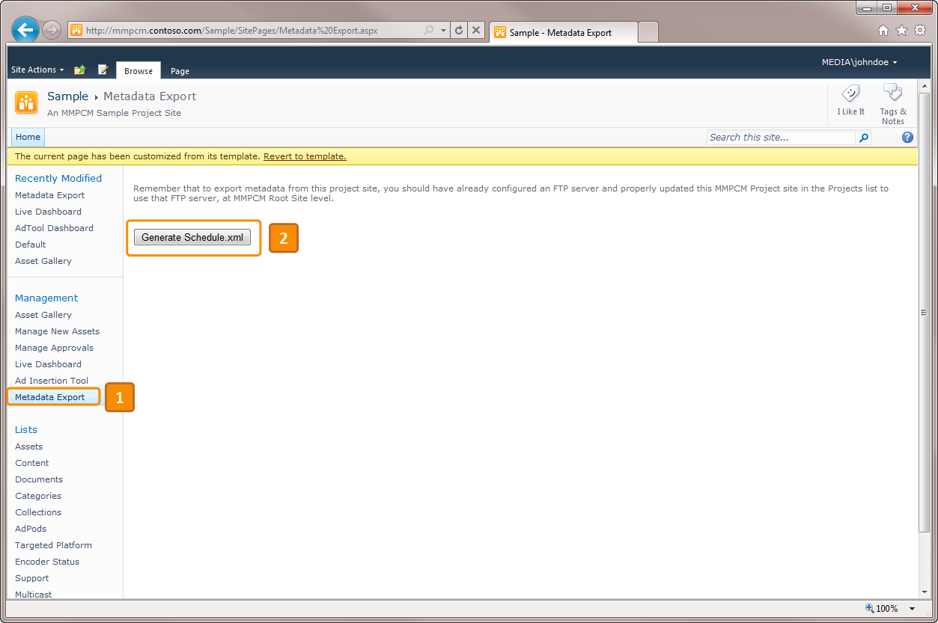
  18. Right after clicking that button, if there were no errors in the communication with the FTP Server, there should be a green tick indicating the Schedule.xml file has been correctly uploaded.
      1. 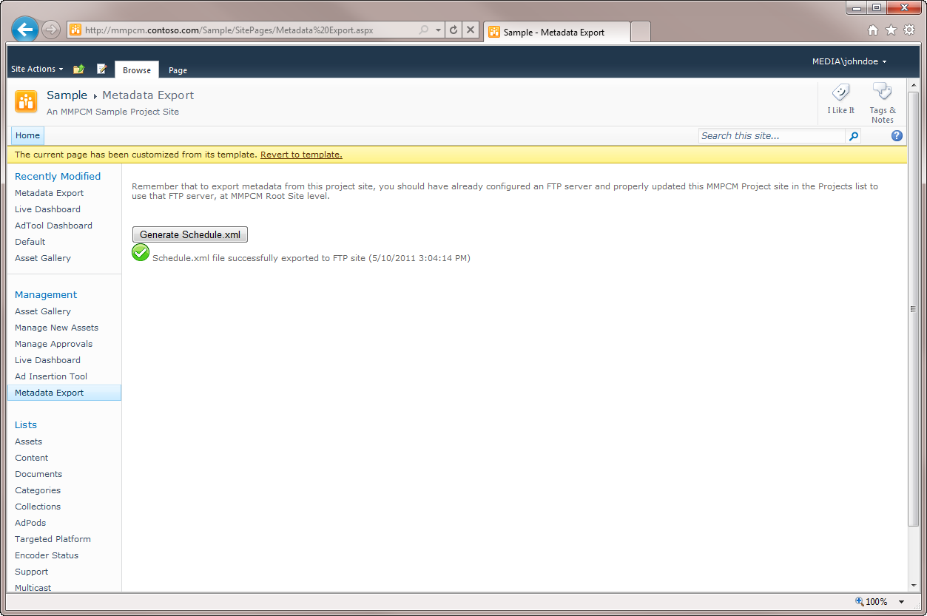
  19. Logging to the FTP Server, there should be a Schedule.xml file ready for consumption.
  20. 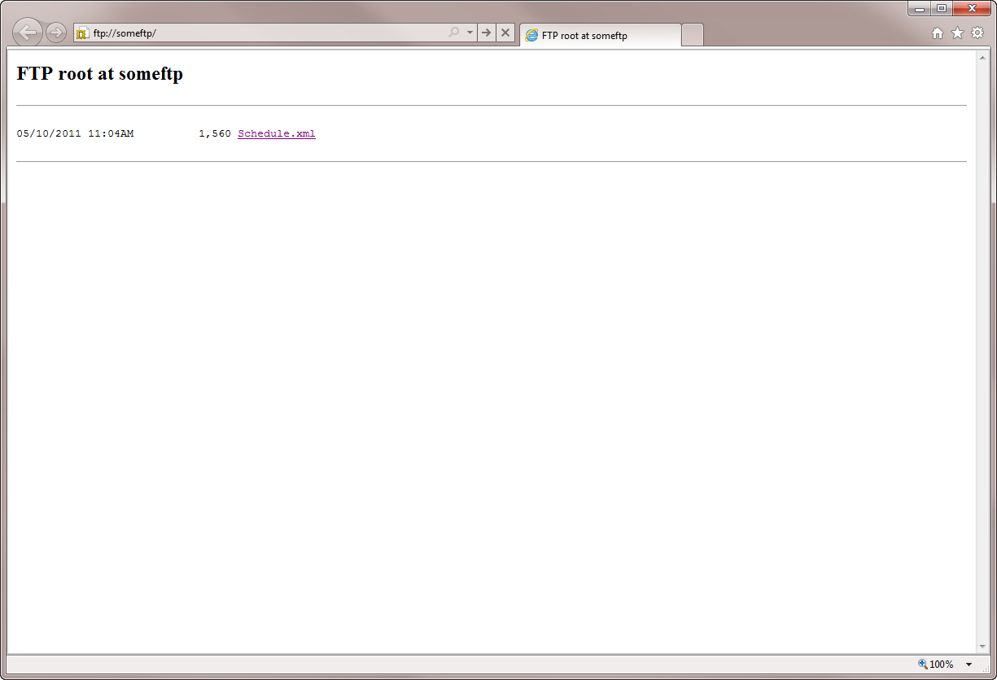
  21. This file has a certain structure. The following information that exists in the MMPCM Project can be found:
  22. Collections
  23. Categories
  24. Assets
      1. 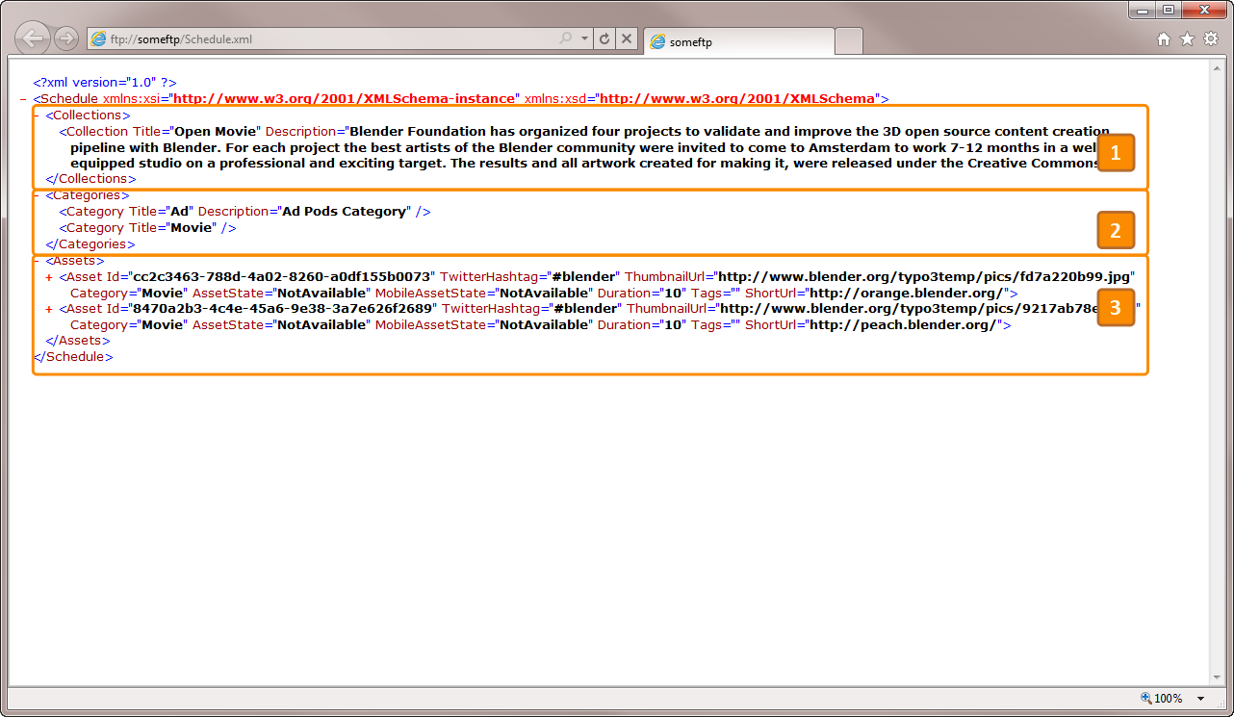
  25. This information can be used to consume the MMPCM data from any external player. If there’s a need for more information to be exported from SharePoint, the **Microsoft.MediaFrameworks.MMPCM.ScheduleXmlLibrary** Visual Studio project must be extended.

# Extensibility

## Customizing a Project Site

Prerequisites:

* Visual Studio 2010
* SharePoint 2010
  1. **Note:** this is an advanced topic. **SharePoint 2010** development knowledge is required in order to proceed. No implementation details are provided.
  2. The MMPCM Package provides two types of customized Project Sites: **Default**, and **Conference**. The latter is extended from the Default Project Template and was used for broadcasting the **Microsoft 2010 Professional Developers Conference (PDC)**.
  3. 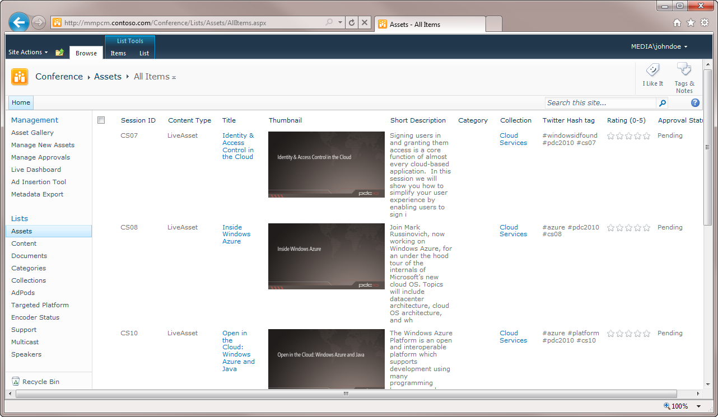
  4. MMPCM – Conference Site Template
  5. In order to customize the Project site Default or Conference, **Visual Studio 2010** is required.
  6. Open the MMPCM Site Template solution in Visual Studio. You should **open Visual Studio as administrator** to avoid any problems that may arise.
     1. 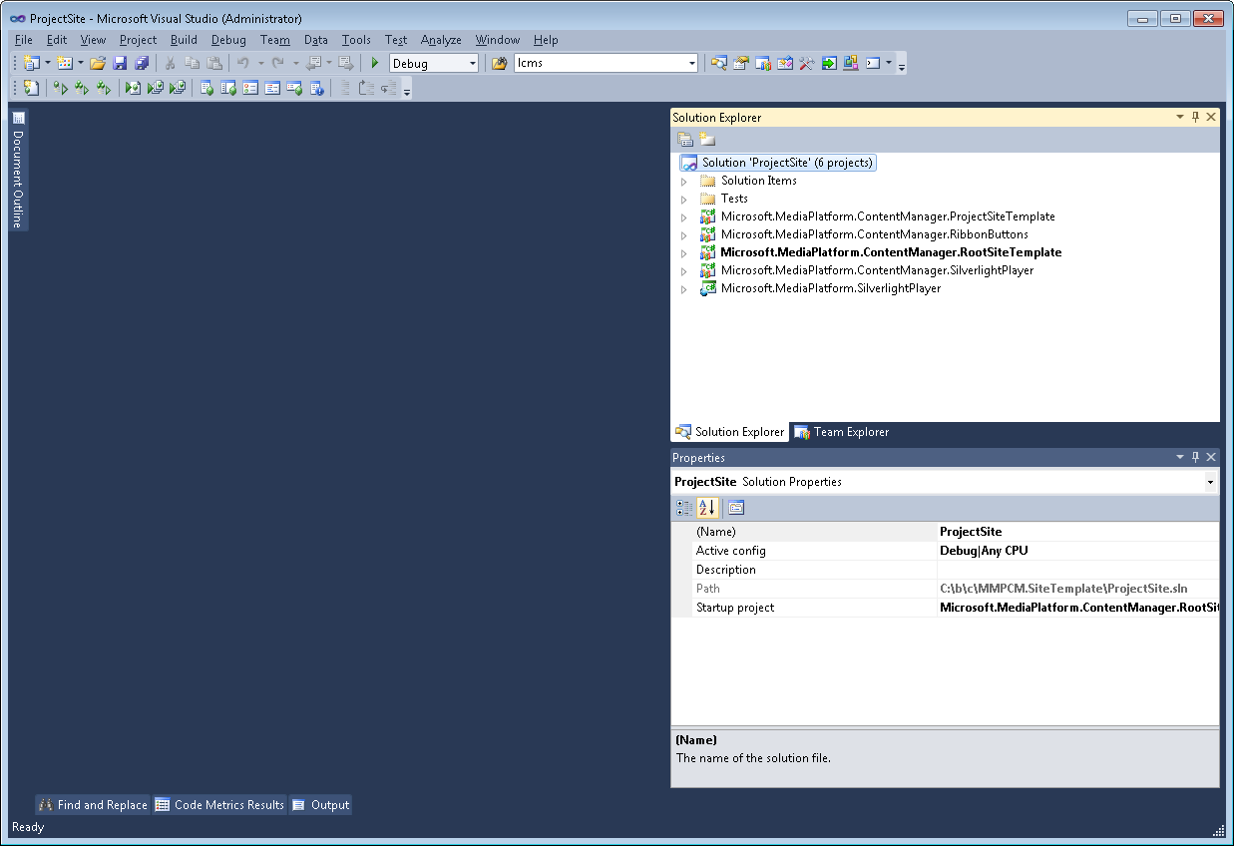
  7. Right click the **Microsoft.MediaFrameworks.MMPCM.ProjectSiteTemplate** VS project, select **Properties**, and the next screen will show up. In the **Application** tab, change the Assembly Name and Default namespace.
     1. 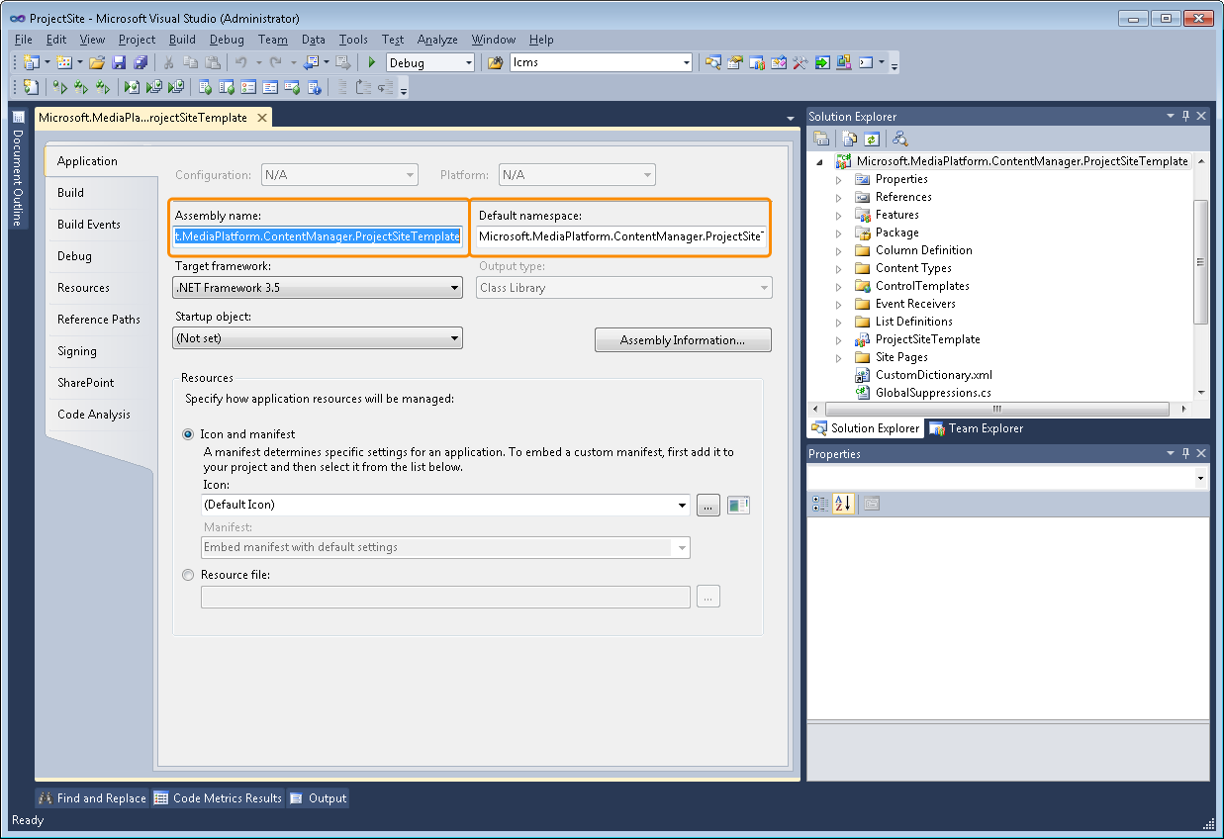
  8. Click **Assembly Information** and change the GUID as well (In the **Tools** menu in Visual Studio, there’s a **Create GUID** tool that will help you create a new GUID).
     1. 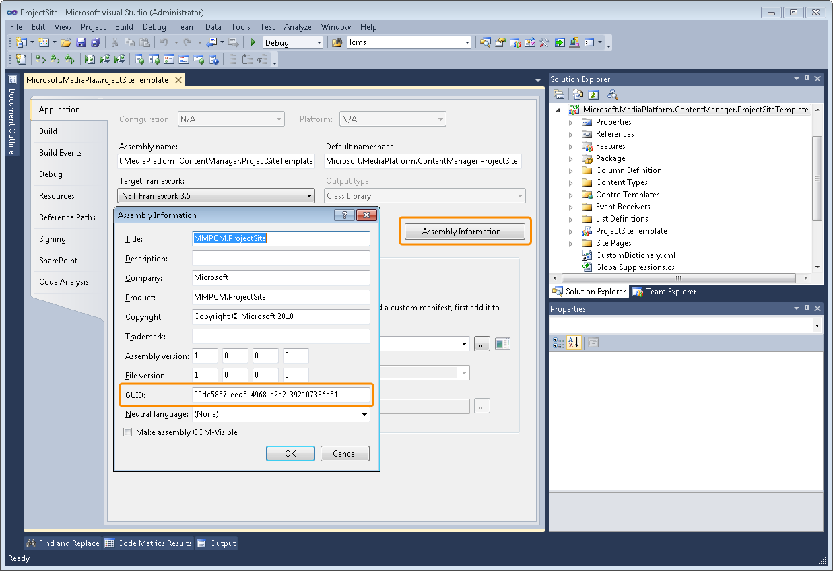
  9. In the same **Properties** page, go to the **Signing** tab, click the key file dropdown list, and select **<New..>** This will create a new assembly key signature for the MMPCM Project Site Template.
     1. 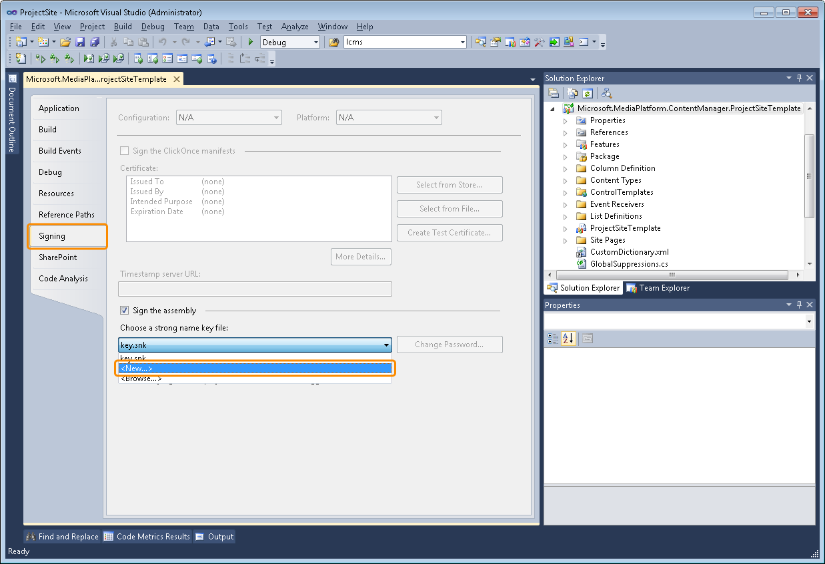
  10. Save properties and close the page.

### Features & Package

* 1. In every feature, there’s a GUID that identifies it as unique. Those GUIDs must be changed for the new MMPCM Project Site to be completely unique, and ensure that there are no collisions between features.
  2. Unfold the **Microsoft.MediaFrameworks.MMPCM.ProjectSiteTemplate** item. Unfold **Features** item.
  3. Double click a feature. There’s a **Feature Id** field in the properties window. Replace that GUID with a new one.
  4. Replace the Title field value with a new one.
     1. 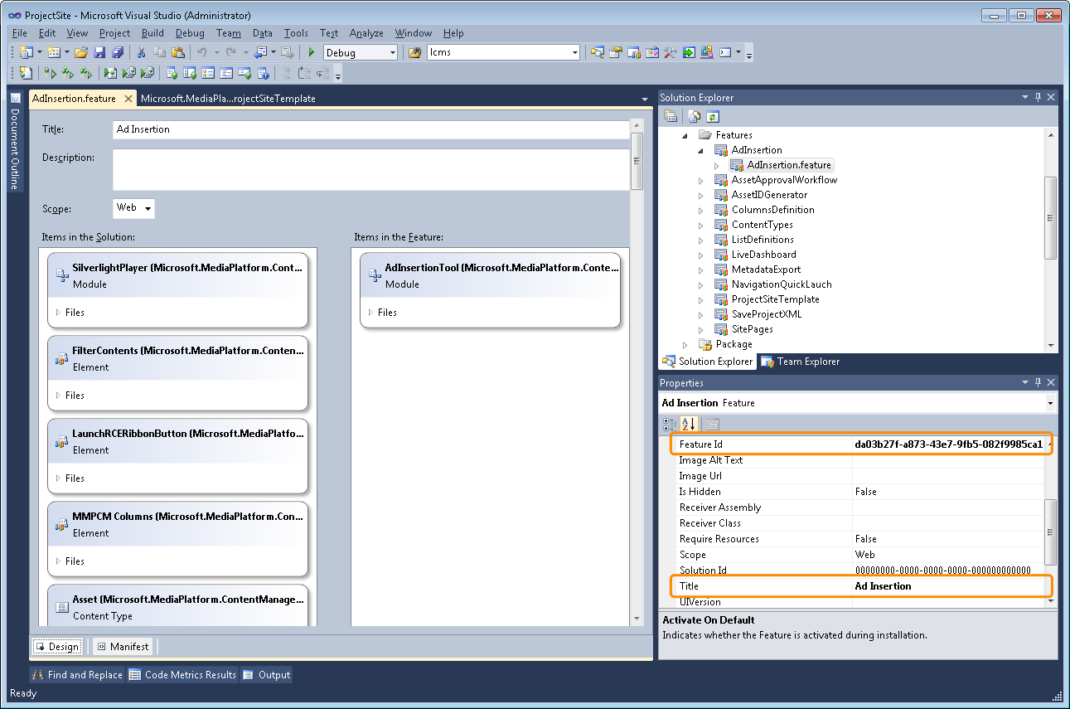
  5. Save the feature. Take note of the GUID you used and the feature, for future reference.
  6. Go to **step 2** and choose another feature, until all features in the **Microsoft.MediaFrameworks.MMPCM.ProjectSiteTemplate** have been modified
  7. The same procedure must be followed for the Package.
  8. Unfold the **Microsoft.MediaFrameworks.MMPCM.ProjectSiteTemplate** item. Unfold the **Package** item.
  9. Double click the Package. There’s a **Solution Id** in the properties window. Replace that GUID with a new one.
  10. Replace the **Name** field value with a new one.
      1. 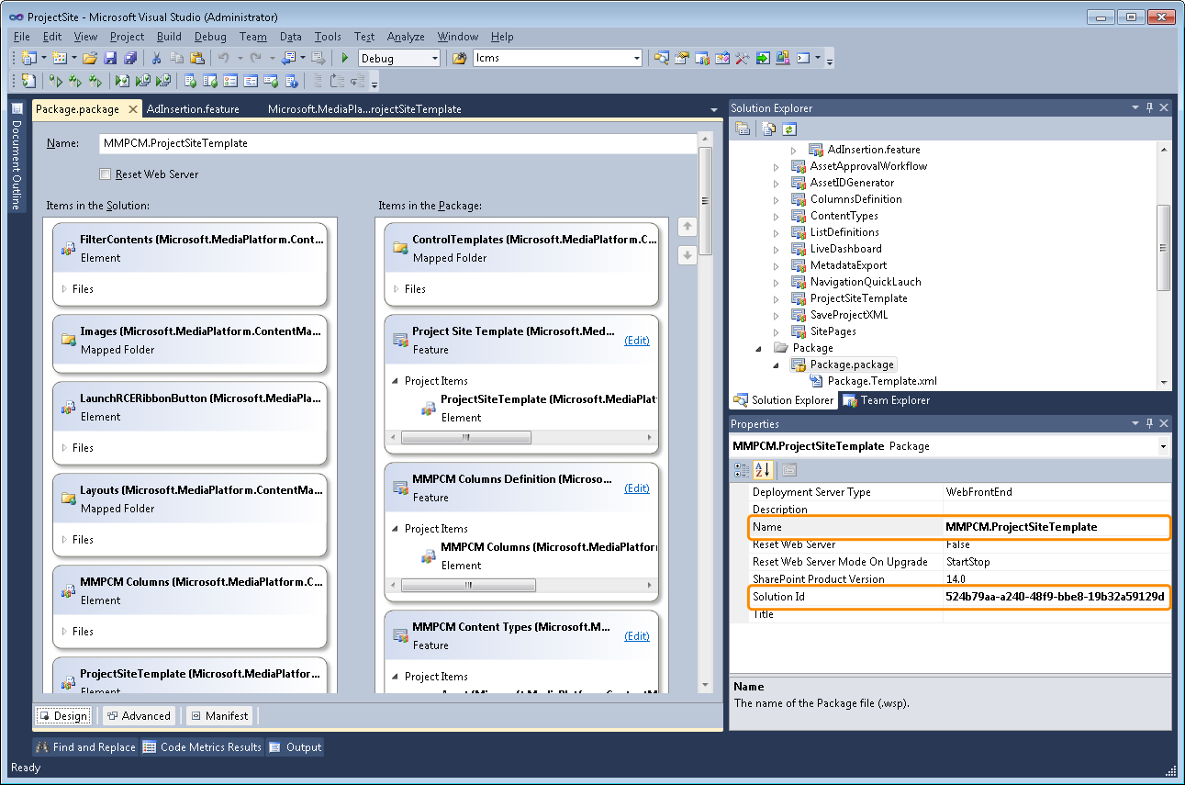
  11. Save the Package.
  12. When all features and package have new GUIDs and names, go to the **ONET.XML** inside the **ProjectSiteTemplate** item, in the **Microsoft.MediaFrameworks.MMPCM.ProjectSiteTemplate**. In this file there are references to some features that must be activated when a Project Site gets instantiated using this solution. Now you must use all those feature GUIDs collected previously, to replace the default ones.

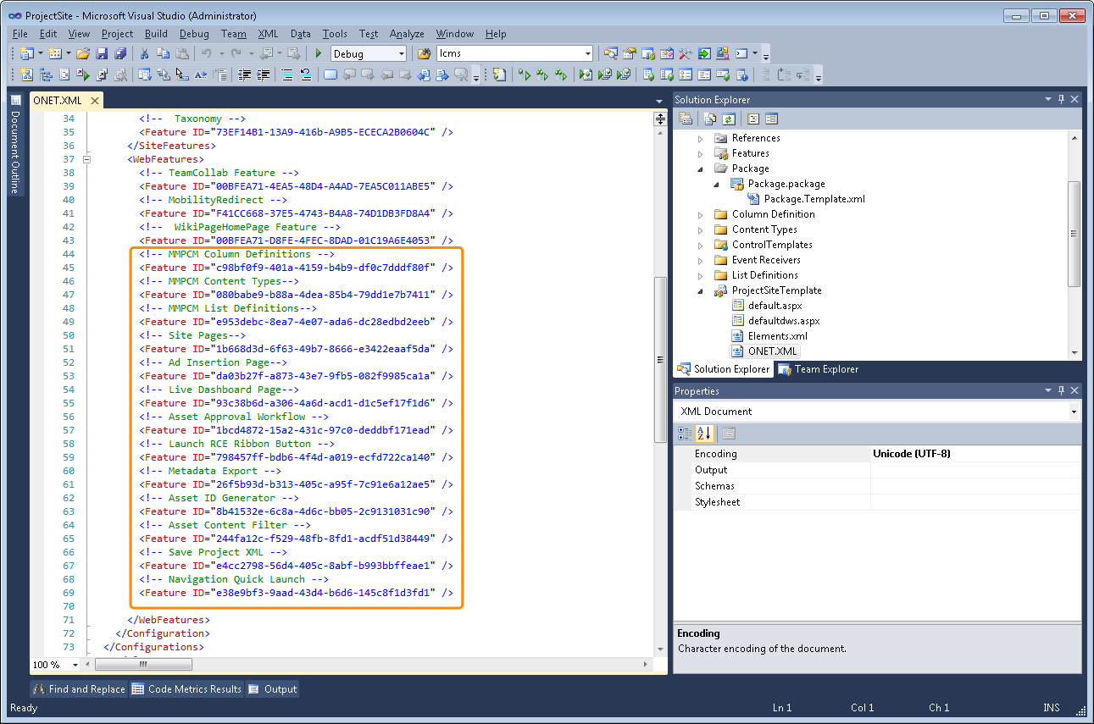

### List Forms

* 1. Asset list’s forms have been customized in a way that every Project Site in the farm uses the same forms. This provides a way to introduce changes that apply to all Project sites at once, but it’s an inconvenience for extending and creating a new version of it.
  2. Unfold up to the **MMPCM.ProjectSiteTemplate**, **ControlTemplates** folder.
  3. Select a .aspx form.
  4. Modify the file name with a new one.
  5. Modify the **Rendering Template ID** in the .aspx form. This ID will be used later, save it with a reference to which form it is in.
  6. Save the .aspx form.
  7. Go to step 2 and choose another form. Repeat until all .aspx forms have been modified.
     1. 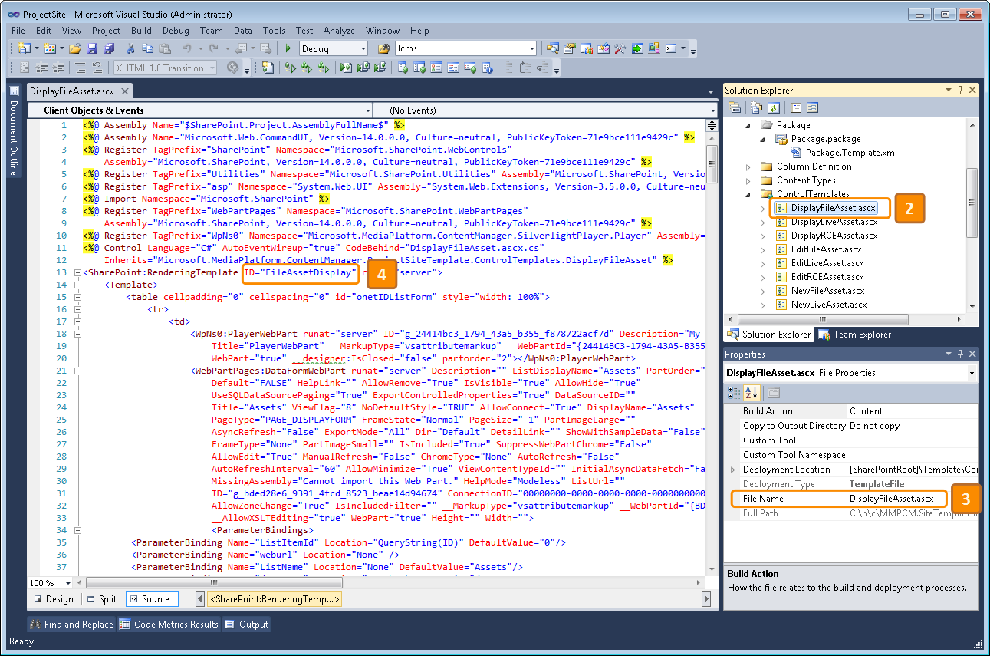
  8. Right after modifying the previous .aspx list forms, an event receiver that links those forms with **Asset Content Types** inside SharePoint must be modified as well.
  9. Unfold **Microsoft.MediaFrameworks.MMPCM.ProjectSiteTemplate**, **Features**, **ContentTypes**, **ContentTypes.feature**, and double click the **ContentTypes.EventReceiver.cs** file.
  10. Find the code that appears in the screenshot below, and replace the string **LiveAssetNew** with the **Rendering Template ID** from the **NewLiveAsset.aspx**, modified previously.
  11. Replace the string **LiveAssetEdit** with the **Rendering Template ID** from the **EditLiveAsset.aspx** modified previously.
  12. Replace the string **LiveAssetDisplay** with the **Rendering Template ID** from the **DisplayLiveAsset.aspx** modified previously.
  13. Go to step 2 and repeat previous steps for the **FileAsset** and **RCEAsset** lines.
  14. Save the **ContentTypes.EventReceiver.cs** file and close it.
      1. 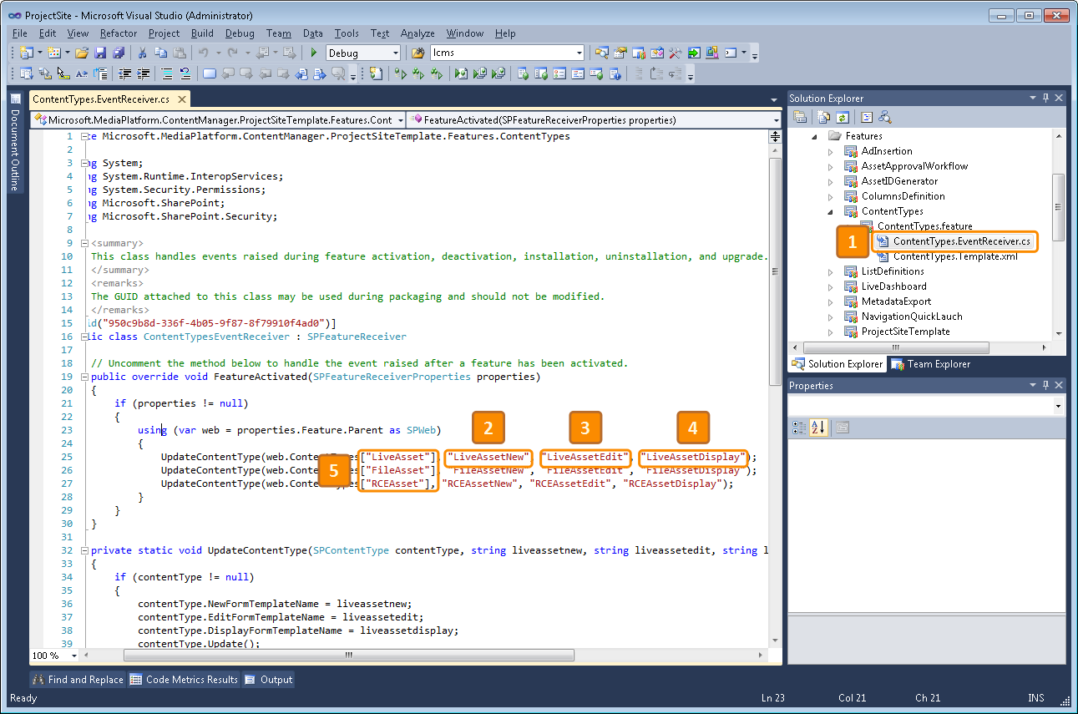
  15. Finally, the name of the Web Template must be changed.
  16. Unfold **Microsoft.MediaFrameworks.MMPCM.ProjectSiteTemplate**, double click the **ProjectSiteTemplate** item. Click it one more time so that folder properties show up.
  17. Replace the **Folder Name** field value with a new one. It cannot contain spaces.
  18. Replace the **Web Template Name** with the same one you used in step 2.
  19. Change the **Web Template Title** with a new one.
  20. Change the **Web Template Description** with a new one.
  21. Save the **Elements.xml** file.
      1. 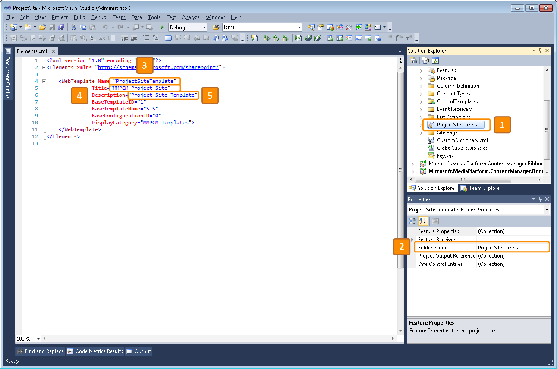
  22. That’s all. You may also change the VS project name if you wish, but with all of these changes should be enough to create a new WSP package and upload it to SharePoint, in order to instantiate new Project Sites based on it.
  23. To create a WSP based on this new Project Site, follow these steps.
  24. Right click the **Microsoft.MediaFrameworks.MMPCM.ProjectSiteTemplate** (or whatever name you chose for it in previous steps)
  25. Click **Package**
  26. Upload the generated .wsp file to SharePoint using SharePoint Administrative Shell, and instantiate a new MMPCM Project Site based on it, inside a previously created **MMPCM Root Site**.
      1. 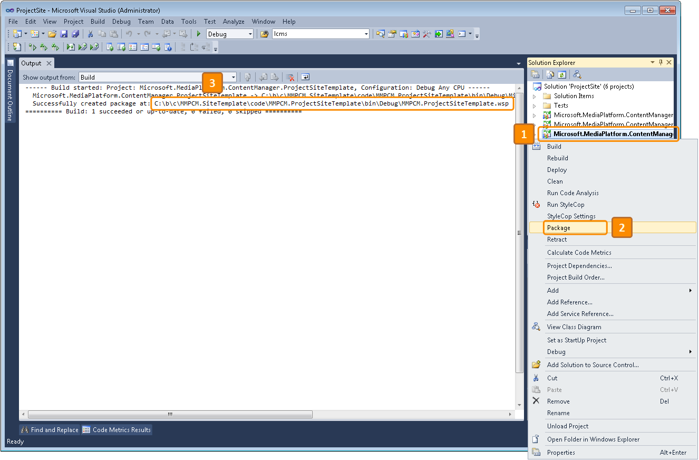

## Using a different Live infrastructure

* 1. Prerequisites:
  + Visual Studio 2010
  + Encoding solution with accompanying web service
  1. **Note:** Check with your encoding solution manufacturer for details on remotely managing the encoding process using web services.
  2. **Note:** this is an advanced topic. **WCF** development knowledge is required in order to proceed. No implementation details are provided.
  3. MMPCM allows developers to change its Live Infrastructure (i. e. swapping the web service that manages the encoder that will be used to broadcast live events).
  4. There are two out-of-the-box implementations available with MMPCM:
  + Expression Encoder Manager: This service allows users to control a local or remote instance of **Microsoft Expression Encoder 4** (through **Encoder Automation Service**).
  + Spinnaker Message Service: This service allows users to control encoders from the **Inlet Technologies Spinnaker** family.
  1. If your organization uses a different encoding solution, you can adapt MMPCM to use it, by making the following changes:
  2. Open the Encoder Manager Visual Studio solution
  3. Create a new Project of type WCF Service Application
     1. 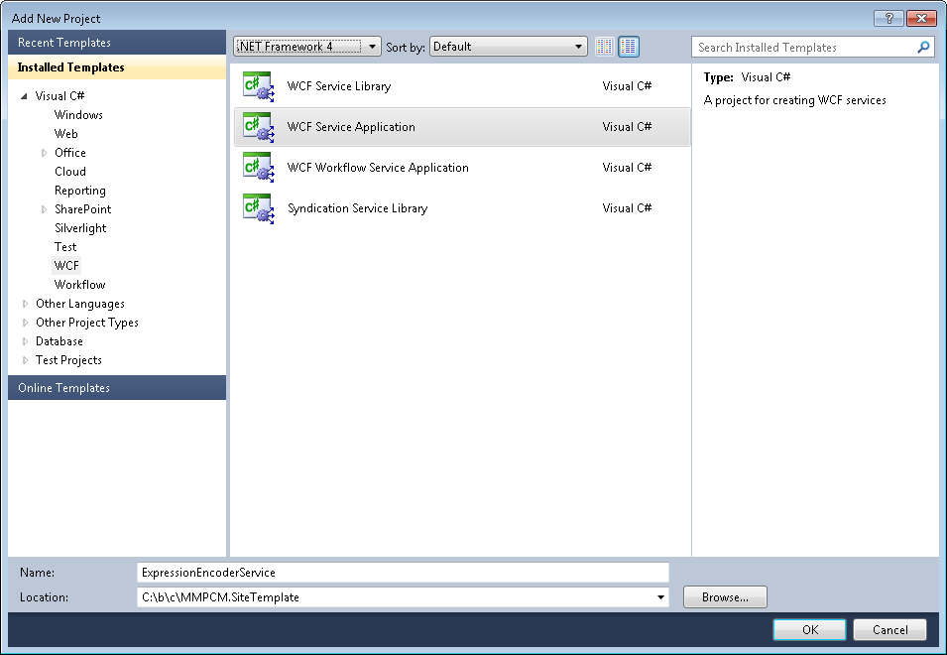
  4. Locate the service **svc** file, and make it an implementation if **IEncoderManagerService** interface.
     1. 
  5. This will add three methods:
  + Start
  + Start (Multicast)
  + Stop
  1. With the parameters seen in the picture below:
  2. 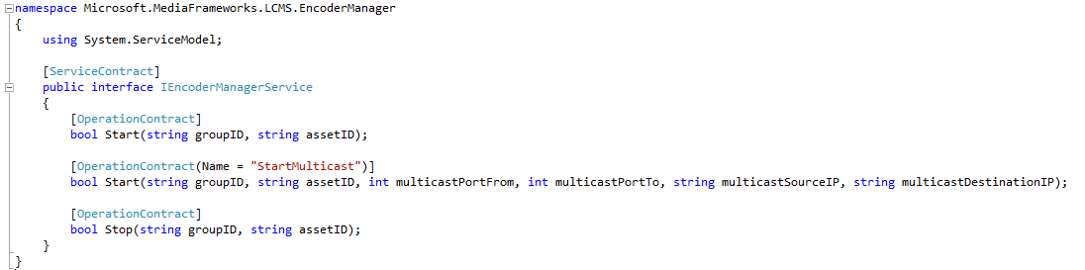
  3. Additionally, you will need to add a service reference to the web service that handles the encoder itself (e. g. **Encoder Automation Service** for **Microsoft Expression Encoder 4**).
     1. 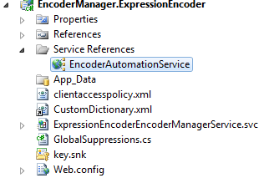
  4. Code the necessary logic in the svc and auxiliary classes.
  5. Publish the resulting web service.
  6. 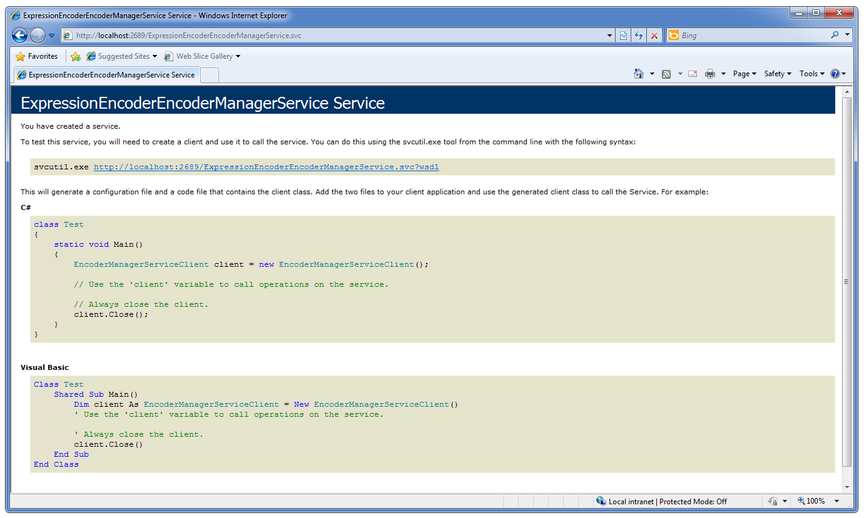
  7. Finally, browse the **Config** list in the MMPCM site, and change the **Encoder Manager Web Service** value for the URL of the service that manages the new encoder infrastructure.
     1. 